Living in Sutton

- Private Sector – House Prices in Sutton & the Surrounding areas

Sutton
Property Prices
Flat | £223,288
Terrace | £333,901
Semi Detached | £415,825

Property prices by London Borough
*taken from the Land Registry House Price Index 30/4/2015

- Sutton £318,684
- Croydon £323,582
- Bexley £288,378
- Greenwich £353,926
- Kensington & Chelsea £1,296,754
- City of Westminster £999,687
- Camden £830,743
- Hammersmith & Fulham £796,434
- Brent £423,595
- Islington £668,825
- Wandsworth £577,825
- Richmond Upon Thames £622,713
- Kingston Upon Thames £418,463
- Barnet £460,560
- Hackney £601,378
- Haringey £488,292
- Hounslow £357,165
- Lambeth £534,744
- Ealing £454,088
- Southwark £549,243
- Merton £472,664
- Tower Hamlets £481,200
- Lewisham £385,353
- Hillingdon £339,227
- Bromley £383,526
- Enfield £329,606
- Harrow £380,769
- Waltham Forest £365,810
- Redbridge £302,573
- Havering £310,235
- Newham £291,364
- Barking & Dagenham £274,467

- Shared Ownership Schemes in Sutton and the Surrounding areas

Within Sutton there are two schemes that are run: the Help to Buy Equity Loan and the Help to Buy Mortgage Guarantee.
Shared Ownership schemes are available within a commutable distance of Sutton in the Kent Sussex and Kent areas.
http://www.helptobuy.org.uk/
http://www.amicushorizon.org.uk/article/11997/Homes-for-sale

- Shared Ownership Schemes in London

To apply for a Shared Ownership scheme in the London area visit www.sharetobuy.com/London. You will need to register your interest in the scheme and contact the appropriate Housing Providers in your areas of interest.
- Keyworker Housing

As a public sector worker you could get help to buy or rent a home as part the Key Worker Living Programme. The websites that follow provide further information:
http://www.affinitysutton.com/rent-a-home/rental-options/key-worker-rent/
http://www.lqgroup.org.uk/sales-and-rentals/home-ownership-and-rental-options/key-worker-homes/

Transport
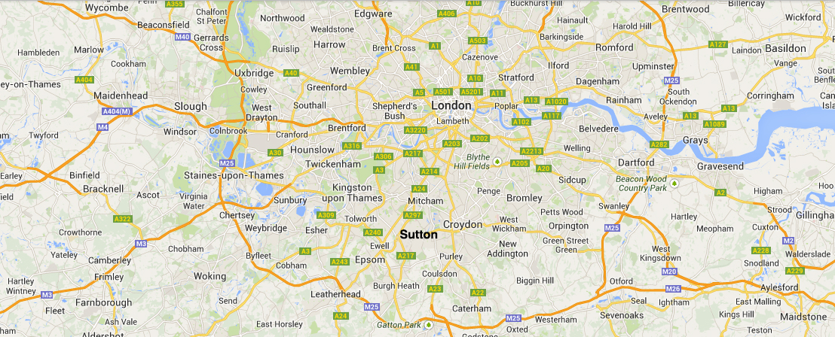

Rail Services
The borough is well-served by the national rail network, with lines through Sutton providing services to the London termini of Victoria (30 minutes) and London Bridge and the ‘Thameslink’ service providing a cross-London rail link to Blackfriars (36 minutes), St. Pancras (46 minutes) International and Luton / Bedford via the Wimbledon and Sutton loop line. Sutton is approximately 12 minutes by train from Croydon.

The line serving Worcester Park in the north west of the borough provides services to Waterloo.

Going out of London there are direct services from the borough to Epsom Downs, Epsom, Dorking, Horsham and Guildford. The borough is currently served by three Train Operating Companies (TOCs) – Southern, First Capital Connect and South West Trains.

There are nine rail stations fully within the borough and one (Worcester Park) spanning the borough boundary. In addition, several stations lie just outside the borough and are likely to be used by borough residents, including Banstead, Mitcham Junction, St. Helier, Stoneleigh, Waddon and Woodmansterne.

For further information on rail services:

https://www.tfl.gov.uk/

Bus Services
The borough is served by an extensive network of bus services, mainly using the main roads and serving town centres and other key destinations. Sutton is a 15 minute bus journey from the Morden terminus of the Northern Line.

Tram Services
The Tramlink network runs between Croydon and Wimbledon with two stops in the north-east corner of the borough at Beddington Lane and Therapia Lane. The tram stop at Mitcham Junction provides a useful interchange with rail services to and from Sutton. The Tramlink depot is also in the borough at Therapia Lane. Tramlink is now operated by Transport for London and has been rebranded as London Tramlink.

The Road Network
Three strategic Transport for London Road Network (TLRN) ‘Red Routes’, two of which, the A24 and A217, link central London to the GLA boundary (and onwards to the M25) and one of which, the A232, provides an east-west route across the borough.

Useful Links that provide further information on our borough:
Schools and Education
School Listings in Sutton | http://www.schoolsnet.com/uk-schools/best-school/top-sutton-schools/16180339/0/-1/5/179.html
Secondary School League Table in Sutton | http://www.bbc.co.uk/news/special/education/school_tables/secondary/11/html/319.stm
General Information relating to Sutton
Borough Guide and regions of Sutton | http://www.allinlondon.co.uk/boroughs/
Opportunity Sutton: projects, business, employment, investment, what’s on | http://www.opportunitysutton.org
Sutton Guardian – local news, leisure and what’s on | http://www.suttonguardian.co.uk/

