What parents & carers should expect from the Team Around the Child:

- A detailed CAF Review or Family Service Plan will be provided to parents / carers and other involved professionals.
- Action points will be agreed in the meeting.
- Parents / carers are in the driving seat of the meeting.
- Family’s individual circumstances will be treated with respect and confidentiality within the meeting and any delicate issues will be managed sensitively.

Contact Information:
Fran Boto on 020 8770 5057 Email: fran.boto@sutton.gov.uk

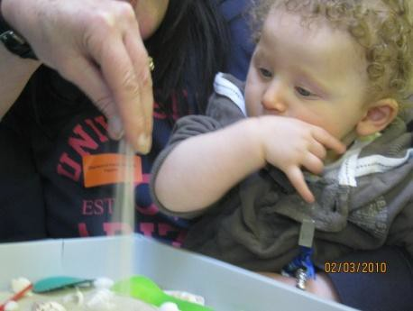
Disabled Children’s Service

Early Support
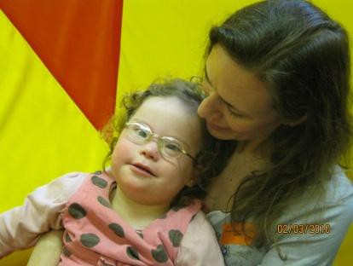
A Parent’s / Carer’s guide to:

Team Around the Child
(Formerly known as Impact)

Inclusive Multi-agency – Parents and Children Together

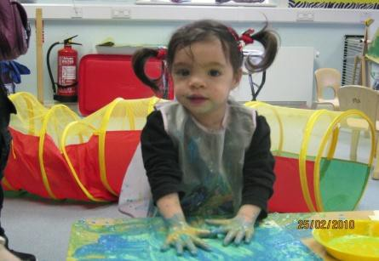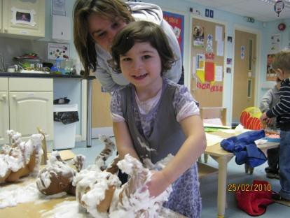

Welcome to TEAM AROUND THE CHILD:
What is Team Around the Child?

A Team Around the Child meeting is an opportunity for parents, carers, children and practitioners to meet up, share information and to decide and plan for the best way forward in the next few months.

Team Around the Child is generally for children with disabilities aged 0 – 8 years. Meetings are kept as informal as possible, you are encouraged to bring along significant people in the child or
family’s life and there is an attempt to look at the needs of the whole family. Meetings last no longer than 1 hour.

Parents / carers are recognised as experts on their children. They are very much in the driving seat of the meeting and are encouraged to ask questions and to raise any points they wish.

A plan is drawn up to best meet the needs identified and is based on the outcomes of being healthy, enjoying and achieving, staying safe, making a positive contribution and achieving economic well-being.

How do I arrange a Team Around the Child meeting for my child & family?

- Parents can contact one of the Early Support Co-ordinators to arrange a meeting
- The CONTACTS team can recommend further discussion with the family present at a Team Around the Child meeting
- You can ask any practitioner involved to refer to the Team Around the Child..

Who can come to the meetings?

YOU, as parents / carers are an essential part of the meeting. Your child will also be welcome to attend – we can arrange for an experienced crèche worker to entertain / care for your child during the meeting if you would like that.

A range of practitioners can attend the meeting, including;

Paediatricians, Early Years SENCOs, health visitors, physiotherapist, speech therapist, Portage worker, dietician, occupational therapist, nursery or school teacher, educational psychologist, support workers and any other significant person in your child / family’s life.
