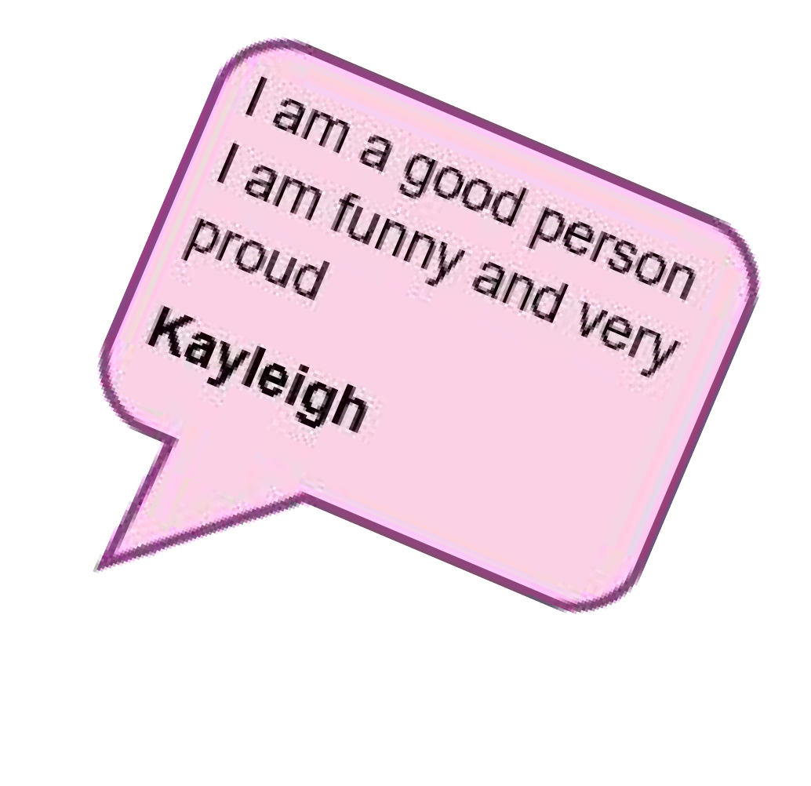
to join the group

call Gracie
01322 619707
www.advocacyforall.org.uk/self-advocacy- groups/sutton-groups

groups@advocacyforall.org.uk

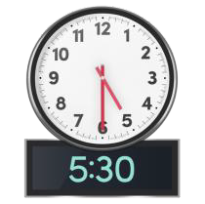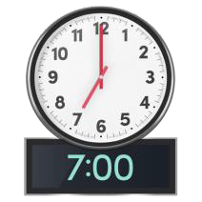We meet twice a month on Wednesdays

I like football
I like being helpful to staff and group members
I like to tell jokes
Dennis
Action Voices

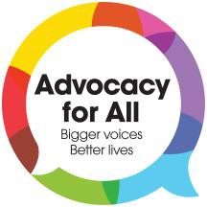
speaking up for young people with disabilities in Sutton

having a voice
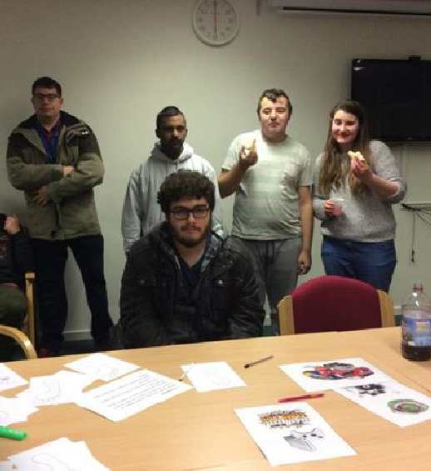
respect

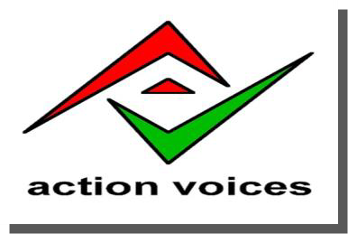

You may call it a disability I call it my life
Mark

What do we do?
- group discussions
- learn how to speak up
- be confident
- drama, dance, music and exercise
- drumming sessions
- social events like bowling, going to the pub and games
- independent travel training

You have a voice. What you say matters!
- Action Voices speak up to the council
- you can help make important changes to make life
better for young people with disabilities
- join us to speak up and have fun

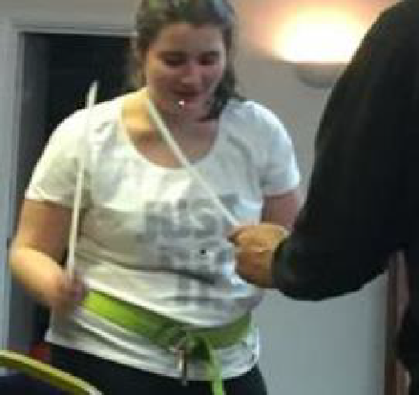
- mystery shopping

having fun

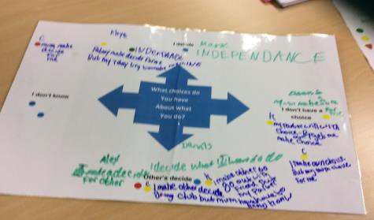
inclusion

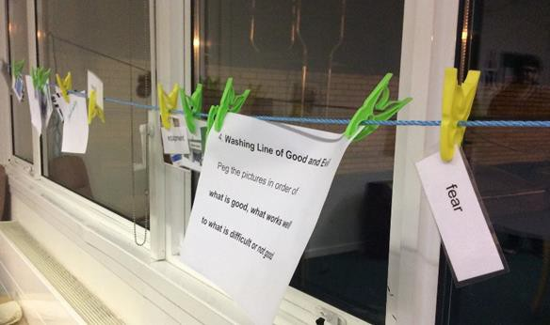
I am very keen to help people. I like to teach and do new things with the young people’s group. I like to be helpful.
Claude
belonging
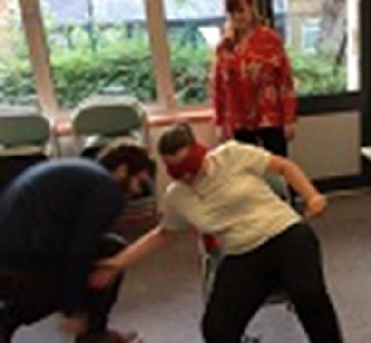

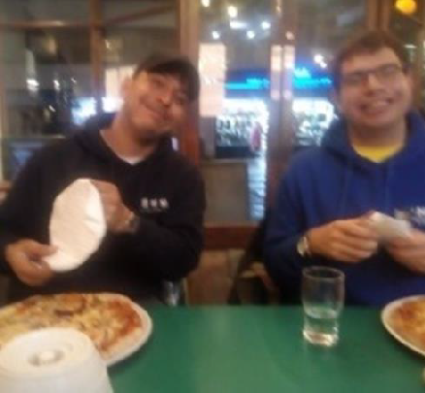
Who do we work with?

I am a happy person I like to help others
I enjoy going out with my friends
Alex
Young people aged 12 to 25 with learning disabilities

