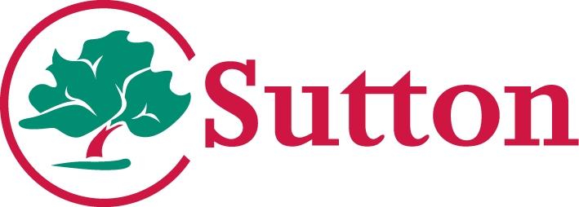

Terry Clark Head of Commissioning and Health
Integration Tel: 020 8770 5000
Date: 30th July 2020

Dear Parent/Carer

Assisted Transport for Children with Special Educational Needs and Disabilities
Following the government announcement that all school pupils are expected to return to school from September, I am writing to update you about assisted travel for children and young people with Special Educational Needs and Disabilities.

The latest government guidance that was issued following the announcement of the return to school made specific reference to transport. The principles outlined in the guidance are that:

- The risk to school children is very low and there are negative health impacts of being out of school.
- The benefits of being back in school far outweigh the very low risk from coronavirus
- Pupils do not mix with the general public whilst on transport so social distancing will not apply from autumn on dedicated transport
- Some schools may keep children in their class groups for the majority of the classroom time, but mix into wider groups for specialist teaching, wraparound care and transport.

Whilst we will try our hardest to make sure the transport we provide for your child remains consistent, with the changes to guidance for schools and changes to the transport workforce due to the pandemic, it is likely that there may be some changes to the assisted transport for your child when they return to school. This could mean that the driver or passenger assistant that has been supporting your child may change, the vehicle they travel in may be new to them or the time that we pick them up may be different. We will however ensure you are kept updated on any changes.

When the assisted travel for your child starts again, the driver and passenger assistant may be wearing face masks that cover their nose and mouth. I understand that this might make

some children anxious. Please take the opportunity to discuss this with your child/children and prepare them for this potential change.

It is not necessary for your child to wear a mask on transport as this may cause some children distress or make them anxious. If your child does want to wear a mask then this is OK too.
You will need to provide a face mask for your child if this is the case.

The Autism Service has put together a “A story on going back to school after lockdown” which explains to children how things might be different on their return to school. This can be found here:
https://cognus.org.uk/wp-content/uploads/2020/05/Going-back-to-school-after-closures.pptx

The Transport Team will let you know details of your transport as soon as they can. If you have not received details of the transport for your child by 24th August 2020 please contact the Transport Team.

You may decide that you now wish to take your child/children to school using your own transport. If this is the case then will we give you a Personal Travel Budget of £0.45 per mile. If you would like to switch to a personal transport budget, please contact the Cognus Transport Team at SEN.Transport@cognus.org.uk. If you decide to take a Personal Travel Budget during the current circumstances, you can go back to the council arranging assisted travel provision, although notice will need to be given in order for us to arrange this.

We will keep you informed of developments as they happen and will update the Local Offer web pages (https://www.sutton.gov.uk/localoffer) with up to date information. If you have any questions or concerns you can email the Children's SEN Assisted Transport Team SEN.Transport@cognus.org.uk or call them on 020 8323 0460.

Yours sincerely

Terry Clark
Head of Commissioning and Health Integration

2

