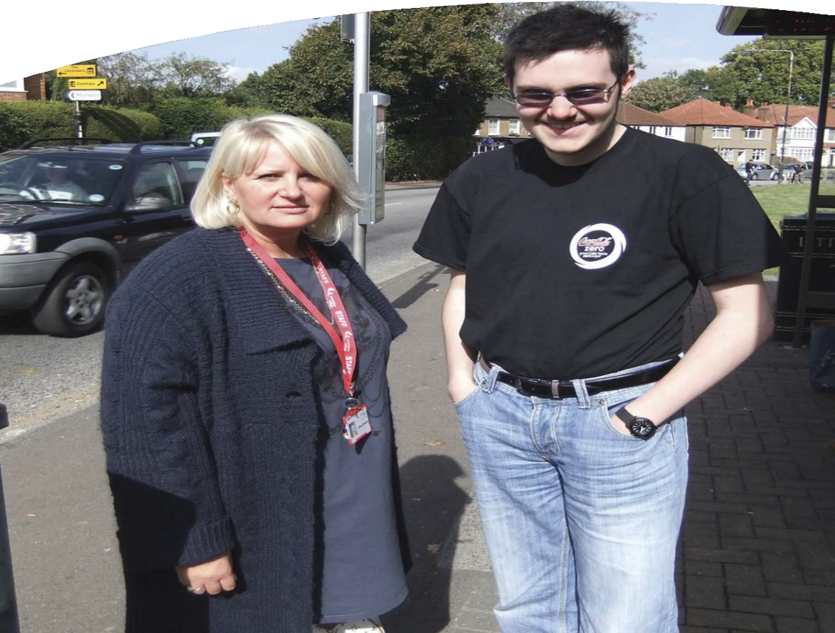Independent Travel Training: A parent’s guide

What is Independent Travel Training?
Independent travel training (ITT) helps to provide young people with the skills they need to travel independently. Independent travel is a crucial life skill that helps to give a young person the freedom to fulfil their potential and live a full life.
ITT is part of the national curriculum and if your child is assessed as being able to commence training, our ITT Team will aim to give them the skills they need to make important journeys whilst providing parents with peace of mind that their young people are travelling safely.
There is a team of experienced independent travel trainers currently working with your child’s school.

What are the potential benefits of Independent Travel Training for your child?
Travel training has been shown to have positive effects on the lives of the young people who are trained, as well as those around them. Successful travel training, for example, can enable families to do more things, both as a family as well as providing more time for separate activities.
Travel training is a very important skill for life. Being able to travel with less support allows young people to do more social and educational activities and helps them to maintain better relationships with peers?. Independent travel skills also help to open up employment opportunities after leaving school. This all contributes to young people leading a more fulfilled life.

How does my child access travel training?
Before any training takes place, the school will first assess that your child is ready, in their view, to be considered for ITT. To be considered for ITT your child must have the potential - once successfully trained - to travel to and from school completely independently (i.e. without an escort).

What happens next?
Once the school has referred your child to the travel training team, a full assessment of their readiness to begin ITT will take place. This
assessment will involve the travel trainer meeting your child, consulting teaching staff and any other relevant professionals, and carrying out a full risk assessment.
During this process, the trainer will assess whether your child will be able - once trained - to complete the home to school journey safely and with minimal risk.

What is my involvement as a parent?
Assessment for travel training will only start when your child is ready. If you think your child is ready to begin travel training but the school has not yet assessed them for ITT, you should contact your child’s school. If the school agrees that your child is ready to be assessed for travel training then they will complete a referral form and send it to the ITT team.
Not every child will be able to be travel trained. If your child is assessed as not being ready for ITT at this stage, then they will be kept on file and re-assessed at a later stage.

What does travel training involve?
If your child is assessed as being able to travel independently, travel training will commence. All of the training is one-to-one and your child will be accompanied at all times for the first phase of training where the basics are learned (such as the Green Cross Code; safe practice; how to get on and off transport; what to do in an emergency etc.). The training process consists of four key stages:

Learning the route
- Your child will be taught a pre-planned route to school which has been developed by the travel trainer to ensure that the safest and simplest possible route has been selected. The trainer may build on knowledge that your child has already picked up (e.g. local bus routes).
- Your child will only be taught the route to school as this is the best way to begin the journey towards full independence. During this phase, the training will take place during school times when public transport options are less busy. The skills and knowledge taught to your child during this phase of training will enable them to deal with travelling at busier times of the day.

Travelling at peak times
- The second phase of training will involve travelling at actual home-to-school travel times. Again, your child will be accompanied at all times by the trainer who will help them learn how to deal with the busier times of the day.

Conﬁrming the young person is safe
- The final stage involves your child making a ‘Confirmation journey’ with no direct support from the trainer. During this journey your child will be shadowed by a different trainer from the team, who will keep them safe and ensure that they are applying what they have learned. Your child will “lead” this journey and the trainer will only intervene if there is risk your child or others.
- These semi-independent journeys allow the ITT team to assess whether your child is able to travel independently and identify any outstanding learning needs.

Recognising their achievement
- After this final, ‘confirmation stage’ has been completed, school staff, travel coordinators and other professionals will get together to make a final decision.
- If it is agreed that your child is ready to begin travelling independently, they will be officially signed off for travel training and awarded a certificate in a school ceremony that recognises their achievements.
- It should be noted that, not all young people will get to this stage and if the team are not confident that your child can travel safely, they will not be signed off. If this is the case, further training may be recommended and an action plan put in place to deliver this training.
Throughout the process, the trainer will be happy to carry out home visits to meet with you and your family and give you the opportunity to ask the travel coordinator questions and get an update on how your child’s training is progressing.

How long does travel training take?
Travel training is delivered in a variety of stages, slowly building up skills and knowledge and going at a pace that suits your child’s needs and capabilities. No timescales are set on the training and each stage will take as long as is needed to complete their journeys safely.

After training, what routes will my child be able
to travel on independently?
Travel training focuses on a specific journey, usually the home-to-school journey, and young people will only be trained on this journey. The reason for this is that it is easier to teach the basics of independent travel on a single route. Your child can then practise what they have learned every day when travelling to and from school and reinforce their new skills, knowledge and confidence.
Your child will need to be able to practice the new skills that they have learned at school. If you do not give parental permission before training commences for your child to travel independently to school following successful completion of training, the ITT team will not begin training your child. This is because, without practice, the independent travel skills they have learned will be lost.

How will this affect my child’s eligibility to
home to school transport?
The council’s independent travel training scheme is currently only available for children and young people who are eligible for SEN travel assistance. The Travel Training team will only begin independent travel assessment and training with your parental consent. This consent gives
our team permission to begin training your child and means that, if trained successfully, your child will travel to school or college independently instead of on council-provided transport. This is a really positive step: if your child has been signed off to travel independently from home to school then they will no longer need other forms of travel assistance.

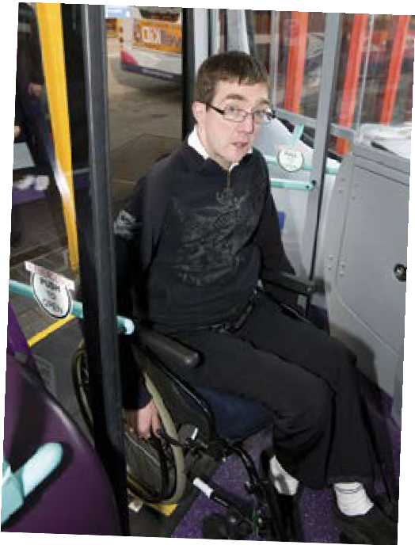

However, if your family or child’s circumstances change, we will review your child’s need for travel assistance. The council will consult you about the appropriate support needed to ensure your child gets to school safely (e.g. independent travel training for the new home-to-school route if you move house or your child changes school).

Will it impact on other benefits?
No. ITT will have no impact on any other benefits you might receive.

What if my child needs a travel pass?
Your child’s home to school travel will be paid for by the council. If your child is aged under 16 years then they will be covered by Transport for London’s ‘Free travel on buses and trams for under 16s’ policy and if they are aged over 16 years they are likely to qualify for a ‘Freedom pass’.
You can find out more information on Transport for London’s website at
www.tfl.gov.uk.
Any additional costs not covered by these schemes will be covered by the council. For example, if your child doesn’t have an Oyster card, our team will help you apply for one and the council will cover the cost of the application.
The school will get in touch with you regarding options relating to your child’s travel pass.

110628

For more information please contact:
Croydon Council SEN Team 1st Floor Davis House
Robert Street, Croydon CR0 1QQ Telephone: 020 8760 5768 (ext. 62394 or 62990)

Internal images courtesy of Office for Disability Issues (www.odi.gov.uk)

