Guidance notes for the Education, Health and Care Plan Needs Assessment (EHCNA)
Completing the All About Me - Year 9+

Introduction

This information has been designed to give you some ideas of what you could include in your All about Me profile.
“All about me” is designed to help you tell others about your family and what is important to you. Please include photographs and pictures if you would like to.
This information is extremely important as it will help professionals to understand your young person’s aspirations, strengths and needs in order to use a person centred approach for the Education, Health and Care Needs Assessment (EHCNA)
The Local Authority will be contacting you throughout the assessment process to offer planning meetings and support and to ensure they understand the impact of your child’s special educational needs on their daily life and learning outcomes.
If the Local Authority decide not to proceed with the assessment or not to issue an EHCP, there will be a Next Steps Meeting offered. The Local Authority will offer a meeting with the professional who knows your child best and the education provider to discuss the best way to support your child to achieve their outcomes.
We recognise that having to repeat information about your child many times, to a range of different professionals can be both time consuming and emotionally draining so have designed these guidance notes to give you some ideas of what you might include. Please ensure that it includes the views, interests and aspirations of the child or young person as it will be used to develop the EHC Plan.
Circles of Support and All About Me Ideas: these are visual tools that you could use to help you engage with young people to complete the All About Me (page 1)
“All about me” ideas: this is a visual tool to give you some ideas of what to include in the All about Me pages for the EHC Plan.

Competing the All About Me form
The All About Me form should include:

Background Information including a short positive introduction to the young person and:
- Heath and Medical Needs such as asthma, medication, epilepsy
- Social care needs including what your child enjoys doing after school and at weekends (see page 5 for social care questions)
- Specialist services and support offered to date
- Education settings attended
- How the child or young person communicates – a summary of how to communicate and engage in decision making such as symbols, Maketon, speech
- Vision/hearing problems and how these affect hearing and sight
- Drinking/Eating including any dietary and specialist needs
- Physical needs and equipment needed
- Self care and independence including personal care
- Sensory needs
- Behaviour that may challenge
- Special interests

Child/Young Person’s Views and Aspirations including how they have been involved in writing the All About Me
Things I enjoy
Things I like and dislike How to support me Things I would like to try What is important to me Who are important to me
What other people like about me (lovely smile, kind, funny etc.) Goals and aspirations
Parent/Carers’ Views and Aspirations which should include your aspirations and goals for your child and your views of their special educational needs

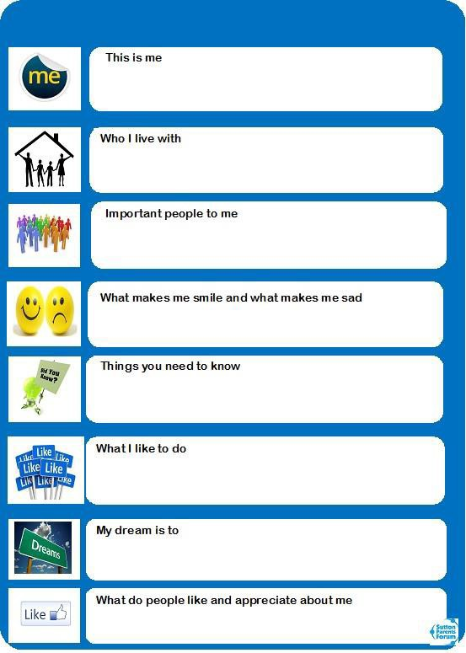
All About Me

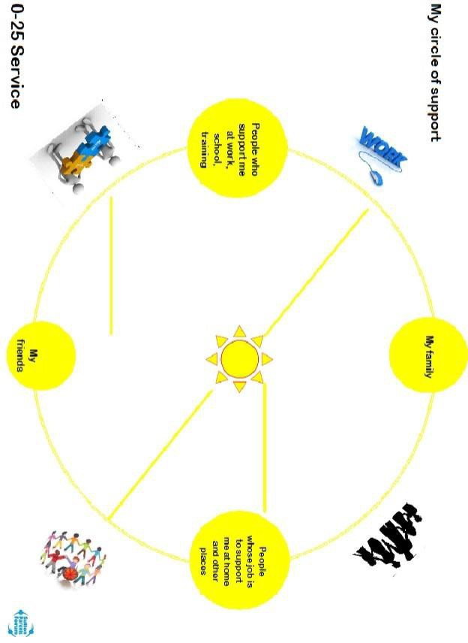

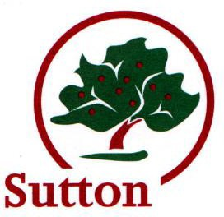
Social Needs Questions for EHC plans, Information for Section D, H1 and H2.
This form is for the family to complete and can be discussed at the first EHC Plan meeting.

If you have received this form, please complete if as fully as you can and bring with you to the first meeting. This information will be used to inform sections of the EHC Plan if one is issued.

- What activities does your child/young person attend on a regular basis?
When do they do these activities, e.g. at the weekends, in the week, or during school holidays?

- How often does your child/young person play with friends each week?

- What are the activities your child/young person enjoys doing? Are there other activities they would like to try? (This information can be used for commissioning purposes).

- What do you do together as a family?

- Do you have family or friends locally that can help either regularly or in an emergency?

- Are you aware of the Local Offer, and have you looked on the local Offer to see what activities may appeal to your child/young person? Http://localoffer.sutton.gov.uk
Is there anything they would like to try?
- Is your child/young person registered on Icount, Sutton’s register of Children with a Disability?
More information about that and the Disabled Children’s service can be found on the website; www.sutton.gov.uk/disabledchildren

- Does your child/young person receive a package of support from the Disabled Children’s service? If they are receiving this help you will have received a letter from the Disabled Children’s Service outlining the support and the cost) If the answer is yes, what services are they having?

Help to complete the forms is available from
Sutton Parent Carer Forum
Email: suttonparentsforum@outlook.com Call: 020 3701 2175

Sutton Information, Advice and Support Service (SIASS)
Email: siass@cognus.org.uk Call: 020 8323 0462

Sutton Mencap – Circles of Support for young people
Email: jude@suttonmencap.org.uk Call: 020 8647 8600

