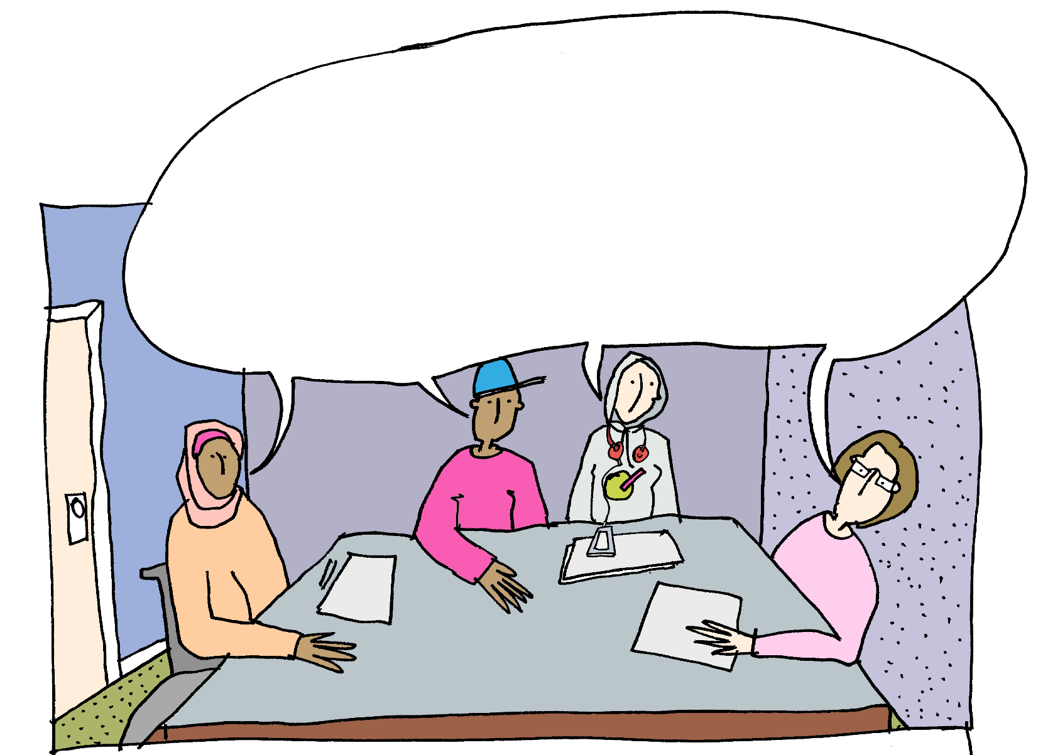

Special educational needs and disability (SEND) complaints:

A guide for Young People in education

© Crown Copyright 2018
This information is licensed under the Open Government Licence v3.0. To view this licence, visit http://www.nationalarchives.gov.uk/doc/open-government-licence/version/3/
Any enquiries regarding this publication should be sent to: Mott MacDonald Ltd at SENDdeliverysupport@mottmac.com

When People Can’t Agree – A Guide for Young People in Education

This guide provides advice for young people aged 16-25 who are unhappy with their special educational needs (SEN) provision or support at school or college and need help and guidance to sort those problems out.

Introduction

Around one in eight of all children and young people in England have special educational needs. For most of them, their schools, colleges, health and social care services provide good quality support. This helps make sure that the young person can benefit from education and help them prepare for life once they leave the education system.
For a small number, however, the path is not always so smooth, and problems can arise about the best ways to help the young person. It is essential that when this happens, problems are dealt with as quickly as possible. The aim of this booklet is to describe how you, as a young person aged 16 or above, can do this. This guide will show you where you can get more information and support if you need it.

Who this guide is for

This guide is intended for young people who are between 16 and 25 years and who have a special educational need or a disability.
Most young people will be receiving SEN Support in school or college, but some will have an Education, Health and Care (EHC) plan. Some young people may need further support to access this guide and local Information, Advice and Support Services (IASS) will be able to help.
It is important to understand the difference between SEN Support and an EHC plan. If you are receiving SEN Support, it is expected that your school or college will take responsibility for assessing your needs. This includes putting in place the right help so you can achieve your best. This is the situation that most young people with a special educational need will find themselves in.

A smaller number will have, or may need, an EHC plan. If that includes you, it is likely that your needs require more special support than a school or college would normally be expected to make. Sometimes this will involve health services or social care services also helping. An EHC plan says what support a young person who has special educational needs must get and is made by the local authority where you live. You should also have input into it. It says exactly what sort of help you will be given.
As a young person between 16 and 25 years, you do not have to go through the processes of this guide alone, you can get a parent, carer, or advocate to support you and do this for you. An advocate is someone who can help you and your parents to say what you want if you find it difficult to do so. For example, you can contact your local Information, Advice and Support Service (IASS) who can help find you someone to help put forward your views or attend meetings with you before and during a complaints process.

Types of problem

There are times when you may disagree with decisions that have been made about your needs and about how to help you. This might include situations such as:
- The help that my school or college is giving me is not enough, or is not right, for my special educational needs or my disability.
- The local authority has made a decision about the help they think I should have and I don't agree with them.
- I have complained a few times about decisions made by my school or college and I’m still unhappy.
- I’ve complained about the decisions made by health or social care services and I’m still unhappy.
- My local authority is taking too long to help me.
- I am not getting the help that was set out in my EHC plan.

Table of Contents
Important Words Page 6

Getting help when you are unhappy Page 11 with your school or college

Getting help if you are unhappy with Page 15 your local authority or the health support
you are receiving

Further help from the Local Government Page 20 and Social Care Ombudsman and
Parliamentary and Health Service

Going to disagreement resolution Page 23 Going to mediation Page 27
Going to Tribunal Page 31

What to do next if you are still not Page 36 happy with the outcome

Acknowledgements Page 37 Website links to external organisations Page 37

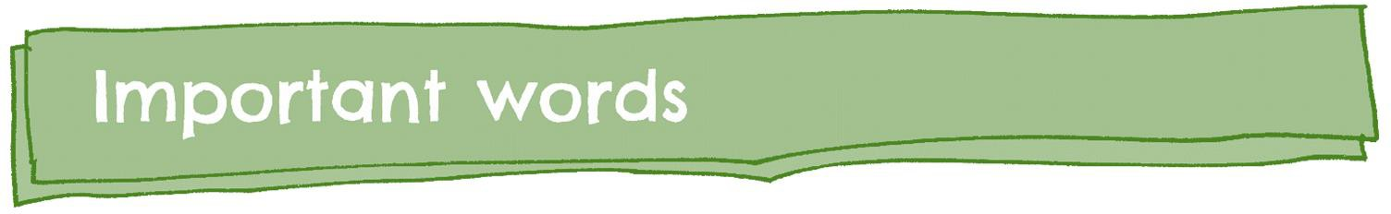

Important words that are used in this guide are explained below.

Advocate | An advocate is someone who can help you and your parents to say what you want if you find it difficult to do so.
Appeal | Appealing is what someone does if they want to try and change a decision about their support that they do not agree with.
Clinical Commissioning Group (CCG) | A clinical commissioning group (CCG) is  responsible for delivering health provision.
College | College is where young people go to gain the knowledge and skills to help prepare for the future. If someone is aged between 16 and 25 years old, then they can go to a college.
Decisions | Decisions are choices people make about what  happens in their life.

Some people may need support to make decisions. For example, having things explained in a different
way.
Disabilities | A person who has disabilities may have problems with their health and  may find it harder to do certain things than other  people.
Disagreement resolution services | Disagreement resolution services help to sort out problems where people do not agree with the support for a child or young person who has special educational needs or disabilities.  In practice this will be very similar to mediation.  You can find out more about both of these in this guide or from your local authority.
Education, Health and Care (EHC) needs assessment | An education, health and care needs assessment will look at what extra support young people with  special educational needs might need in their life.
Education, Health and Care (EHC) plan | An education, health and care plan says what  support a young person who has special educational needs must get.
Health provision | Health provision can help someone to stay healthy,  like having physiotherapy.
Health service | A health service is the organisation who gives you  your health provision.

Information, Advice and Support Service (IASS) | An Information, Advice and Support Service is where you and your parents can go to find out more information about special educational needs and disabilities and how to get the support you need.
Local authority | A local authority is the group of people who look after things in a local area, like services to support young people who have special educational needs and disabilities.
Local Offer | A local offer is information about the support and services that young people who have special educational needs and disabilities and their families  can get.
The Local Government and Social Care Ombudsman (LGSCO) | The Local Government and Social Care Ombudsman will look at complaints related to local  authorities. This includes education and social care.
Mediation | Mediation is a meeting to help people who disagree about something, like the support someone gets.  They can meet to try and find a way of agreeing about it.  There is usually someone else there to help them to do this. This person is called a mediator.
Mediation adviser | A mediation adviser will provide information about  mediation and can answer any questions you may have.

 | If you decide not to go to mediation, the mediation adviser would be the person who gives you a mediation certificate.
Ombudsmen | The Ombudsmen are organisations that can look at specific complaints. Complaints can be about how you have been treated by your local authority or Clinical Commissioning Group or about the delivery  of your provision
Parents | For most young people, it is their parents (their mum and/or their dad) who looks after them. But some young people are looked after by other people who do some of the things that parents do. This could be:  a grandparent  a brother or sister a carer  a foster carer
Provision | Provision is the help or support that you get for your special educational needs, your health needs or social care needs.
The Parliamentary and Health Service  Ombudsman (PHSO) | The Parliamentary and Health Service Ombudsman will look at complaints related to health.

Review | A review is a meeting where a local authority, a school or college, and some other people look at the support you get and if it is right for you.
School | School is where young people go to gain the knowledge and skills to help prepare them for the future.
Social care provision | Social care provision is the support someone gets to help them do things like washing, cooking and  meeting up with friends.
Special Educational Needs | A young person who has special educational needs may:  find it harder to learn than other people of their age  need extra support to learn.
Special Educational Needs and Disabilities Tribunal | The Special Educational Needs and Disabilities Tribunal is a court that listens to appeals and  decides if a decision should be changed.
Special Educational Needs provision | Special educational needs provision is the support  that young people who have special educational needs can get in school or college.
Special Educational Needs Co-ordinator (SENCO) | A Special Educational Needs Co-ordinator (SENCO) is a teacher who is responsible for special  educational needs at school.
Young people | Young people are aged between 16 and 25.

Getting help when you are unhappy with your school or college
Important words
- College
- EHC needs assessment
- EHC plan
- IASS
I am not happy with the help that my school or college are giving
me
- Local Authority
- Local Offer
- School

You might not be happy with the help and support that your school or college is giving you. If you are not happy it is important to remember you can go to a trusted family member or advocate for advice and support or contact your local IASS.
You can also go to a teacher, headteacher or the Special Educational Needs Co- ordinator (SENCO). They will be able to tell you if your school or college can provide the help you need.
If you are unhappy after you have spoken to your teacher, headteacher or SENCO, you should look at your school or college’s website and follow their complaints process. If you are still unhappy, you should contact your local authority to complain. Please look at the next section of this guide to help with this.
If your school or college is doing everything they can but you still need more help, you can speak to your local authority.

You can ask your local authority:

- To carry out an Education, Health and Care (EHC) needs assessment
- To look at reviewing your EHC plan (if you already have one)
- For any other help and advice about your support in school or college

If you still have problems with the support or help you need, read the remaining sections of this guide for more information. There are people and organisations that can give you further advice and support to help you sort out any problems you may have.

Where you should go for further information

Your local authority’s Local Offer

Information, Advice and Support Service (IASS)
Your local authority’s Local Offer contains further information on the help and support available to you.
You can find your Local Offer here: https://www.sendirect.org.uk/information/i-need-information- on/my-local-offer/

You can contact your Local Information, Advice and Support Service (IASS) for information, advice and support on:
- Schools, colleges and training
- Healthcare
- Other issues about Special Educational Needs and Disability

The advisers will try to help you, and they won’t tell you what to do – they’ll help you to decide. They also won’t tell other people about what you’ve discussed unless you want them to. They might also be able to attend meetings with you if you think it would be helpful. You have a right to get information, advice and support on your own or with parents or carers. It is up to you.
You can find more information about IASS and can find your nearest IASS here: http://cyp.iassnetwork.org.uk/in-your- area/

Make a note of the problems or questions you have.

Think about what would make it better or make you happier.

Have information ready about your problem or question.

  - Your IASS, school or college will listen to you. They will take your problem seriously.
  - They will try to help you sort out any problems you may have as quickly as they can.
  - You should be involved by your school or college in the decisions made about your support. Your views should be considered when they are making these decisions.
  - You should be given information and support by your school or college if it is needed to help you take part in any of the decision-making or complaints processes.
  - If you can’t resolve your problem, your local authority or IASS will be able to give you information about other services you can use to help resolve your problem. These include Ombudsmen, disagreement resolution, mediation and Tribunal services.

Getting help if you are unhappy with your local authority or the health support you are receiving
- EHC needs assessment
- EHC plan
- IASS
- Health service
- Local Authority
- Local Offer
- School
- CCG
I am not happy with the help that my local authority is
giving me
I don’t think I am getting the support I
need from health
You might not be happy with the help and support that your local authority, health
service or CCG is giving you. You may be:

  - Unhappy with what is in your EHC plan.
  - Unhappy that your local authority is not doing what they said they would or should be doing.
  - Unhappy that health services are not doing what they said they would or should be doing.
The best place to start is to speak to your local IASS. They will be able to direct you to someone who can tell you if your local authority can provide the help you need. If the help or support is about health, you should speak to your local Healthwatch.
They will help you to make a complaint or explain who to speak with to solve your problem.

If you are unhappy after having spoken to your local authority, you should follow their local complaints procedure. This will be available on the local authority website and in their Local Offer.
The Local Government and Social Care Ombudsman (LGSCO) has a top tips document which may help you when making a complaint: http://www.lgo.org.uk/make-a-complaint/top-tips-for-making-a-complaint
If you are unhappy after having spoken to your health service or CCG, you should follow their local complaints procedure. Details of this will be on their website.
If you want to make a complaint to the ombudsmen, you will need to have finished making a local complaint. Further details on the ombudsmen can be found in the next section of this guide.
Where you should go for further information

Your local authority’s Local Offer
Your local authority’s Local Offer contains further information on the help and support available to you.
You can find your Local Offer here: https://www.sendirect.org.uk/information/i-need- information-on/my-local-offer/

Information, Advice and Support Service (IASS)
You can contact your local Information, Advice and Support Service (IASS) for information, advice and support on:
- Complaining to your local authority
- Healthcare
- Other issues about Special Educational Needs and Disability

The advisers will try to help you, and they won’t tell you what to do – they’ll help you to decide. They also won’t tell other people about what you’ve discussed unless you want them to. They might also be able to attend meetings with you if you think it would be helpful. You have a right to get information, advice and support on your own or with parents or carers. It is up to you.
You can find more information about IASS and can find your nearest IASS here: http://cyp.iassnetwork.org.uk/in-your- area/

Your local Healthwatch
You can contact your local Healthwatch for advice or support on:
- Making a complaint about health or a CCG
- Resolving an issue about health or a CCG
You can find your local Healthwatch service here: http://www.healthwatch.co.uk/find-local-healthwatch

NHS
Complaints Advocacy Services

NHS Complaints Advocacy Services can provide support in making a complaint about health services. Details can be found by contacting your local authority.

Make a note of the problems or questions you have.

Think about what would make it better or make you happier.

Have information ready that explains your problem or question.

  - Your IASS, local authority, health service or CCG will all listen to you. They will take your problem seriously.
  - They will try to help you sort out any problems you may have as quickly as they can.
  - You must be involved by your local authority in the decisions made about your support. Your views should be considered when they are making these decisions.
  - You should be given information and support by your local authority if it is needed to help you take part in any of the decision-making or complaints processes.

  - If you can’t resolve your problem, your local authority or IASS will be able to give you information about other services you can use to help resolve your problem. These include Ombudsmen, disagreement resolution, mediation and Tribunal services.

Further help from the Local Government and Social Care Ombudsman and Parliamentary and Health Service Ombudsman

    - Clinical Commissioning Group
    - EHC needs assessment
    - EHC plan
    - The Local Government and Social Care Ombudsmen (LGSCO)
- Health provision
- Local authority
- Ombudsman
- The Parliamentary and Health Service Ombudsman (PSHO)
- Social care provision

I’m unhappy with how my EHC needs assessment was done

I don’t think I am getting the support that is in my EHC Plan

You might disagree with the way your local authority or Clinical Commissioning Group (CCG) has carried out your EHC needs assessment, or the delivery of the education or social care provision in your EHC plan. You can complain to the Local Government and Social Care Ombudsman (LGSCO).
Remember, you must have complained to your local authority first. The LGSCO has a ‘top tips’ document to help you do this: http://www.lgo.org.uk/make-a- complaint/top-tips-for-making-a-complaint

If you are unhappy with the delivery of the health provision in your EHC plan, you can complain to the Parliamentary and Health Service Ombudsman (PHSO). You must have complained to the local health service involved first.
You should speak to the LGSCO and PHSO once you have received a response to your complaint at a local level.
You can read more about how to complain to the LGSCO and the PHSO by clicking on the links in the computers below.

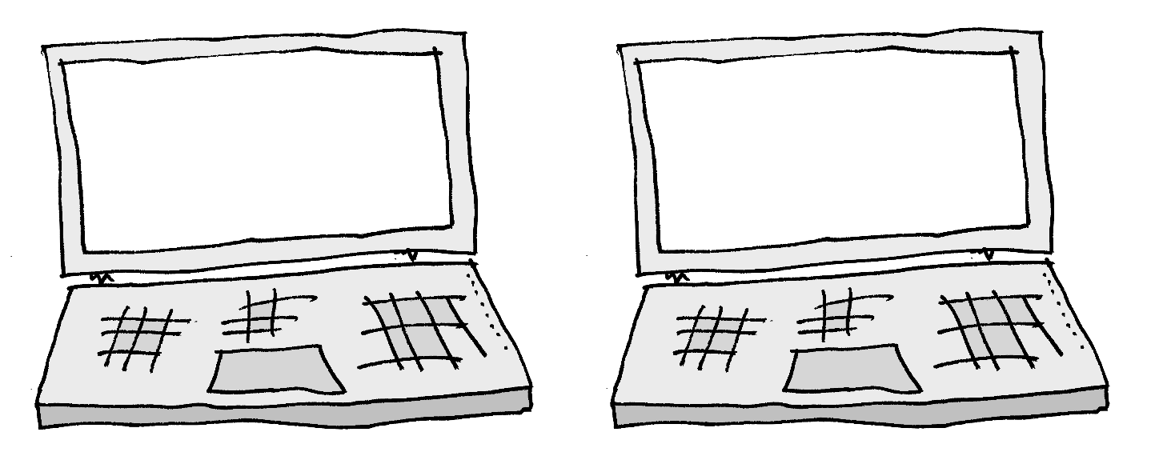
Complaining to the PHSO
Complaining to the LGSCO

Where you should go for further information
IASS
Your local IASS can talk to you about the Ombudsman in more detail. They can show you how to contact them if you decide you want to do this. You can find more information about IASS and the details of your local service here: http://cyp.iassnetwork.org.uk

Make sure you have followed your local complaints process and have a response from them.

Have all the information about your complaint ready
  - When it happened
  - How it made you feel

Think about what would make it better.

- The Ombudsman will consider your complaint and let you know what will happen next.
- If they agree with you, the Ombudsman can ask the local authority or CCG to do different things depending on your complaint.
  - This webpage explains what the LGSCO might ask the local authority to do: https://www.lgo.org.uk/make-a-complaint/possible-outcomes
  - This webpage explains what the PHSO might ask the CCG to do: https://www.ombudsman.org.uk/making-complaint/what-we-can-and- cant-help
- They might not agree with you and will explain the reasons why. If this happens you should contact your local IASS for more information.

Going to disagreement resolution

Important words

- College
- Disagreement resolution services
- Local authority

- School
- Special Educational Needs provision

I don’t have an EHC plan but I am not happy with the support I am getting

Many problems can be sorted out by talking with your school, college, local authority or health services. Sometimes, it can be difficult to reach agreement. Disagreement resolution services are available to help with some types of problems.
This is very similar to mediation but disagreement resolution services apply more widely. They may be delivered by the same provider. These services can be used by all young people with SEN, not just for young people who are being assessed for an EHC plan or who already have one.
The problems they can help with are:

  - If you are unhappy with the way that your local authority, school or college are helping you with your education, health or social care.

  - If you disagree with the special educational provision that you have in school or college.
  - If you are unhappy with the special educational, health or social care provision that you are getting whilst you are having an EHC assessment.
  - If you are unhappy with the special educational, health or social care provision when your EHC plan is being written.
  - If you are unhappy with the special educational, health or social care provision when your EHC plan is being reviewed or reassessed.
  - If you are unhappy with the special educational provision you are getting when you are waiting for your Tribunal appeal.
The people who deliver disagreement resolution services do not work for the local authority – they are mediators from separate organisations or companies. A meeting or discussion will take place to help people who disagree about something, like the support someone gets, to try to find a way of agreeing about it.
The service is free to use and is voluntary. If you decide that you don’t want to use the disagreement resolution services, you don’t need to. Schools, colleges, local authorities and CCGs can also decide they don’t want to use it.
Details of disagreement resolution services must be provided in the Local Offer.

The route you take will depend on what sort of decision you disagree with. Your IASS can help you to decide.
Where you should go for further information
IASS
Your local IASS can talk to you about disagreement resolution in more detail. They can show you who to contact if you decide to do this. They may also be able to attend meetings with
you.
You can find more information about IASS and the
details of your local service here: http://cyp.iassnetwork.org.uk

Questions you might want to think about:

What do you disagree with?

What do you want to happen that isn’t happening?

Questions you might want to ask:

Who needs to be at a disagreement resolution meeting?

Can I have someone come with me at the meeting?

  - The mediator will listen to you and what you disagree with your school, college, local authority or CCG about.
  - The mediator will also listen to the school, college, local authority or CCG. They will help you and the school, college, local authority or CCG to make a decision that you are all happy with.
  - The mediator will not tell other people what you have spoken about.
  - The service is voluntary so you or the school, college, local authority or CCG may decide you don’t want to use it.
  - The disagreement resolution services might be able to help you solve your problem, but you might find that they can’t. If this happens, you should speak to your IASS about what you should do next.

Going to mediation

Important words

    - EHC needs assessment
    - EHC plan
    - Local authority
    - Mediation

- Special Educational Needs and Disability Tribunal
- Special Educational Needs provision
- Mediation Adviser

I don’t want to go to Tribunal but I need help to resolve my problems

If you want to appeal to the Special Educational Needs and Disability Tribunal about your EHC needs assessment or EHC plan, you must contact a mediation adviser before sending your case to the Tribunal.
Mediation is free. Mediation tries to solve your problems in an informal way with the help of a mediator who does not work for the local authority, school or college. The mediator tries to help you reach a resolution that everyone is happy with. The mediator will not tell other people what you have spoken about.
If you use mediation, you may find that you do not need to go to Tribunal.

If you disagree with what the local authority has written in your plan, or if the local authority has not agreed to do an assessment or make a plan and you are unhappy

about this, you must contact the mediation adviser within two months of the date of the letter the local authority sends you telling you about their decision.
If you disagree with the name of the school or college the local authority has put in your EHC plan, or the type of school (such as special school, mainstream school), you do not have to contact a mediation adviser before you send your case to the Tribunal.
In the letter that the local authority sends to tell you about their decision, they must also tell you about mediation, how to contact a mediation adviser and how to contact IASS for independent advice.
Mediation is voluntary, and you do not have to use it if you decide not to after you speak to a mediation adviser. If you do decide to go to mediation, the local authority and CCG (if either or both are needed) must attend.
The mediator should speak to you before the session to make sure they understand your concerns and can answer any questions you have about mediation. You can also ask an independent adviser from IASS about mediation.
If you decide not to use mediation, you can tell the mediation adviser this. They will then send you a certificate within 3 working days. You can then send this along with your case to the Tribunal. This is how you register an appeal.
If you decide to use mediation, the local authority (or CCG, if you have a problem about any health issues in your EHC plan) must take part. The meeting will be arranged within 30 days after you speak to a mediation adviser.
After the mediation, you will receive a certificate within 3 working days which will enable you to register your appeal if you didn’t reach an agreement

Where you should go for further information

Local Offer

IASS

Your local authority’s Local Offer contains further information on the mediation services available to you. You can find your Local Offer here: https://www.sendirect.org.uk/information/i-need- information-on/my-local-offer/

Your local IASS can talk to you about mediation in more detail. They can show you how to contact the mediation service if you decide to do this. They may also be able to attend meetings with you. You can find more information about IASS and the details of your local service here: http://cyp.iassnetwork.org.uk

Take copies of any important documents with you
to the meeting.
Think about whether you want anyone to come to
the meeting with you. A parent? A friend or other family member?

Think about why you are going to mediation and what you expect to happen.

Make a list of the key issues you want to talk about at mediation.

During the meeting, if anybody says anything you do not understand, ask them to explain – don’t sit in silence and worry!

  - The mediator must be someone who does not work for the local authority or the Clinical Commissioning Group and will listen to your concerns. They will try to help you reach an agreement with the local authority, or Clinical Commissioning Group if you have a problem with the health part of your plan.
  - If you decide that you would like to use mediation, the local authority or the mediator will arrange a session within 30 days of you deciding.
  - The mediation session should take place somewhere that you are comfortable with and is convenient for you. You will be told where and when the mediation session will take place at least 5 working days before it happens.
  - The mediator should speak to you before the session to make sure they understand your concerns. They should also speak to the local authority or CCG.
  - You can bring a friend, family member, adviser or advocate to the mediation session if you would like.
  - After mediation has finished or if you decide not to use it, you will receive a certificate from the mediator within 3 working days.
  - Mediation can help to solve your problem, but if you are still not happy and you want to send your problem to the Tribunal, you need to send your mediation certificate too.

Going to Tribunal

Important words

    - Appeal
    - Decisions
    - EHC needs assessment
    - EHC plan
- Local authority
- Mediation
- Special Educational Needs and Disability Tribunal
- Special Educational Needs provision

I have been to mediation but I am still not happy

I want to make an appeal

If you do not agree with a decision that is made about your education, health and care needs assessment or your education, health and care plan, you can ask for this to be changed. This is called an appeal. You may have already spoken to your local authority about this and been to mediation, or decided you did not want to go to mediation.
The Tribunal is a panel of people who will look at your appeal and make a decision about what should be done.
The Tribunal will only look at certain types of problems – these problems are:

  - If your local authority has decided not to carry out an EHC needs assessment or re-assessment.
  - If your local authority has decided not to issue you with an EHC plan after your assessment.

  - If you disagree with how your special educational needs have been described in your EHC plan.
  - If you disagree with the SEN provision in your EHC plan.
  - If you disagree with the school or institution, or type of school or institution named in the plan, or if none has been named.
  - If your local authority decides not to amend your EHC plan after a review or re-assessment.
  - If your local authority decides to stop your EHC plan.

In most cases, you can only send an appeal to the Tribunal once you have received a certificate from a mediation adviser. If you don’t have a certificate, the ‘Going to Mediation’ section of this guide tells you how to get your certificate. You don’t need a certificate if the only thing you want the Tribunal to make a decision about is the school or other institution named in your plan.
When you are sending an appeal to the Tribunal, you need to send a copy of the letter you received from your local authority that tells you their decision. You must send your mediation certificate and explain why you disagree with the decision your local authority has made. You must also state the dates you received the letter and certificate. You have to send all of this to the Tribunal.
This must be within two months of your local authority sending you a letter about one of the situations listed above or within one month of your mediation certificate being issued, whichever is later.
The Tribunal usually only looks at the educational decisions made by the local authority, but now has some new powers and can look at health and social care concerns too. To appeal about health or social care issues, you must be making an appeal about a special educational aspect of an EHC plan at the same time (one of the situations listed above).
You will need to tell the Tribunal that you want them to look at health and/or social care concerns when filling out the application form. Any changes that the Tribunal asks to be made for health and/or social care will be non-binding. This means that the law does not require the local authority or CCG to follow them. However, it is expected that they will do what the Tribunal recommends. If they don’t, you can complain to the LGSCO or PHSO which is described earlier in this guide.

This new process is called the ‘SEND single route of redress national trial’ or the ‘national trial’. The government is trialling this new process for two years. At the end of that time, it will assess how well the process has worked and decide on what happens next.
When you have sent your appeal to the Tribunal, it can take up to 12 weeks for a hearing to happen. You and your local authority will be invited to the Tribunal so that they can hear about your case. A letter which explains the Tribunal’s decisions and recommendations and their reasons will be sent to you in the post 10 working days after you have been to the Tribunal.

Where you should go for further information
IASS
Your local IASS can talk to you about the Tribunal in more detail. They can show you how to contact them if you decide to do this. They will also be able to help you if you decide to go to Tribunal. You can find more information about IASS and the details of your local service here:
http://cyp.iassnetwork.org.uk

Think about any additional help you may need to make an appeal. This could be from IASS or a charity such as IPSEA who offer free and independent legally based information, advice and support for children and young people with SEND.

Be very clear about the reasons why you are appealing and how you can back up your point of view.

Think about what could be done to help fix the problems you have.

  - If you want to send your case to the Tribunal, you will need to send a copy of the decision that you are unhappy with and the reasons why you don’t agree with the decision.
  - After you have sent your case and all of the papers to the Tribunal, you will be invited to a Tribunal hearing. You will be told when and where this hearing will take place.
  - If your local authority has decided not to carry out an EHC needs assessment or re-assessment, you may not need to attend a hearing. A decision can be made after you have sent all of the papers to the Tribunal.

  - For all other appeals, they will try to hold the Tribunal as close to where you live as possible.
  - A judge and a panel of Tribunal members will be at the hearing. These people will listen to both you and the local authority (and CCG if you are also unhappy with a health decision that has been made) before they make any decisions or recommendations.
  - The local authority (and CCG if you are also unhappy with a health decision that has been made) will be at the Tribunal.
The Ministry of Justice has created videos to try to explain what it is like going to Tribunal – you can watch these videos through this link: https://www.youtube.com/playlist?list=PLORVvk_w75PxU3wF72j3jLYqGqISyMhZ4

What to do next if you are still not happy with the outcome

If you have been through the guide and have followed all the advice and you still have issues that are unresolved, there are further options that you may wish to consider. The SEND Code of Practice explains these options. These can be found from page 265, paragraphs 11.67 to 11.111. You may want to ask your local IASS for help in understanding these options.
https://www.gov.uk/government/uploads/system/uploads/attachment_data/file/39881 5/SEND_Code_of_Practice_January_2015.pdf

Acknowledgements
This resource has been developed by Mott MacDonald through the Delivering Better Outcomes Together (DBOT) partnership in collaboration with the following groups and organisations:
  - Department for Education
  - Council for Disabled Children
  - FLARE Young People Group -https://councilfordisabledchildren.org.uk/our- work/participation/practice/flare
  - Jon Ralphs for graphics and illustrations

Many other individuals not named above have contributed their views and input to help shape this guide.
Some of the definitions have been reproduced with permission kindly granted by DfE and MENCAP.

Website links to external organisations
Please find below links to organisations mentioned in this guide who might be able to help you.
- Information Advice and Support Services (IASS) – https://cyp.iassnetwork.org.uk/
- Independent Parental Special Education Advice (IPSEA) – https://www.ipsea.org.uk/
- Local Government and Social Care Ombudsman (LGSCO) - https://www.lgo.org.uk/
- Local Healthwatch services - https://www.healthwatch.co.uk/find-local-healthwatch
- NHS Complaints Advocacy Services - https://www.voiceability.org/support-for- you/nhs-complaints-advocacy
- Parliamentary and Health Service Ombudsman - https://www.ombudsman.org.uk/
- The Special Educational Needs and Disabilities Information Organisations Group (SENDIOG) - https://councilfordisabledchildren.org.uk/information-advice-and- support-services-network/what-send-information-organisations-group

