Cognus are constantly evolving our therapy work in line with national best practice. Any adaptations are always after discussions with the LBS Commissioning Team and we ensure that, wherever possible, we are aligned with local health provision and school SENCOs to deliver a seamless service, making sure that all statutory assessments are undertaken and any resulting therapy delivered.

Both our Speech and Language Team and Occupational Therapy teams work within the guidance of their respective Royal Colleges and all are HCPC registered. We are proud to have an excellent, committed and creative team, many of whom are nationally recognised for their expertise and continue to deliver very high-quality provision across Sutton.,

Some key facts and figures for 2020/21:

- We have more therapists working for Cognus than ever before (4 times the number of OTs and 7 times the number of SaLTs since 2017);
- Recruitment of high-quality therapists to permanent roles has been challenging compared to previous years; this is not a local issue, but a national challenge and the pandemic has added to the challenge;
- We deploy resources across the whole area to meet needs and as effectively as possible with the available capacity;
- We are currently coproducing a holistic early intervention model, engaging with schools to support this;
- Our new ways of working (embedded model, teletherapy) have been well received and will be retained, where appropriate, after consultation across the area;
- We are working in partnership with NHS and LBS colleagues to use all feedback received to improve the experience families gain from the local therapy offer;
- We are working with key stakeholders (SPCF, LBS, SENCOs) to ensure communication about our service(s) improves for everyone;
- The Cognus Therapies team are doing some excellent work using social media, podcasts and partnering with national agencies to deliver better services and key messages in the most effective ways;
- The team continue to listen to those we deliver therapy to and for, consider national best practice and evolve the best offer possible (within finite resources);
- We are excited to be working more closely with SPCF who, after their parent/carer engagement events in the Spring Term, are running a Focus Group for parent carers who want to be involved in shaping services moving forward. Contact suttonparentsforum@outlook.com if you would like to join the Focus Group.

We have captured just some of the examples of great work and practice below. We understand that there are challenges as a direct result of the pandemic and the Therapy team are working tirelessly to deliver what is needed across the local area with our partners. We continue to look forward with confidence and are excited about what the future commission and partnership working holds for the future.

Should you have any questions relating to the services Cognus are providing please do not hesitate to get in contact with your therapy lead.

A list of key team members can be found here:
Patsy Winkley – Team Manager
Julie Kiely – Assistant Team Manager Alex Benjamin – Principal OT
Alison Rees – Highly Specialist SaLT – Early Years and ASD Ashlea Stephens – Highly Specialist SaLT – POST 16

Emily Harnett - Highly Specialist SaLT – Down Syndrome Helen Gardner - Highly Specialist OT – ASD and MLD Helen Raby - Highly Specialist SaLT – DLD
Jessica Brown - Highly Specialist OT – Mainstream
Lisa Ogden - Highly Specialist SaLT – SEMH, Young Offenders and Trauma Rachel Wilson-Dickson - Highly Specialist SaLT – SEMH
Rose Fletcher - Highly Specialist SaLT - ASD
Tamara Rainsley - Highly Specialist SaLT – HI specialist

Please contact your therapist directly via name.surname@cognus.org.uk or email the team inbox at
cognustherapies@cognus.org.uk and your query/feedback will be forwarded to the appropriate member of staff.

Working with Schools and Positive Feedback
We work collaboratively with schools to support the needs of children and young people to support the development of their skills, support them to achieve their outcomes and promote their independence to enable them to prepare for adulthood. Here’s a couple of examples of some of the feedback we have received recently:

“Just a quick note - After a fairly grim.… paper a couple of weeks ago (ended with a meltdown), M told me last night that he had used the mind mapping approach you showed him … for his second paper and he was … happy with the exam. This is MASSIVE as English exams have been a real challenge for Matthew so thank you so much! “

“Bec has supported both Rainbow and Ark in developing the use of colourful Semantics across the school. She worked alongside a teacher to deliver highly effective training to staff in both departments. Bec is always available and willing to chat to myself as Lead of the base to problem solve issues around complicated, often out of date EHCP’s. Bec supports parents too, delivering training in Colourful Semantics and Proloquo2Go, providing additional resources for the home and also sharing individual achievements. The children Bec works with make good or better progress … has also supported the introduction of Personalised Learning Intention Maps … embedding therapy into the classes. It is honestly a pleasure to work with Bec, she is a huge asset to our school.”

Teletherapy and Engagement with Families
During lockdown and on an ongoing basis in some instances, teletherapy has been used to deliver both SaLT and OT. We received positive feedback from many families and young people about this method of delivery and for some young people and settings it is their preferred method for receiving therapy. Being online enabled parents to engage in the sessions and many stated that they now they understood what their child/young person did in therapy sessions. It offered us an opportunity to engage directly with families and this is something that we wish to continue with. We recognise that not all families felt the benefits of remote therapy and some stated that they preferred for their children/young people to receive face to face therapy; when this has been the case, we have offered alternatives including face-to-face in the home, outside in the garden, in public parks and/or we delivered later in the year.

Recruitment
Cognus Therapies team, along with many other services locally and nationally, have been impacted by the COVID- 19 pandemic, particularly in the area of recruitment and retention of staff. There is currently a Government recognised shortage of therapists in the United Kingdom which has been exacerbated by the COVID-19 pandemic.

The Cognus team are a large team comprising therapists from the UK, as well as from overseas. Cognus are proud to work with colleagues from overseas as they offer a wealth of experience and knowledge to the team to enhance our service.

The pandemic has affected us all and during the COVID-19 pandemic, we had a number of overseas therapists return to their home countries (mainly South Africa, Australia and New Zealand).
Recruiting therapists from the UK and overseas remains a high priority but is particularly challenging at the current time, but we are hopeful that with lockdown easing, this will become easier.

We currently have a proactive recruitment campaign underway with the Royal College of Occupational Therapy, the Royal College of Speech and Language Therapists, NHS Jobs and through the Cognus Website and are hoping that we will be able to recruit new and dynamic members of staff to join our team. Our terms are flexible, with both part-time and term-time contracts on offer, with the option of working additional hours to support us at this time.

We would like to assure you that the statutory requirements of therapy written into Section F of your children’s Education Health and Care Plans will be delivered where there may have been any gaps as a result of lockdown. We are working flexibly to support schools and families, including offering drop-in sessions to support schools and to ensure that every child has a therapy programme.

Should you feel that any urgent therapy needs require consultation or support in the interim, please don’t hesitate to contact us directly. We endeavour to provide an initial response to any enquiry within three working days and within ten working days where further detail is required. (Please see page 2 for contact details.)

Transition from The NHS to Cognus
We have regular meetings with our colleagues from Health to ensure that a smooth transition, if required, takes place for therapy delivery. We are currently producing a leaflet to explain the different areas of therapy in Sutton, for example which service provides which support. We hope this will be ready before the Autumn term 2021.

Twitter Account
We have a Twitter account that is regularly updated with new for the Therapy Team. Please follow us at
@cognustherapies

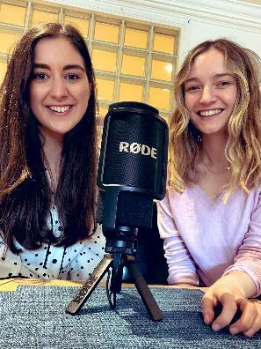
Podcasts
Our latest podcast (as part of Cognus’ Education Untapped series) features two of our therapists Emily Harnett and Tamara Rainsley who spoke to two families who are active members of the Down Syndrome community, both locally and nationally as part of Down Syndrome Awareness Week. The episode highlights some of their personal experiences and how we can all work towards raising our awareness and attitudes.
Take a listen here: Down Syndrome Awareness - Cognus Therapies (buzzsprout.com)

Staff News

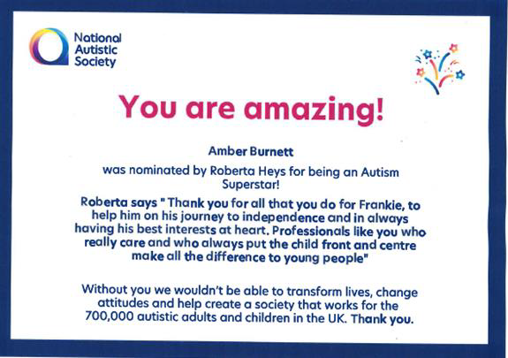
Cognus OT receives nomination from parent as an Autism Superstar.

Amber Burnett, Occupational Therapist has recently been nominated by one of our parents, Roberta Heys. In her nominations she stated:
“Thank you for all you do for Frankie, to help him on his journey to independence and in always having his best interests at heart.
Professionals like you who really care and who always put the child
front and centre make all the difference to young people.”

The Therapies teamwork with a huge number of children and young people in the Local Area developing their Speech and Language and Occupational therapy skills to support their access to education and develop their independence.

Cognus SaLT to run 50k for the National Deaf Children’s Society

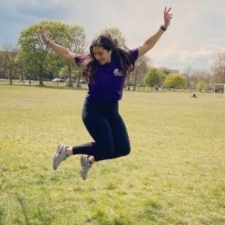
Tamara Rainsley (Highly Specialist Speech and Language Therapist) shares news
about her running 50K in May for the National Deaf Children’s Society (NDCS).

“I have taken on the challenge of running 50k in May for the National Deaf Children’s Society as part of Deaf Awareness Week. I will be taking on this challenge locally and also around the wonders of Cornwall during my annual
leave. I am not sure if my reckless 5-a-side injuries can cope with the upcoming kms but there’s only one way to find out! It’s a charity close to my heart from both a personal and professional perspective I will be sharing parts of my journey on the Cognus Therapies Twitter page. Wish me luck!”

