SIASS Newsletter
S P R I N G / S U M M E R 2 0 2 1

SIASS is here when you need someone to #SENDhelp

Call us: 0208 323 0462
Email us: sutton@siass.co.uk

Follow Sutton SIASS on Or follow @Sutton_IASS on
www.siass.co.uk

Sutton Information Advice and Support Service
OFFICE HOURS
SIASS staff are normally available Monday-Friday from 9-5pm via telephone or email.
If we are unavailable to take your call, or if you call outside office hours, please leave a voicemail. We aim to return calls within 3 working days, though almost always return calls by the next working day.
We are currently working from our home offices, which allows us to attend to a higher quantity of casework and meetings and do so with maximum confidentiality. However, if you need us to support you in person at a meeting, we are willing to do so as our schedules allow.

24 Denmark Road, Carshalton, SM5 2JG Tel: 0208 323 0462
Email: sutton@siass.co.uk

Staff Update
SIASS NEWSLETTER
Over the last 6 months, there have been a number of changes to the SIASS team. In March 2021, our experienced caseworker, Jo Hussain left SIASS for another job opportunity as her contract with us drew to a close.

In October 2020, Laura Haupt was hired to the new role of SIASS Manager. Laura comes to us with a support and counselling background. She moved here from America with her husband and children to be closer to her family in Sutton. Her experience in SEND is both professional and personal, as both of her children have additional needs.

In February 2021, Victoria Walden was hired as SIASS Caseworker. Vicky comes to us from an education background, working with children with SEND as well as caring for her own children with SEND.

Early Resolution-Focussed
SIASS has been working hard to bring awareness to the service and its remit, including reinforcing the message that SIASS is an impartial service, committed to early resolution of issues faced by families wherever possible. In fact, the earlier we are involved the better!

One of the key ways SIASS supports early resolution of problems is by bridging communication gaps between families and schools or the Local Authority, and getting everyone on the same page with clear expectations about actions and outcomes.

Our Advice? Give Mediation a Chance.
Whenever you have a legal right to appeal to Tribunal, you must first "consider mediation". Surprisingly, in Sutton only 30% of those with a right to appeal decide to try mediation first (this is far below the national average).
Of those who choose to mediate, 82% of those mediations result in a legally binding mutual agreement between the family and Local Authority. This doesn't always mean the family gets exactly what they thought they wanted, nor does it mean the LA gets their way, but it means that both parents and LA work together to reach consensus about the plan moving forward with the best interests of the child or young person at the heart of the discussion.

Our advice? Try mediation first! It can save you 2-4 months, loads of paperwork and stress, and achieves a legally binding agreement 82% of the time.

Youth Outreach and Engagement
In January 2021, we started a monthly online meeting for Young People aged 16-25 years old with SEND, the SIASS Youth Forum. This group exists as a source of friendship and support for the young people who participate, as well as a monthly opportunity for them to directly ask questions of SIASS Staff or talk about anything on their minds.

In addition, SIASS Staff ask the young people a few questions to help tailor the service to better meet young people's needs and increase direct access to advice and information. Thanks to the feedback we have gleaned from this group, later this year we will be starting a SIASS YouTube Channel where we hope to co-produce video content with the Youth Forum to share relevant SEND information directly with children and young people.

SIASS Youth Forum meets on the 3rd Tuesday of every month via Zoom. New members are always welcome so if you are aged 16-25, email laura.haupt@siass.co.uk for the zoom link or to be added to the youth participants list to receive monthly updates.

Volunteers starting soon
SIASS will be adding Information & Support Volunteers to the service during the summer to help expand our staff capacity to meet more needs. Our volunteers will receive full training in Safeguarding, GDPR, Equality, Confidentiality, Impartiality, and more before beginning to answer phones. In addition, all volunteers will receive IPSEA level 1 legal training to support their SEND knowledge. While our caseworkers will still be attending all meetings, communicating with school and LA staff, and supporting parents in completing EHCNA and Appeal paperwork, our friendly volunteers likely be the first point of contact for many of our new enquiries for casework. They will take down important information, offer support, and signposting, and pass information on to qualified caseworkers where a higher level of support and intervention is needed.

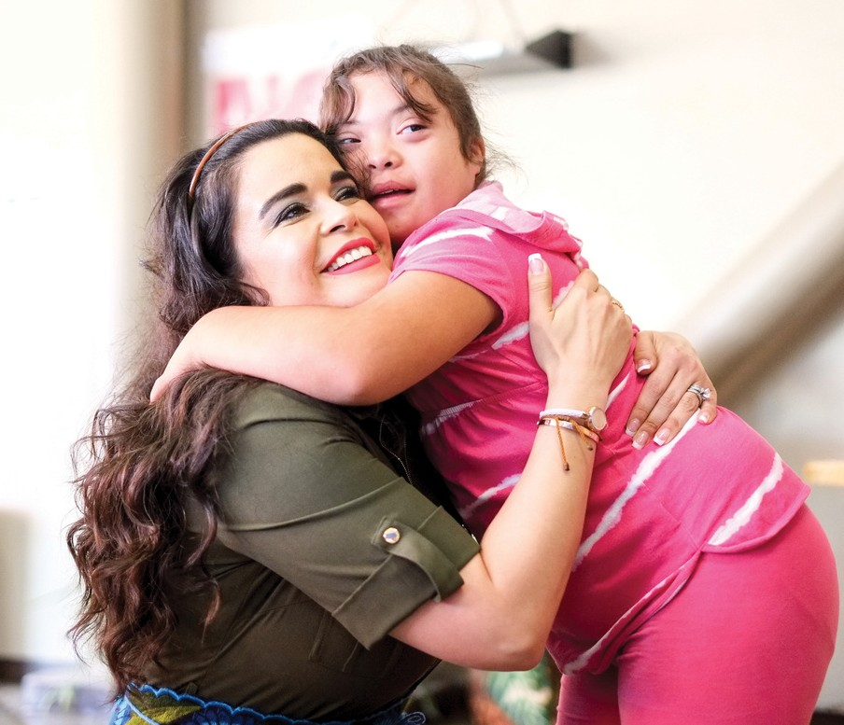Parent/Carer recruitment for SIASS Steering Group Unsurprisingly, parents/carers of children or young people with SEND make up the vast majority of SIASS service users. If we are to deliver a
service that meets their needs it is important that their voice is heard and they have the chance to participate in our Steering Group which meets every other month. We are currently recruiting for 3 parent/carers to be added to steering group beginning in September 2021. If you would be willing to serve a 3 year term on this body, offering SIASS vital parent/carer input every other month, please email a brief bio about yourself and your family to laura.haupt@siass.co.uk to be shared with our steering group at July's meeting for election.

