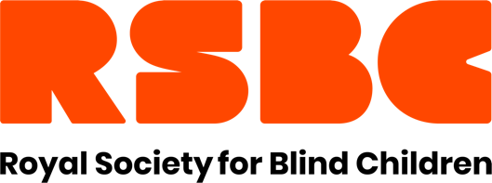

The Royal Society for Blind Children
The Royal Society for Blind Children (RSBC) offers a range of free services for vision impaired children and young people, and their families.

1. RSBC Live Life, Go Further Programme
The RSBC Live Life Go Further programme includes a wide range of fun activities for vision impaired young people aged 8-25 that are delivered across England and Wales, all of which contribute to reducing isolation, building friendship groups, and learning new skills. Activities run throughout the year, with additional sessions during school holiday periods.
We work in partnership with local organisations across the country to help everyone find something that interests them in their area. Sessions are delivered face-to-face and online.
We’re always adding new activities to our Live Life Go Further programme but here are some recent examples:
- Health and Wellbeing activities including sports, fitness workouts, cookery and healthy living workshops.
- Social and Independence activities including Supper Squad, Audiobook club and Sisterhood (for young women and girls)
- Creative and music sessions
- Assistive Technology (for both Parents and Young People) and gaming sessions

2. RSBC Families First
RSBC offers emotional and practical support for any family with a vision impaired child between the ages of 0-25.
A diagnosis of vision impairment can be challenging for the whole family. The implications can be varied and significant, and many families may want some support to help them manage.

RSBC Families First is here to help. We have an experienced team of Family Practitioners across England and Wales who offer support based on each family’s needs.

Support can be accessed whenever it is needed but may be particularly useful around times of change. These might include at the point of diagnosis, deterioration of vision, changing schools, changes within the family, or managing the transition into adulthood. RSBC Family Practitioners can provide support over the phone or internet, in your home, at school or a convenient location.

3. RSBC Dorton College of Further Education
RSBC Dorton College offers a day provision for vision impaired students (16-25).
Based in the London Borough of Bromley, we promote best-in-class, inclusive education and learning at all levels. Students follow an individual programme of academic learning and skills development, including support from a QTVI and help with specialist technology.
We work closely with a range of partners, from both mainstream and specialist educational settings, to ensure that students get the very best from their time with us. We have ‘hybrid’ partnership arrangements with local General Further Education Colleges, which further increases the range and opportunities our students have access to.

4. RSBC Information and Advice Service
We understand that it’s not always easy to access the extra help that is available through benefits, grants and concessions.
We offer free information, guidance, and support for parents/guardians of vision impaired children (aged 0-25) or vision impaired young adults aged 16-25.
We can advise on:
- Welfare Benefits including Disability Living Allowance (DLA) and Personal Independence payment (PIP)
- Grants
- Transport and Travel concessions including Freedom Pass, Blue Badge and Motability applications
- Accessing other RSBC services
We can also offer confidential, practical support for:
- Form filling
- Written and online applications
- Mandatory reconsideration and appeals.
Please note RSBC Information and Advice Service does not provide Housing Advice. If you need Housing Advice, please contact www.shelter.org.uk or your local Housing Advice Centre.

5. RSBC Employment programme
We support vision impaired young people (16-25) to develop the confidence and skills to achieve their employment aims.
Our employment programme prepares young people for the job-hunting process through CV and application writing, mock interviews, technology training, work experience and meeting potential employers.
Once we have helped someone secure work, RSBC continues to offer support and mentoring for both the young person and the employer for six months.
We also advise on training, further education and self-employment.

