London Borough of Sutton policy for the education of children and young people unable to attend school because of health needs

Contents

Introduction 1
The Statutory Framework 1
London Borough of Sutton Responsibilities 2
Arranging provision 2
STARS Provision 3
School responsibilities 4
Reintegration 5
Hospital in-patients 5
Children with life limiting and terminal illness 6
Further sources of information 6

Introduction

This policy sets out how the London Borough of Sutton will comply with its statutory duty to ensure suitable full-time (or part-time when appropriate for the child’s needs) education of children and young people of compulsory school age who, because of health needs, would otherwise not receive a suitable education. This policy applies to all children of compulsory school age residing permanently in the London Borough of Sutton.

The local authority recognises that all children and young people are entitled to an education of high quality which meets their individual needs, and is committed to ensuring that the needs of this vulnerable group of learners are met. We recognise that there is a shared responsibility between the local authority, schools and partner agencies to successfully implement this policy. It is centred on high quality integrated service provision in order to promote better outcomes for this cohort of children and young people.

The Statutory Framework

In January 2013 the Department for Education published statutory guidance entitled ‘Ensuring a good education for children who cannot attend school because of health needs – Statutory guidance for local authorities’. It provides comprehensive guidance to local authorities and related services. Roles and responsibilities, including those of the local authority and school, are outlined in detail. This policy should be read alongside this guidance and any future relevant guidance.

There is a requirement that each local authority publish a policy detailing standards, procedures and responsibilities for those pupils unable to attend school due to health medical needs. In line with Section 19 of the Education Act 1996 we have a duty to:
make arrangements for the provision of suitable education at school or otherwise than at school for those children of compulsory school age who, by reason of illness, or otherwise, may not for any period receive suitable education unless such arrangements are made for them.

This policy sets out the roles and responsibilities of the local authority, schools and the relevant alternative education service provider which, in the London Borough of Sutton, is Sutton Tuition and Reintegration Service (STARS).

London Borough of Sutton Responsibilities

The London Borough of Sutton is responsible for ensuring pupils who are absent or likely to be absent from school due to health needs for more than 15 working days (either consecutive or cumulative), with the same medical condition, are provided with suitable full time education. This includes pupils who suffer from a recurring chronic condition.

STARS (a short stay school) is responsible for undertaking this role on the Local Authority’s behalf. STARS will arrange provision as soon as they are notified by a school or the LA that an absence will last more than 15 days; it should do so at the latest by the sixth day of the absence, but aims to do so by the first day of absence.

The London Borough of Sutton is responsible for ensuring that there is a named senior officer with responsibility for the provision of education for children and young people who are unable to attend school because of medical needs.

The named person is: Beverly Williamson, Head Teacher of STARS, tuition@starservice.org.uk

Arranging provision
Schools should make a referral to STARS at the earliest date when a pupil is too sick to attend school by using the STARS referral form as provided in the ‘Further Sources of Information’ section of this policy. Medical evidence from a medical consultant stating that the pupil is currently too sick to attend school needs to be included in section B of the referral. Consent for a referral must be obtained from the pupil and parents/carers.

STARS conducts a weekly referrals meeting and will write to the school via email to advise as to whether the referral has been accepted. If the referral is not accepted a reason will be given and the school may be signposted to another agency.

The provision agreed will be informed by advice from medical professionals, the school, the views of the parents and the pupil. Where the pupil’s illness is protracted, updated medical evidence will be requested.

Where there is no medical evidence from a consultant, in order to avoid delay in provision the school should coordinate a multi-agency meeting or Team Around the Family (TAF) with the Local Authority’s named senior officer, the head of SEN support, a representative from STARS and any other professional considered appropriate, in order to establish what support is needed. Medical evidence from a GP may be accepted but will need to state that further investigation from a medical consultant has been sought.

STARS Provision

In line with the statutory guidance, STARS will ensure that provision offered is regularly reviewed, is bespoke to the needs of the individual and continues to be appropriate for the pupil. The aim of this provision is to:
- minimise disruption to learning;
- deliver an appropriate and personalised education
- enable a pupil to maintain their academic progress and attainment, and
- successfully reintegrate pupils into mainstream provision at the earliest opportunity when they are well enough to return.

STARS will deliver suitable personalised provision based on the level of need and age which will include:
- Individual one to one teaching in the home or hospital or other suitable venue such as a public library.
- Small group teaching and personalised learning delivered at The Drapers Centre.
- Education in the Hospitals: The Royal Marsden Hospital for Children and Queen Mary’s Hospital for children.

Full-time education is not defined in law but it should equate to what the pupil would normally have in school – for example, for pupils in Key Stage 4 full-time education in a school would usually be 25 hours a week. If they receive one to one teaching, the hours of face to face provision will be fewer as the provision is more concentrated. Consideration will need to be made with due regard to the pupil’s condition as full-time provision might not be in the pupil’s best interests.

The focus of the provision will be on core and examination entry subjects, however STARS will provide a broad and balanced curriculum including the social and emotional aspects of learning. Provision will be personalised and respond to the changing health status of the child.
STARS will provide educational progress reports at least three times a year to parents and schools and feedback at regular review meetings. Regular, and at least termly, meetings will be held at schools to discuss attendance, engagement and readiness for reintegration of each pupil.

STARS seeks individual pupil’s voice throughout, from when a pupil is first referred up to transition and the support needed to reintegrate. STARS also carries out regular pupil surveys and any highlighted worries are addressed on an individual basis.

STARS will ensure that high quality educational provision is provided and staff are provided with appropriate professional development and are kept up to date with educational developments and current good practice.

School responsibilities
STARS will support schools to ensure a pupil can stay on the roll of their mainstream school where possible.
In some rare occurrences, a pupil may transfer onto the roll of STARS where it is inevitable that the pupil’s health is such that they will not be able to return to their mainstream school before they leave STARS at the end of year 11. Grounds for removing a pupil of compulsory school age from the school admission register are set out in the Education (Pupil Registration) (England) Regulations 2006. In line with these regulations, this would not occur without parental consent, and certification from the school medical officer.
Prime responsibility for the pupil’s education lies with their school, even if STARS has become responsible for providing the pupil’s education. Continuity is important for the pupil: knowing that they can return to their school friends can help their recovery and educational progress. Where the pupil is receiving education via STARS the school will B code absence in the school register for the sessions accessed by the pupil.
Schools are responsible for providing support to pupils who are absent from school because of illness for a shorter period than 15 days for example by enabling access to the school virtual learning platform or sending work home.

All schools must have a publicly accessible policy that sets out how pupils with health needs will be supported, which is covered in more detail under the statutory guidance ‘Supporting pupils at school with medical conditions: Statutory guidance for governing bodies of maintained schools and proprietors of academies in England’, 2015, and covered in the Part 2 Policy Document: Sutton Medical Needs in Schools.

Schools should have one named contact person to liaise with STARS, parents and health professionals. This works best where the named contact is a member of the senior management team and has the authority to agree support on reintegration for example the Inclusion Manager. STARS will hold termly reintegration reviews with the named member of staff.

The named school contact will ensure that class teachers/heads of department provide STARS, as requested, with all necessary curriculum resources in order that the pupil can complete courses and prepare for assessments and examinations. The school will provide opportunities for the pupil to maintain contact with their peers and the wider school community through newsletters, invitations to performances and events etc.

The school will provide STARS with all relevant educational information, including prior assessments, attainment and achievement, curriculum details, public examinations entered, dates of examinations etc. and with information on any reasonable adjustments, and any support or differentiation that is required.

STARS is an examination centre and will enter pupils who have been attending the centre as agreed with the school. Where pupils are referred to STARS late into year 11 after initial examination entries have been made, STARS will liaise with the schools to agree how examination entries are managed.

Reintegration
For most pupils, school is the best learning environment, because it provides them with access to the full National Curriculum and support, activities and social interaction. Whatever the reasons for pupils attending Alternative Provision, reintegration to a mainstream setting will almost always be in the pupil’s best interests. The best outcomes will be secured through a pupil-centred approach which involves early planning and regular review of progress and which maps out options and identifies the support required for this to be successful.

Therefore the aim of STARS’ support is to reintegrate pupils back into mainstream education at the earliest appropriate opportunity and planning for reintegration will begin as soon as the pupil enters STARS. Arrangements for reintegration will be discussed with school staff and each pupil will have a personalised reintegration plan as per section 25 of the guidance. STARS will keep readiness for reintegration under continual review so that planning for this is revised and updated when required.
STARS will support the reintegration of a pupil where necessary by allocating a suitable member of staff appropriate for the needs of the pupil. Schools will facilitate the successful reintegration of pupils by making any necessary reasonable adjustments under equalities legislation which may include, for example, a gradual (but time-limited) reintegration, appropriate differentiation of the curriculum, additional adult support or attendance at a learning support facility within the school.

Reintegration plans will involve:
- Advice from STARS in collaboration with Health professionals, the home school, the young person and parents which will determine the appropriate time and pace of reintegration.
- The package and process will be agreed by all parties and regularly reviewed.
- The home school will provide support as needed to facilitate the pupil’s successful return to school.

Hospital in-patients
Support can be provided through the Hospital School for children and young people who are in-patients at hospitals in the local area (The Royal Marsden Hospital for Children and Queen Mary’s Hospital for Children ). STARS offers teaching on the first day of admission regardless of how long the admittance may be.

In certain instances, particularly in the case of severe mental health needs, children may be placed in specialist residential hospitals outside of the Local Authority by the National Health Service (NHS). Many of these facilities have access to an onsite education provision or school that can offer education as part of the package of care. The Local Authority retains responsibility for the education of these children whilst they remain in hospital and upon their return to the Local Authority following discharge. In advance of a proposed discharge, planning with all relevant professionals will be key, particularly in the instance that an alternative educational provision is being proposed, parents/carers or professionals working with a child who falls into this category should contact The Local Authority’s named senior person to discuss future educational provision and plans to ensure a smooth transition into the school/setting.

Children with life limiting and terminal illness
The Local Authority will continue to provide education for as long as the child’s parents and the medical staff wish it.
If the pupil and parents wish to withdraw from education their wishes will be respected if the decision is supported by medical advice.

Further sources of information
- ‘Ensuring a good education for children who cannot attend school because of health needs Statutory guidance for local authorities’ January 2013: http://www.education.gov.uk/aboutdfe/statutory/g00219676/health-needs-education
- ‘Alternative Provision: A guide for local authorities, head teachers and governing bodies of schools, pupil referral units and other providers of provision’: http://www.education.gov.uk/aboutdfe/statutory/g00211923/alternative-provision
- Advice to schools on attendance: http://www.education.gov.uk/schools/pupilsupport/behaviour/attendance
- STARS admissions policy: https://www.starservice.org.uk/
- London Borough of Sutton named officer: Beverely Williamson, Headteacher of STARS, tuition@starservice.org.uk

Appendix 1. STARS referral route and support flowchart

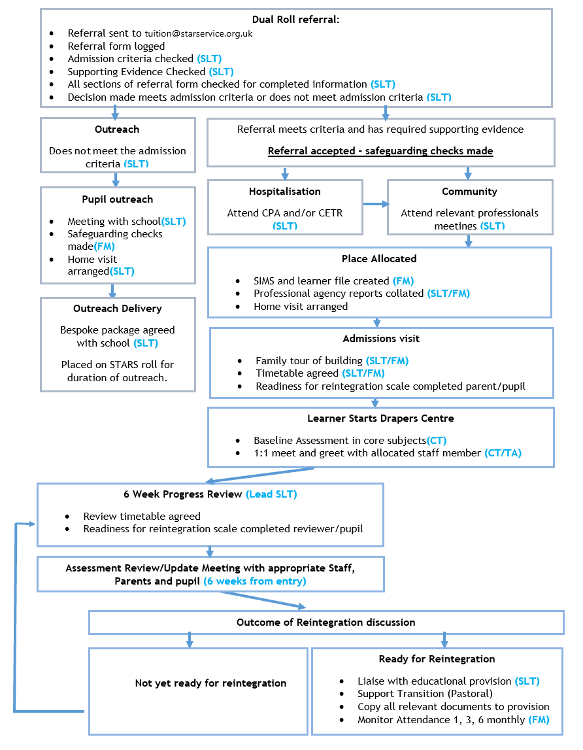

Department for Education, ‘Ensuring a good education for children who cannot attend school because of health needs, statutory guidance for local authorities’ January 2013 section 4
Department for Education, ‘Ensuring a good education for children who cannot attend school because of health needs, statutory guidance for local authorities’ January 2013 section 15
Department for Education, ‘Ensuring a good education for children who cannot attend school because of health needs, statutory guidance for local authorities’ January 2013 section 25

