London Borough of Sutton
Parking Services

THE RESIDENTS' PARKING SCHEME
All residents of Sutton's Controlled Parking Zone can apply for a residents' parking permit and/or visitors' parking permit vouchers.

WHEN APPLYING FOR A RESIDENTS' PARKING PERMIT YOU WILL NEED TO
PROVIDE:

1. Proof of residence: we will accept a tenancy agreement or Council Tax letter
(no more than three months old). If you are moving into the area we will need confirmation of your new address, for example a solicitor's letter or a tenancy agreement.

2. Proof that you are the registered keeper of the vehicle: we will need to see a
copy of the vehicle registration document (V5) showing your current address
within the zone. Alternatively, we will accept an insurance document showing you as the policy holder with the address and vehicle details.

If you are applying for a permit for a company car, we will need a letter on
headed company notepaper from the company secretary (not the applicant)
confirming that you have sole use of the vehicle (stating the vehicle registration number) which is kept at the address of the application.

3. Payment: £51 per year for the first vehicle in the household, £81 per year for a
second vehicle in the household, and £153 per year for each of the third or fourth. A maximum of four permits will be issued to a household.

4. Your email address: so that we can send you an electronic renewal notice when
your permit is due to be renewed.

No refunds are available once a permit has been issued.

USING A RESIDENT'S PARKING PERMIT:
You must display the permit clearly in your windscreen - failure to do so will result in
the issue of a Penalty Charge Notice.

The permit is only valid for the vehicle on the application form and allows you to park:

a. In a permit holder bay in your colour zone (shown on the permit and the bay
signs).
The zone is in force from 8.00am to 6.30pm Monday to Saturday.

b. In pay-and-display bays before 9.00am and after 4.00pm Monday to Friday
and at all other times (including all day Saturday).

You must surrender your permit if you change your address or change your vehicle.

PLEASE READ THE FULL TERMS AND CONDITIONS OVERLEAF BEFORE
COMPLETING THE APPLICATION FORM.

Residents Parking Scheme Page 1
Amended March 2015

London Borough of Sutton
Residents' Parking Scheme

GENERAL INFORMATION

A

1.

2.

3.

B

1.

2.

3.

4.

5.

ELIGIBILITY FOR RESIDENTS' PARKING PERMITS

Residents' Parking Permits will be issued only to persons:

a) whose usual address lies within the Controlled Parking Zone (CPZ) (see
note D), and

b) who own or use a passenger vehicle, a goods carrying vehicle the overall
height of which does not exceed 2.28 metres and the overall length of
which does not exceed 5.25 metres, a motorcycle or an invalid carriage.
The applicant must be the registered keeper of each motor vehicle to which an
application and permit relate and each vehicle must be registered to the current address within the zone.

You must therefore enclose with each application a copy of the vehicle
Registration Document (Form V5), showing your current address. If the vehicle
is supplied by your employer, a letter is required on headed company
notepaper from the Company Secretary (not the applicant) confirming that the applicant has exclusive use of the vehicle.

Visitors vouchers will be issued only to persons whose usual address lies within the CPZ and only one application can be made per household.

COMPLETING THE APPLICATION FORM

A separate application is required for each vehicle. Each question on the application form must be answered fully.

Enter the name of the actual applicant for the Parking Permit, the registration, make, model and colour of the vehicle.
If your name and address does not appear on the London Borough of Sutton
electoral register, evidence must be provided of your residence at the address
given. Vehicle Registration Document, Tenancy Agreement or Council Tax
letter is usually sufficient - only photocopies should be sent by post. If you
have not yet moved to the address given on the application form then please
give your present address, the date that you will be moving and enclose official confirmation of the new address (e.g. a solicitor's letter).

Parking Services must be informed of any subsequent change of address.

A Permit cannot be backdated but will be dated to expire 12 months from its date of issue.

Residents Parking Scheme Page 2
Amended March 2015

6.
The permit fees payable to the Council are as follows:
£51 per annum for the first vehicle in the household,
£81 per annum for the second vehicle in the same household,
£153 per annum for the third vehicle in the same household,
£153 per annum for the fourth vehicle in the same household.

A maximum of four permits will be issued per household.
Payment must accompany the completed Application Form. Cheques should
be made payable to "London Borough of Sutton". Cash should not be sent through the post.

7. Application forms should be returned by post to:
Parking Services
London Borough of Sutton
Civic Offices, St Nicholas Way
Sutton SM1 1EA
Enquiries can be made at the Civic Offices or by telephone during
office hours (020 8770 5070). Or you can e-mail us on parking@sutton.gov.uk.

8.

C
1.

2.

3.

4.

5.

6.
Please allow fourteen days for the issue of a Permit and/or Visitor vouchers.
Applications for Permits to be renewed should be made online at least 14 days
prior to the date of expiry of a current Permit at www.sutton.gov.uk/permits.

CONDITIONS OF USE
Each Permit will be issued with a protective cover and must be displayed on
the vehicle to which it relates in such a way that the details are readily visible from the front, passenger side of the vehicle.

A Permit is only valid for the specific vehicle named on the Application Form and on the Permit.
A Permit will enable the holder to park in any vacant Permit Holders Bay within
the zone to which the Permit relates as indicated by the colour of the Permit
and repeated on the signs controlling the parking place. The hours of
operation of the zone are from 8.00am to 6.30pm Mondays to Saturdays
inclusive, subject to any parking bay suspensions that may be made from time
to time and subject to any change notified by the Council from time to time.

A Permit will not enable a holder to park in parking spaces controlled by "Pay
and Display" signs between the hours of 9.00am and 4.00pm Monday to
Friday. Permit holders may park on Pay and Display bays at all other times including all day on Saturdays.
A Permit will not enable a holder to park in parking spaces controlled by signs
displaying a different zone colour or in disabled persons' (Blue Badge), solo
motorcycle or Doctors' bays or on any yellow line restriction. From time to time some Permit Holder Bays may be "suspended" which means that all parking is prohibited at these times. Please do not use your Permit to park in these bays when they are suspended as your vehicle will be issued with a Penalty Charge Notice and it may be towed away.
A Permit does not give the holder the right to park outside his / her home or
guarantee the availability of a parking space.

Residents Parking Scheme Page 3
Amended March 2015

7.

8.

9.
10.

11

12.

D
Permits must be surrendered if the holder changes address or ceases to own
or use the vehicle for which the Permit was issued.
A Permit Holder who surrenders a Permit to the Council after the permit has
become valid shall not be entitled to a refund.
Permits are not transferable from one person to another.
A new Permit must be obtained in the event of a change of vehicle and will be
issued free of charge for the unexpired period of the original Permit. Any
change of vehicle must be notified immediately to the Parking Services
Section who will then advise of the procedure for obtaining a replacement permit.
If a Permit is lost, stolen, destroyed, defaced or mutilated the Permit holder
shall notify the Council immediately and the permit shall cease to be valid. An
application form for the issue of a new Permit will be sent on request. A new
Permit will be issued for the unexpired period of the original Permit and an administration charge of £25 will be made.
The responsibility to renew any Permit on its expiry rests with the Permit
Holder.

WARNING

The Council will prosecute under the Thefts Acts or other relevant criminal
legislation if a person, with intent to deceive:
a) Forges or alters or uses or lends to or allows to be used by any other
person a Residents Parking Permit.
b) Makes or has in his/her possession any document so closely resembling
any such Residents Parking Permit as to be calculated to deceive.
c) Knowingly makes a false statement for the purpose of obtaining a
Residents Parking Permit.

The Council reserve the right to withhold or withdraw a Permit.

Penalty Charge Notices will be issued to any vehicle not displaying a valid
Residents Permit including circumstances where the registration number on the Permit does not match the number on the vehicle and where the Permit has expired.

It is an offence under the Vehicles (Excise) Act 1971 to use or keep a
mechanically propelled vehicle on a public road if the vehicle is untaxed.

The definition of "resident" for the purpose of obtaining a Residents' Parking Permit and / or Visitors' Vouchers is a person whose usual place of abode is
at premises, the postal address of which is any street or part of street
described in a Schedule to the appropriate Sutton (Controlled Parking) Order for that zone.

Residents Parking Scheme Page 4
Amended March 2015

F.

1.

2.

3.

4.

5.

6.
VISITORS' PARKING PERMIT VOUCHERS

Each household within the Controlled Parking Zone is entitled to purchase an unlimited number of visitor parking vouchers per year with no expiry date. The first 50 hours (converted to days) visitors' parking vouchers are FREE. Additional hours will be charged as per the attached application form.

Additional hours visitor parking vouchers can be purchased online, they will have no expiry date or limit on numbers requested.
The voucher must be completed in accordance with the conditions of use
detailed on the reverse of the visitor parking permit.
The visitor permit is only valid in the zone indicated. Visitors displaying the
completed permit may park in the permit holder only bay at anytime, OR the
pay and display bay between 8.00am and 9.00am or 4.00pm to 6.30pm Monday to Friday or all day Saturday. The visitor voucher is not valid between 9.00am and 4.00pm Monday-Friday in the pay and display bay.

The Visitors' Parking Permit Vouchers are valid only in the zone indicated on
the Vouchers and do not guarantee a parking space in a permit holder parking bay.

Please allow fourteen days for the issue of Visitors' Parking Permit Vouchers.
If you have not received your vouchers within the 14 days, please call Parking Services on 020 8770 5070.

Lost or stolen Visitors' Parking Permit Vouchers will not be replaced.

Residents Parking Scheme Page 5
Amended March 2015
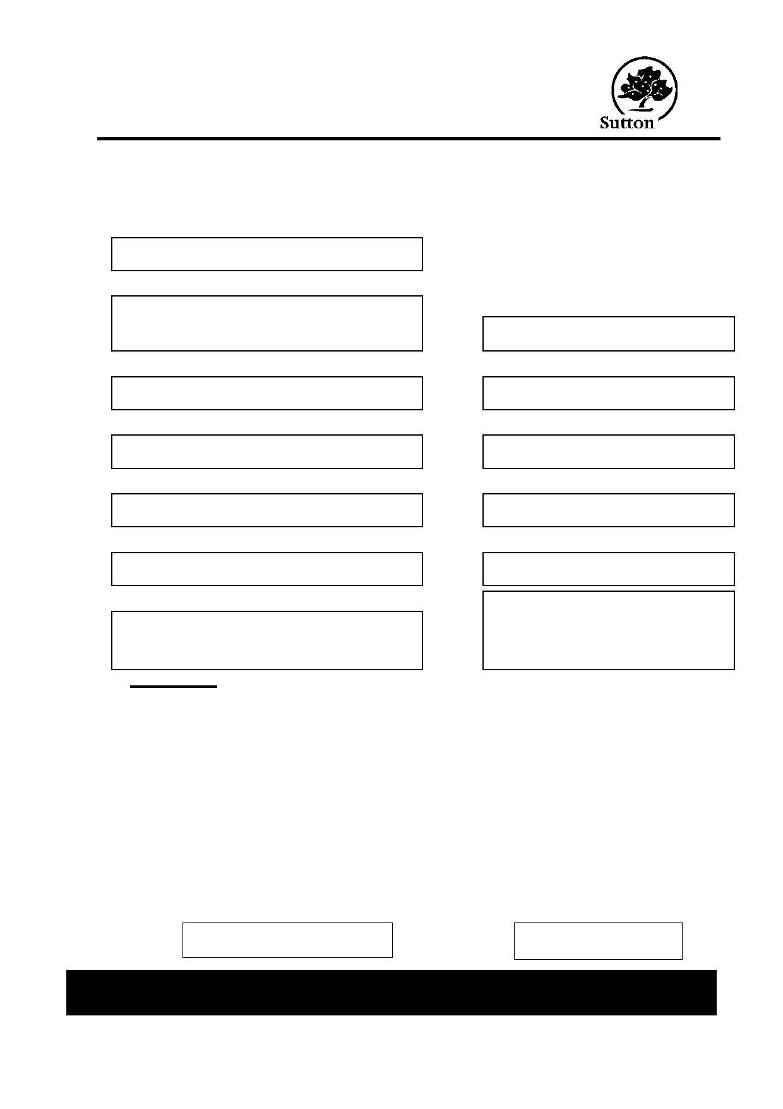
London Borough of Sutton
RESIDENTS' PARKING / VISITORS' VOUCHER
APPLICATION FORM

Please read the accompanying information carefully before completing this form. NB. Sections marked with an asterisk (*) must be completed for all applications.
*1 NAME in full (Mr / Mrs / Miss / Ms)

*2 ADDRESS within controlled parking zone VEHICLE DETAILS:
8 REGISTRATION NUMBER

*3 POSTCODE 9 EXISTING PERMIT NO (if any)

*4 DAYTIME TELEPHONE NUMBER 10 VEHICLE MAKE

5 EMAIL ADDRESS 11 VEHICLE MODEL

*6 When did/will you move to the above address?

*7 PRESENT ADRRESS if different from above

Declaration

12 VEHICLE COLOUR

13 ○ I own the above vehicle /
○ I use but do not own the above
vehicle
[please delete as appropriate]

● I will inform the Parking Services Section of the Council and surrender the permit if:
(a) I cease to be a resident at the above address.
(b) I cease to be the owner / user of the above vehicle.

● I enclose a cheque for the sum of £ ________ made payable to the London Borough
of Sutton
● I declare that I have read and agree to abide by the terms and conditions governing the
issue and use of Residents Parking Permits and Visitors Permits in the London Borough of Sutton.
● In making this application I understand that authorised officers of the Council may
check statements made in this application against the Electoral Roll and Vehicle Licensing Agency.

SIGNATURE DATE

Please ensure you enclose correct PAYMENT and DOCUMENTATION with your application.
Return to Parking Services, Civic Offices, St Nicholas Way, Sutton, SM1 1EA.

Residents Parking Scheme Page 6
Amended March 2015

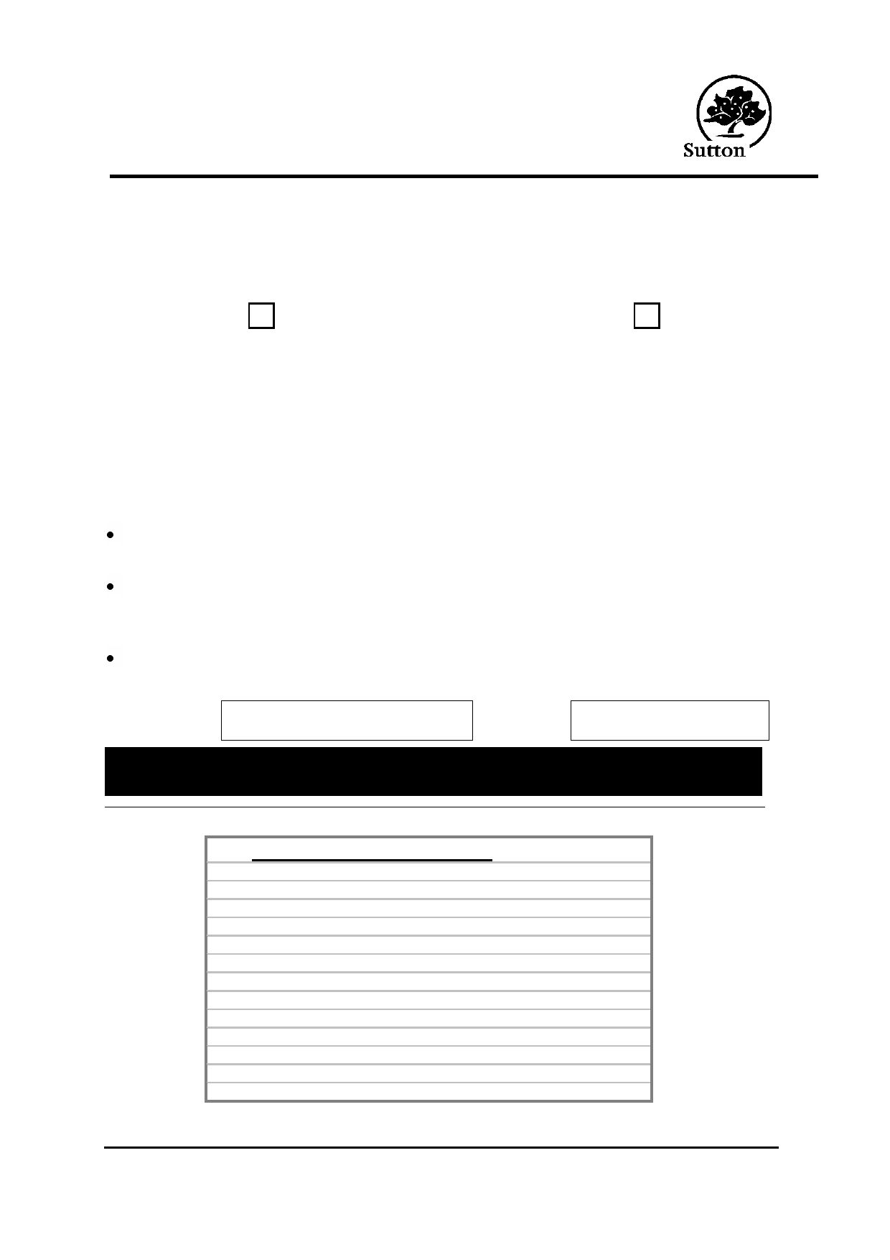
Residents Parking Scheme

APPLICATION FORM - VISITORS' PARKING

VISITORS' PARKING PERMIT VOUCHERS
Please tick the box to be issued with Visitors' Parking Permit Vouchers and enclose
payment of the appropriate amount:

Book of 100 hours at £61 per

50 hours FREE
book (insert number required)

If you are not applying for a Resident Permit but wish to be issued with Visitors'
Parking Permit Vouchers, you should still complete the details asterisked overleaf.

If more than one person in your household is applying for a Resident Permit, you must agree between yourselves to whom the Visitor Vouchers should be sent.

DECLARATION

If I am issued with Visitors' Parking Permit Vouchers, I will inform the Council and surrender the Vouchers if I cease to be a resident at the above address.
I declare that I have read and agree to abide by the terms and conditions
governing the issue and use of Residents' Parking Permits and Visitors' Parking Permit Vouchers in the London Borough of Sutton.
In making this application, I understand the authorised officers of the Council may
check statements made in this application against the Electoral Roll.

SIGNATURE DATE
Return to: Parking Services , London Borough of Sutton, Civic Offices, St Nicholas
Way, Sutton SM1 1EA.

FOR OFFICE USE ONLY

Received by
Ch / Ca / PO / C+P
Accounting Officer Sheet no.
Electoral Roll
Other Documents
DVLA
Own / Use
Zone R / B / G
Permit No.
Visitors Permit Vouchers No's
Date Issued Date Expires
Input by
Date
Amount £

Serial No:

Residents Parking Scheme Page 7
Amended March 2015

