Sutton’s Future

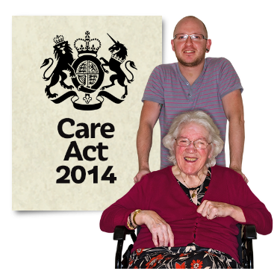

The Care Act 2014
Care and Support
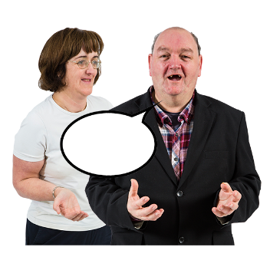
Public Consultation
Closing Date – 21 February 2016

Questionnaire

Please answer the questions below.
Notes for questions 2 – 12 are in the booklet that comes with this questionnaire. The notes may help you to answer these questions.
Question 1
Who are you? Please tick 1 box

Service User

Carer If you are a carer, how old is the person you care for?_____________
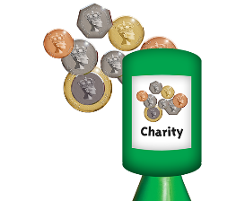

Voluntary Organisation

Social Care Provider

Sutton Resident
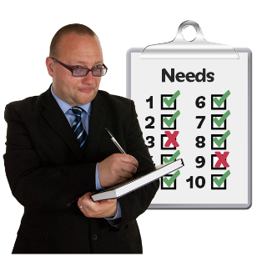
Question 2
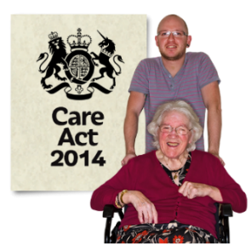
How to decide who has the right to services

Do you agree or disagree that Sutton Council is right to use the rules in the Care Act?

Strongly Agree

Agree

Do not Agree or Disagree

Disagree

Strongly Disagree

Don’t know

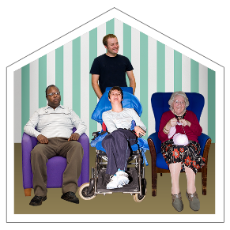
Question 3
Charging for Residential and Nursing Care
Do you agree or disagree that people living in care homes should still be charged for their accommodation and support?

Strongly Agree

Agree

Do not Agree or Disagree

Disagree

Strongly Disagree

Don’t know
Question 4
Deferred Payments

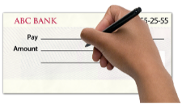
Do you agree or disagree that the Council should use the interest rate decided by the Government when setting up Deferred Payment agreements?

Strongly Agree

Agree

Do not Agree or Disagree

Disagree

Strongly Disagree

Don’t know

Question 5
Extending the use of Deferred Payment agreements
Do you agree or disagree that the Council should use Deferred Payments with people who need support but do not live in care homes?

Strongly Agree

Agree

Do not Agree or Disagree

Disagree

Strongly Disagree

Don’t know
Question 6
Deferred Payment Debt Security
Do you agree or disagree that the Council is right to protect itself from the risk of losing money on Deferred Payments?

Strongly Agree

Agree

Do not Agree or Disagree

Disagree

Strongly Disagree

Don’t know
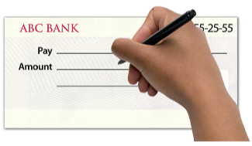
Question 7
Interest Rates (what you pay for a loan)
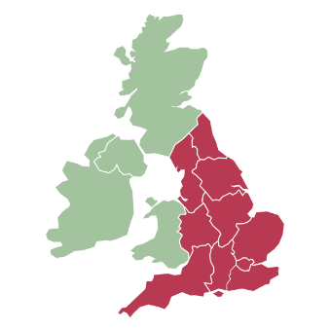
Do you agree or disagree that the Council should use the national rate, and charge the same as other councils?

Strongly Agree

Agree

Do not Agree or Disagree

Disagree

Strongly Disagree

Don’t know

Question 8
Paperwork Costs
Do you agree or disagree that where possible the Council should get back the money it spends on contracts for self-funding clients?

Strongly Agree

Agree

Do not Agree or Disagree

Disagree

Strongly Disagree

Don’t know

Question 9
Direct Payments
Do you agree or disagree that it is a good idea for the Council to give people a choice of how they get Direct Payments?

Strongly Agree

Agree

Do not Agree or Disagree

Disagree

Strongly Disagree

Don’t know

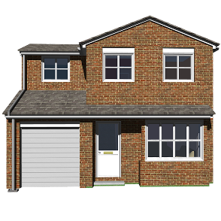
Question 10
Capital limits increase (savings and property a person can have before they must pay for care services)

Do you agree or disagree that the Council should keep to the limits that are set for the whole country?

Strongly Agree

Agree

Do not Agree or Disagree

Disagree

Strongly Disagree

Don’t know
Question 11
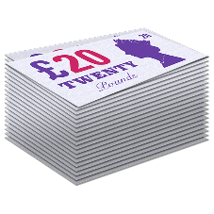
Setting a maximum weekly charge

Do you agree or disagree that it is still fair for the Council not to have a maximum weekly charge for services given outside a care home?

Strongly Agree

Agree

Do not Agree or Disagree

Disagree

Strongly Disagree

Don’t know

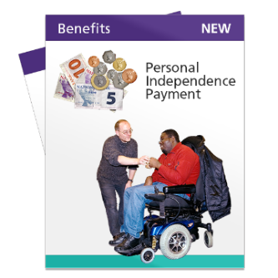
Question 12
Treatment of Personal Independence Payments (PIP) when working out how much money people should pay for services
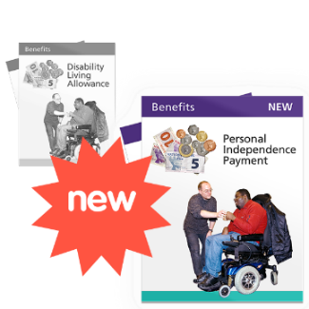
Do you agree or disagree that the Council should treat PIP the same as it did the Disability Living Allowance (DLA) when charging for services?

Strongly Agree

Agree

Do not Agree or Disagree

Disagree

Strongly Disagree

Don’t know
About You
Your answers to questions 13 – 21 will help us understand the views of different kinds of people in Sutton. Then we can plan services to meet the exact needs of our service users and residents. You do not have to answer these questions. But as you do not have to give your name, we will not know what answers you give.

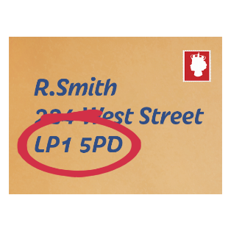
Question 13: What is your postcode?

________________________________

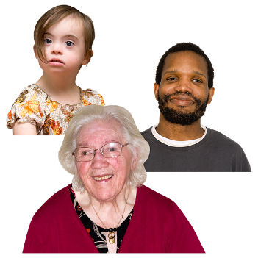
Question 14: How old are you?

- – 24 25 – 34 35 – 44

45 – 54 55 – 64 65 – 74

75 – 84 85+
Question 15
Is it hard for you to do day-to-day activities because of a health problem or disability which has lasted, or is expected to last, at least 1 year?
Please tick all the boxes that are true for you

No

Yes, because I find it hard to move around

Yes, because I cannot hear well

Yes, because I cannot see well

Yes, because I have a learning disability

Yes, because I have a mental health problem

Yes, because I have another disability
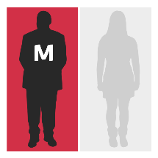
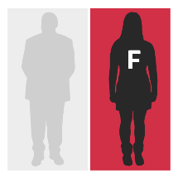
Question 16: Are you a man or a woman?

A man A woman

Question 17
Are you…? Please tick 1 box

Married In a Civil Partnership

Widowed Divorced or separated

Other Do not want to say

Question 18
Have you been pregnant and / or on maternity leave in the past 2 years?

Yes No

Question 19 - What is your family background?
Please tick 1 box

Asian or Asian British:

Indian Pakistani

Bangladeshi Chinese

Sri Lankan Tamil

Any other Asian background

Black or Black British:

Caribbean African

Any other Black or Black British background

Mixed background:

White and Black Caribbean White and Asian

White and Black African Other mixed background

White or White British

British English

Scottish Welsh

Northern Irish Irish

Gypsy or Irish Traveller Polish

Other Eastern European

Any other White or White British

Other ethnic group:

Other ethnic group – Arab Any other ethnic group

Question 20: What is your religion?

Buddhism Christianity

Hinduism Islam

Judaism Sikh

No religion / Atheist Other religion

Do not want to say

Question 21

How do you describe your sexuality?

Bisexual Gay woman / lesbian

Gay man Heterosexual

Other Do not want to say
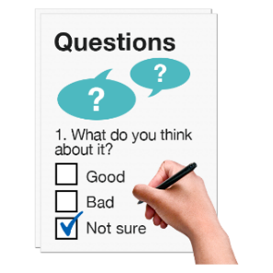
Please put this questionnaire into an envelope.

Send it back to us by 21 February 2016 using our Freepost address below. You do not need a stamp.

Care Act, third floor
London Borough of Sutton
FREEPOST CN2117
Civic Offices
St Nicholas Way
Sutton
SM1 1BR

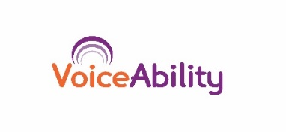
Easy Read by:

