PROPERTY
TO LET
SITE HUT AND SECURE LAND
BUCKLAND WAY ALLOTMENT SITE
PONDSFORD AVENUE
WORCESTER PARK, KT4 8NQ

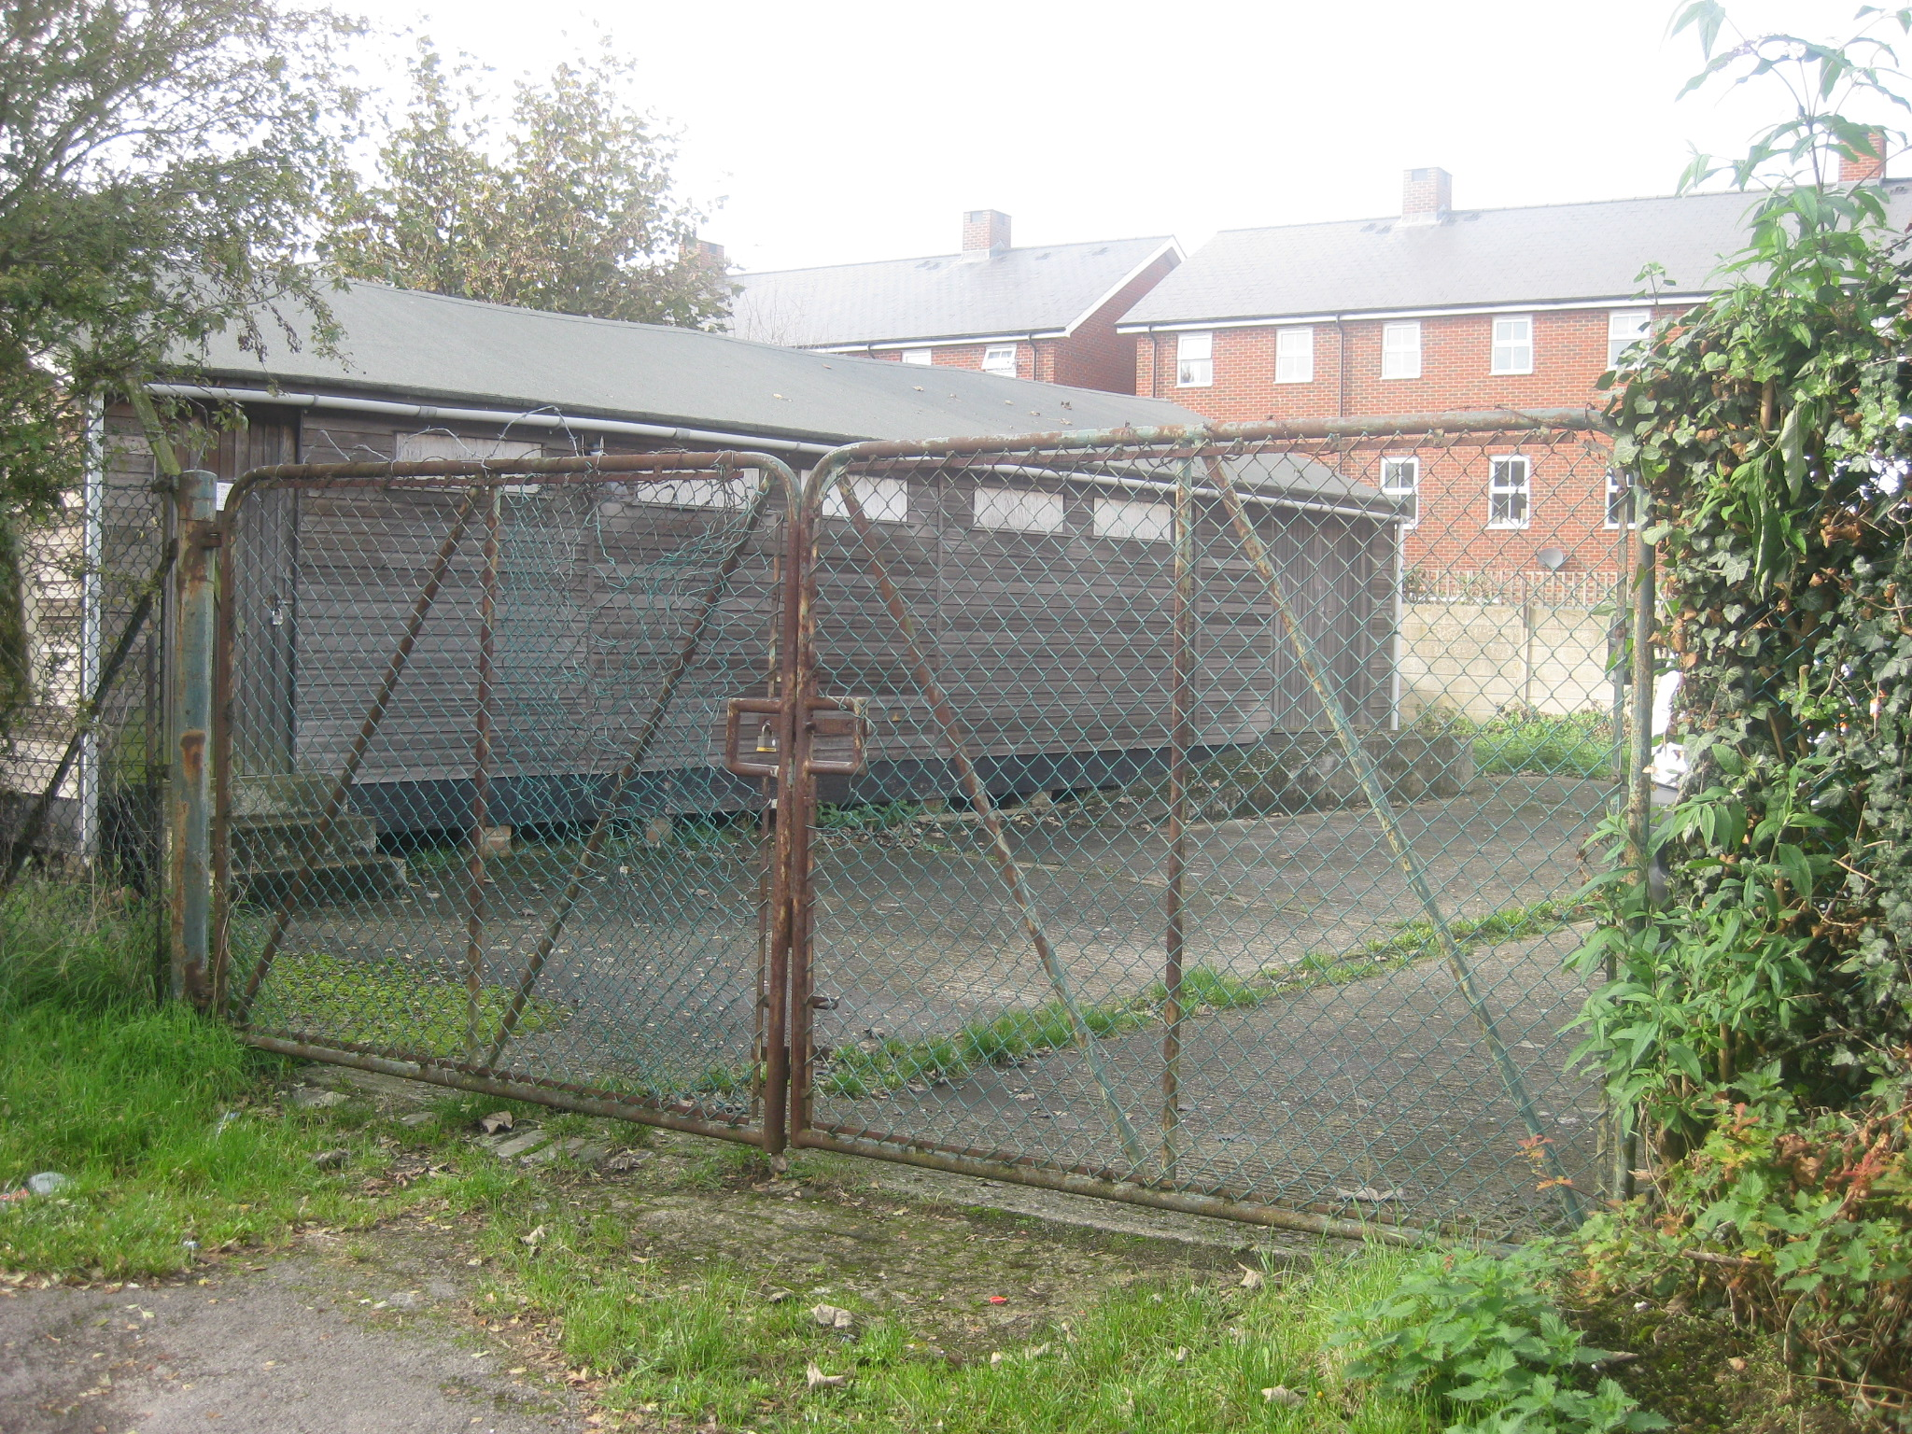

DESCRIPTION
The property comprises a single story wooden site hut and hard surfaced land, secured through metal fencing and a padlocked wire mesh gate.

AREA
Land 361.00m²
Site Hut 70.88m²

PLANNING
The property is situated on statutory allotment land and as such, any use will be subject to consent from the Government Office for London. The previous Licensee used the property for storage space and parking of a large van and trailer.

LOCATION
The property is situated along Boscombe Road, Worcester Park and forms part of the Buckland Way Allotment Site. It is conveniently located 2 miles from both Morden and Sutton town centres. There are good transport links, including Morden Underground Station approximately 2.5 miles away and there are several local bus routes.

TERMS
The premises will be available on an annual licence.
RENT
Offers invited.

COSTS
Each party will be responsible for their own costs.

CONTACTS
For further information please contact Nick Stevenson on 020 8770 6159 or Andrew Brady on 020 8770 6333.

OFFER
All offers must be made by 31st March 2016 in writing to Asset Management, London Borough of Sutton, 24 Denmark Road, Carshalton, Surrey SM5 2JG or by email to nicholas.stevenson@sutton.gov.uk

SITE PLAN
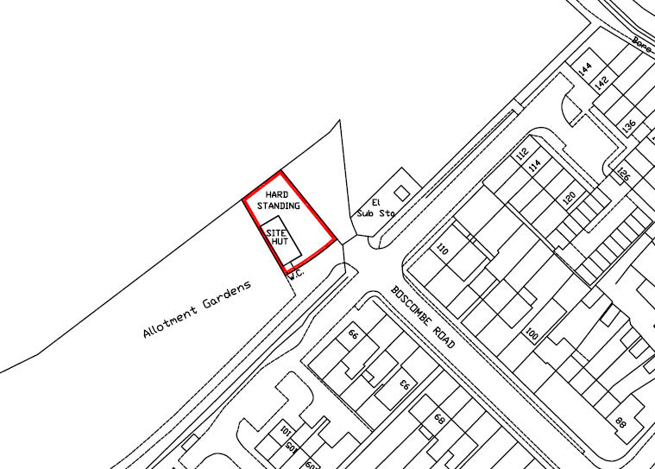

Conditions Governing these Particulars

1. These particulars do not constitute any part of an offer or contract and are supplied entirely without prejudice. The Council does not accept any responsibility as to the accuracy thereof or otherwise.

2. All prospective tenants must satisfy themselves as to the suitability of the site for the intended use.

3. The Council does not make or give any person in the employment of the Council any authority to make any representation or warranty in relation to the premises or information supplied thereof.

4. Agents should look to their clients for remuneration.

5. The Council does not bind itself to accept any offer submitted.

6. It should be noted that it is a criminal offence punishable by imprisonment to give or offer any gift or consideration whatsoever as an inducement or reward to any officer of the Council and any such action will preclude the offerer from making subsequent offer applications.

7. The information given in these particulars is subject to contract.

These particulars are set out as a general outline only for the guidance of intended lessees and do not constitute, nor constitute part of, an offer or contract. All descriptions, areas and necessary permissions for use and occupation and other details are believed to be correct but their accuracy is not guaranteed and they are intended only as a guide and do not obviate the need to make appropriate searches, enquiries and inspections. They form no part of any contract or offer and are given without responsibility on the part of the Council or its Officers. No responsibility is taken for any inaccuracy or expenses incurred in viewing the premises. The terms are subject to contract.

