Travel Training

Bus days - boost your confidence in independent travel
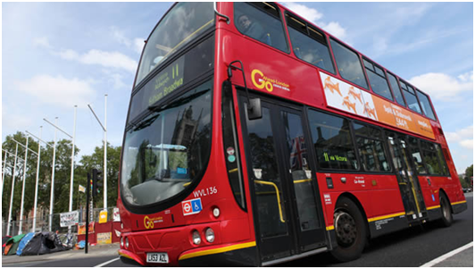
A real but controlled training experience on a double-decker bus aiming to help increase confidence & encourage independent travel, organised by Sutton Community Transport.

Bus Days ** are a real but controlled training experience (staged on a double-decker bus) aiming to help increase confidence and encourage independent travel. Find out more here:
* Bus Days run once a month;
* each sessions lasts approximately 90 minutes with up to two sessions running on each date, subject to demand/resource availability (morning 10.30am-12noon, afternoon 12.30-2pm);
* we run scenarios around difficult events/situations which may occur during travel and advise how to deal with them.
* training includes aspects of travel such as personal/belongings safety as well as transport specific information;
* we meet in a central Sutton location;
* we can book groups or individuals
onto the bus days.
Forthcoming Sutton Bus day dates,
attendance must be booked in advance:
Thursday 12th May 2016
Thursday 9th June 2016
Wednesday 15th June 2016
Wednesday 28th September 2016
Thursday 13th October 2016
Thursday 10th November 2016
Thursday 8th December 2016

To find out more and to book your place
Contact us and ask for the Bus Days:
 020 8683 3944 / E: charityprojects@suttonct.co.uk)
This valuable resource for the residents of Sutton has been made possible thanks to Partnership Working and grant funding to continue in 2015/16 from the Sutton Community Fund:
Partnership Working
• Transport for London’s Mentoring team
• The Metropolitan Police’s Safer Transport team
• Sutton Community Transport
• GoAhead bus company

