Inclusion Sports Day
Friday 17th February 2017, 11-2pm
Registration Form

Full Name

Date of Birth

Gender

Ethnicity


Address
Telephone number

Email address

Photo Consent 
Yes/No
Any Additional Needs

Active (over 30 mins moderately intensive physical activity during past 1 week) or inactive.


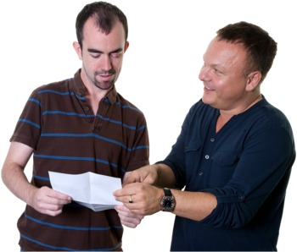
Please return this form to: Michael Harrington
Disability Manager
Crystal Palace Football Club Foundation
Selhurst Park, London, SE25 6PU or
MichaelHarrington@cpfcfoundation.org

