The Sutton Milestones – The Brighton Road
I joined The Milestone Society in 2020 to find out more about the history of the three milestones dated 1745 in the London Borough of Sutton where I live. The stones mark the route from Southwark, south of London Bridge, via Kennington, Clapham, Figge’s Marsh, Mitcham and Sutton to Banstead Downs, which was a popular destination for horse racing as early as the 17th century. Eight stones survive along this route. At this time the road was no more than a muddy lane impassable in the winter months.
In the 1750s the route was extended to Brighton, then a small fishing village called Brighthelmstone, which had been put on the map by Dr Richard Russell who advocated the health benefits of sea air and sea bathing in the Sussex village.
Westminster Bridge opened in 1750 allowing traffic to travel to different destinations in London and in 1755 the Reigate Turnpike Trust was established. The roads were widened and hardened with gravel and flint and toll gates set up. More milestones were erected through Reigate leading to Brighton and the stage coach era began.
Sutton, 12 miles from London, was the first staging point for the coaches. An account from 1801 describes the journey leaving Blossoms Inn in Lawrence Lane at 7am, crossing the river at London Bridge. Passengers alighted for breakfast at 9am at the 17th century Cock Inn in Sutton (now sadly demolished), partook of a glass of elderberry wine at the Tangier Inn, Banstead (also gone), made a stop for lunch in Reigate (at the White Hart or The Swan), had dinner at Staplefield Common, a liquor at Handcross, tea at Patcham, and arrived in Brighthelmstone at 7pm.
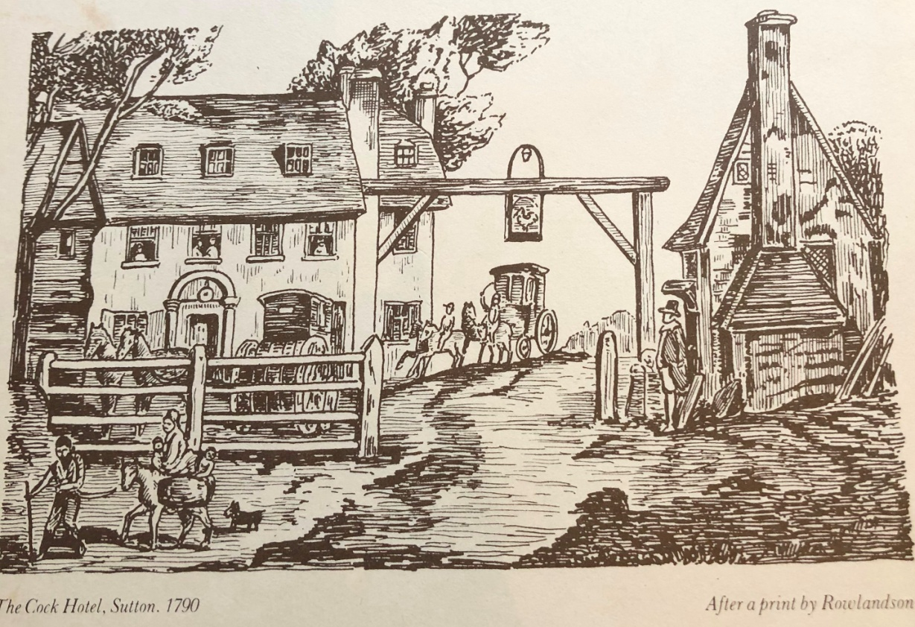
The Cock Hotel, Sutton 1790 (print by Thomas Rowlandson)
looking south to the Brighton Road, then called Sutton Lane
The Cock was not a cockerel, as the sign over the road suggests, but the name given to the horses that could be hired to pull heavy carriages up the steep hill to the cross-roads at the top of Sutton.

I was puzzled by the fact that the stones are defaced on the flanks, and that while those in Rose Hill Park and the High Street show the destinations as Royal Exchange and Whitehall, the stone from the same set in Brighton Road shows XIII miles to the Standard at Cornhill. The Surrey Rep, Janet Dowding, provided an answer. Her researches show that the Standard, a water pump at a junction of roads at Cornhill, was the earliest measuring point in London and remained so even after its removal in 1674. Whitehall was a later destination, indicating that the stones must have been re-carved after the opening of Westminster Bridge.
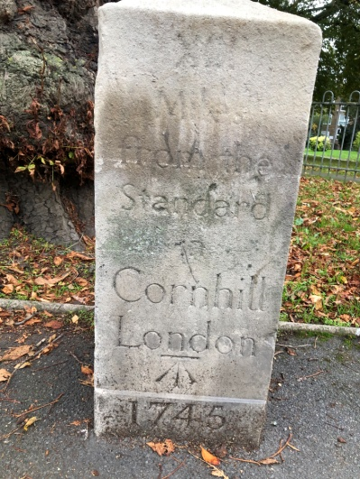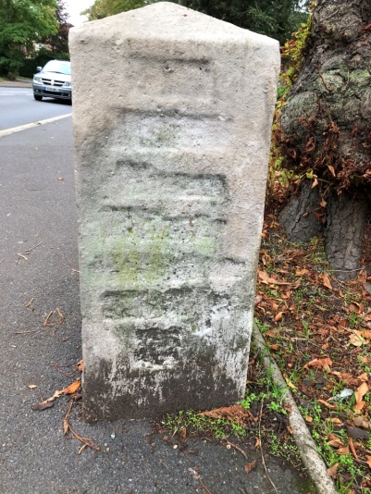
Brighton Road Milestone(opposite Egmont Road) Defaced right flank
But this is not the only time the stones have been re-carved.
A photograph taken in 1910 in an old book of Sutton shows the High Street milestone with modern numbering on the left flank reading ‘Whitehall 11 ½ Miles’ , presumably with the former destinations with roman numerals left intact on the front face as they appear today having been re-carved after WW2.
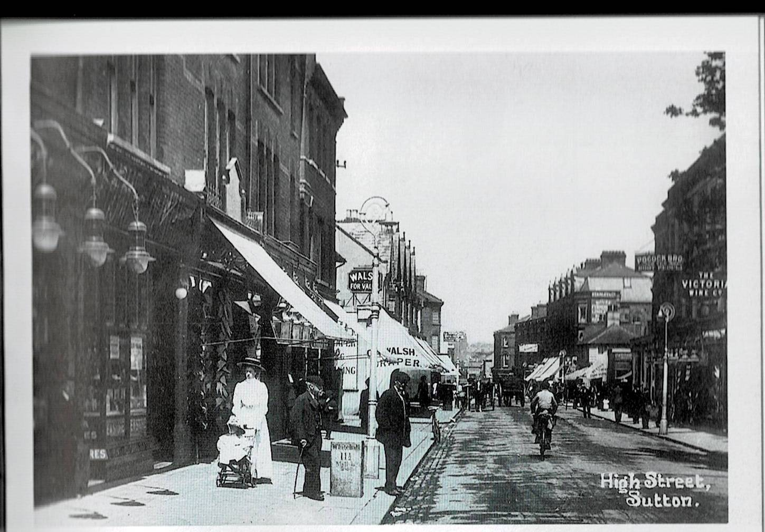
Picture credit: Jane E. M. Jones Sutton Pocket Images
We know that the milestones were removed in WW2 following fears of an enemy invasion. The Minutes of the Highway and Works Committee 12th June 1940 state:
“On the instructions of the Ministry of Transport all direction signs and milestones have been removed from the public highways in the Borough”.
The question remained as to whether they were defaced prior to removal and the Archivist at Sutton Library found this reference to defacing in the Council Minutes of 5th October 1972:
“A question was asked by Alderman Letts whether ‘in view of the fact that it is extremely unlikely that the milestones of England will ever again be of value to a potential invader, his committee will consider restoring such milestones as still remain to their former splendour, and reinstating the lettering which was removed from them in 1940.’
The implication was that they were not restored and re-sited until the 1970s but at a recent visit to the archives, I found a follow-up reference in the Council Minutes of 23 January 1973 confirming that, following Alderman Letts’s question, a report had been undertaken:-
“The report revealed that there were five milestones in the Borough; they had been re-inscribed at the end of the 1939-45 War and were in a reasonable condition.”
The other two milestones referenced are one in Cheam Road, installed in 1755 when a turnpike road was made going east-west between Carshalton and Ewell, crossing the north-south London to Brighton road at the Cock Inn, and the other in London Road, an alternative route from London via Morden along the line of the old Roman road.
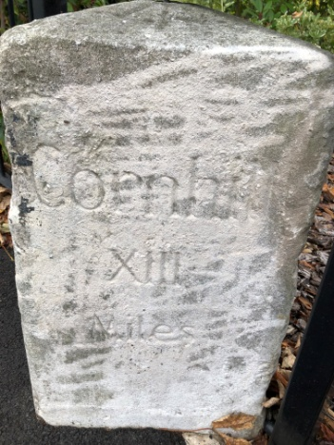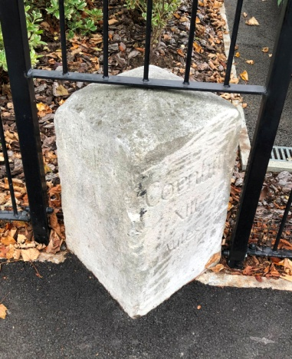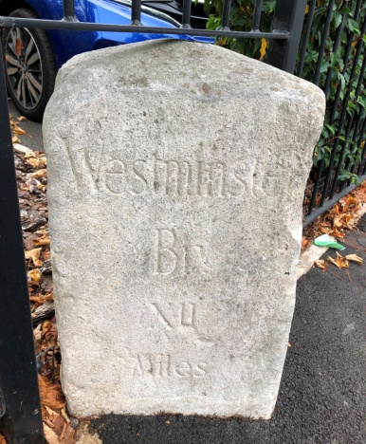
Milestone 1755, showing Westminster Bridge XII Miles and Cornhill XIII Miles
On the Cheam Road between Rosebery and Derby Roads

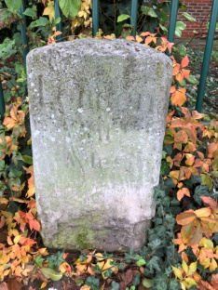
Milestone London XII Miles
On the London Road outside Elmcroft Community Centre
The Archives also answer the question of why the Brighton Road milestone was re-carved with Cornhill as the destination. This one was restored by a private donation from Mr Ely, owner of Ely’s department store in Wimbledon. The stone stood outside his house in the Brighton Road. (Ely’s store is still there but sadly the large villas along the Brighton Road have been replaced with blocks of flats). An old map of 1888 showed that this milestone once gave Cornhill and Westminster Bridge as the destinations. After the War, Mr Ely chose to re-inscribe the stone with the earlier more historic destination, leaving the left and right flanks defaced.

Evidence of earlier restoration of this stone appears on the defaced right flank.
An inscription remains at the bottom giving the stonemason’s name of J Parrott Sutton 1892,
but sadly one has to guess what the inscription once said.

It is pleasing from an historical point of view that Sutton Council chose to re-carve our milestones after the War with the original Roman numerals, but the milestones in other Boroughs along the route towards London show modern numbering, either re-carved or left intact in 1940. This needs further investigation when time and lockdowns allow.
The Reigate Turnpike Trust ceased operation on 31 October 1881, but miraculously, the early 19th century tollhouse that once stood at Rose Hill has survived. It was moved on rollers for 1 ½ miles to Wrythe Green where it exists today as a private home now named Woodcote House, a Grade 2 listed building.

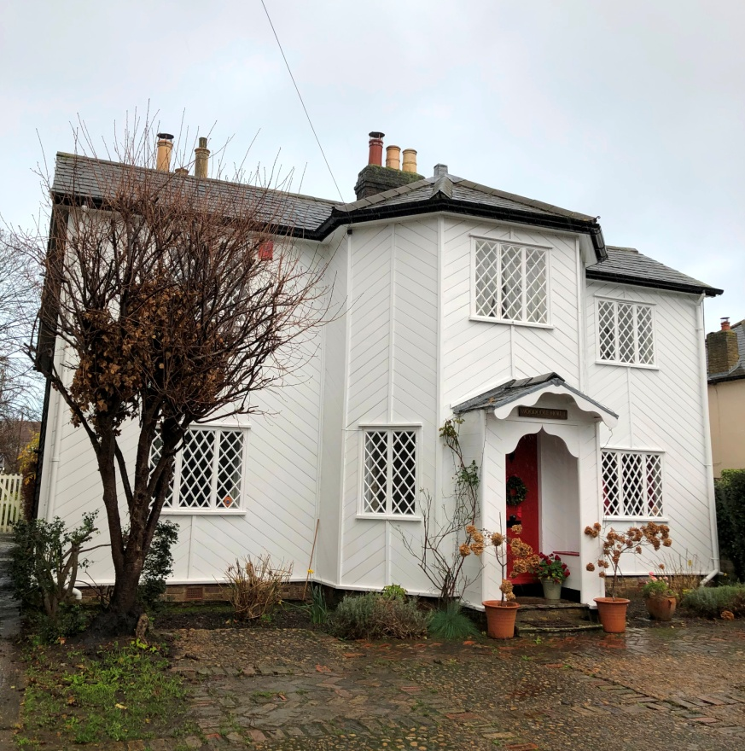

In the course of my researches, I found that while four of the Sutton milestones were listed as scheduled monuments in the 1970s, the Rose Hill milestone was overlooked for some reason and I have applied to Historic England to rectify this. In the meantime, with advice from Ian Thompson from the Society, we have cleaned our milestone, and the Friends of Rose Hill Parks have been awarded £3200 from Sutton Council to refurbish the area around it and to put up an information board.
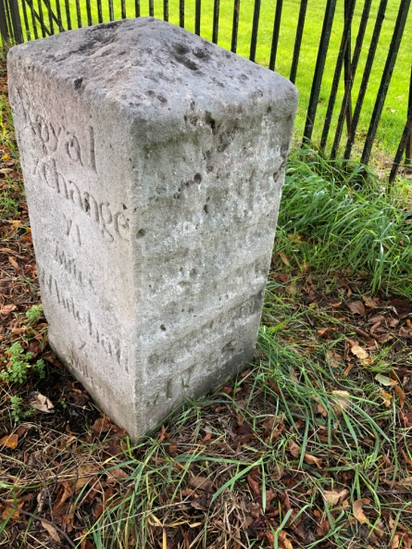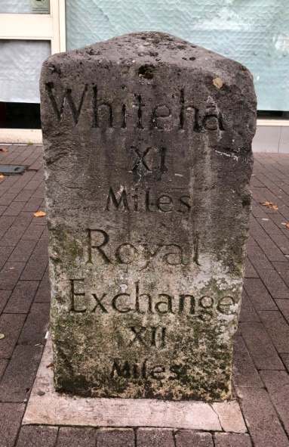
Milestone dated 1745 at Rose Hill Milestone High Street opposite Benhill Avenue

Royal Exchange XI Miles Whitehall X Miles Whitehall XI Miles Royal Exchange XII Miles

With so many historic buildings lost in Sutton over the years, the milestones stand as silent reminders of the reasons for Sutton’s early development from a few isolated farms to being a major commercial and passenger route from the Capital and, with the coming of the railways in the 1840s, becoming the busy and prosperous town it is today.

An Article for The Milestone Society by Margaret White – December 2020
Sources
A History of Sutton by Derek W James Archiuk.com (old maps)
History of Cheam and Sutton by C J Marshall 1936 London Borough of Sutton Archives
Marking the Miles by Carol Haines
Metadyne Metropolitan Milestones Website
Metropolitan Surrey Milestones by Colin Woodward 2011
Surrey Roads from Turnpike to Motorway by Gordon Knowles (Surrey Industrial History Group)
Sutton Pocket Images by Jane E. M. Jones The Brighton Road by Charles G Harper 1892
The Milestone Society The Turnpike Road System in England by William Albert

