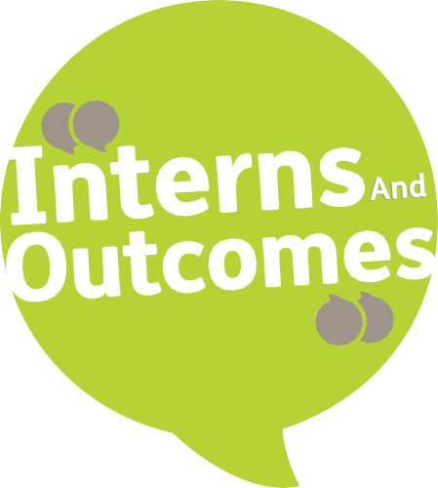

Did you know that 1 in 50 people in the UK have a learning disability, but just 6% are in paid employment?1.
Mencap believe that with the right support, people with a learning disability can get a job and enjoy an independent, fulfilling life.
But we need your funding to make this a reality.

What is a learning disability?
A learning disability is a reduced intellectual ability and difficulty with everyday activities – for example, household tasks, socialising or managing money – which affects someone for their whole life.
People with a learning disability tend to take longer to learn and may need support to develop new skills, understand complicated information and interact with other people. People with certain

specific conditions, such as Down’s syndrome and autism, can have a learning disability too.
Did you know that
1 in 50
people in the UK have
a learning disability?

<?>The Health and Social Care Information Centre (HSCIC, 2015), 3

The Interns And Outcomes programme offers people with a learning disability the opportunity to get practical work-based learning experience.

What is Interns And Outcomes about?
We have built on the success of our award-winning
Supported Internship Study Programme
and developed this into a national model: Interns And Outcomes. It’s a programme that offers people with a learning disability, aged 16 to 24 years old, the opportunity to get practical work-based
learning experience, providing a smooth transition from education to paid employment or further study.

Who is the programme for?
Interns And Outcomes is for young people aged 16-24 who have an Education, Health and Care (EHC) plan.

How the programme helps
Interns And Outcomes offers a range of benefits, helping people with a learning disability to:
raise their aspirations build skills and confidence
better understand employment show employers what they can do progress towards paid work.

Creating more job opportunities
We believe that helping employers better understand learning disability through our programme can make a real, lasting difference. If employers become more switched-on, this can create greater opportunities in the long-term future, and more people with a learning disability in work, fulfilling their potential.

4

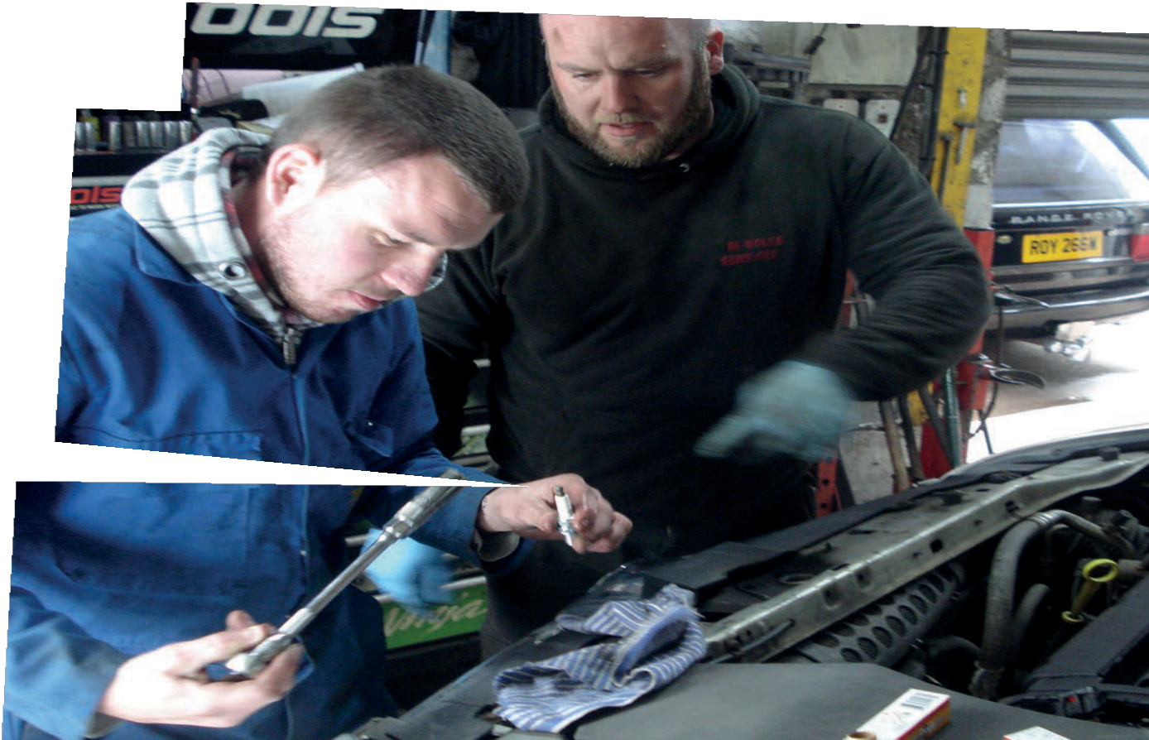Why the programme is needed
Being a young person with a learning disability presents a huge challenge when trying to break into the world of work. For many, it can be very difficult to transfer skills learned in a classroom setting into a work environment.
Employers often fail to see beyond a person’s learning disability due to a lack of understanding, or look for skills or experience that many
individuals don’t have. Compounding this are things such as online-only application processes, formal interviews and a lack of adjustments in the workplace – barriers that employers don’t always realise they have created.
Interns And Outcomes offers a great opportunity for young people with a learning disability to learn practical vocational skills in a real work setting, which helps to address some of these barriers. And it’s a chance for individuals to demonstrate the contribution they can make to a workforce.

Interns And Outcomes offers a great opportunity for young people with
a learning disability to learn practical vocational skills in a real work setting.

5

What the programme offers
The programme can be tailored to the unique needs and career aspirations of the individual. Interns And Outcomes:
is a full-time study programme
offers a long-term work experience placement
enables each individual to learn the skills they need for work through practical on-the-job learning, supported by a job coach
is very flexible and can be delivered as an accredited or non- accredited provision.

What’s included?
Interns And Outcomes comprises:
assessment of prior learning and educational attainment vocational profiling – a tool for documenting and structuring information about an individual’s abilities and interests enrolment and induction
pre-placement preparation
matching to an employer according to skills, development needs and choice
work experience – 1-3 placements, dependant on the person and the employer
Support provided throughout the placement by a job coach accredited or non-accredited work-related and personal development learning, including English and maths
observation and records of progress and achievement
non-accredited personal and social development, for example, travel training, communication skills, social skills for the workplace, money management and timekeeping skills as well as plans to move on to other pathways to work
sustainability and tracking – working with the employer and individual to ensure placements are a success.

Interns And Outcomes can be delivered through different models, depending on the individual’s needs.

How it works
Interns And Outcomes can be delivered through different models, depending on the individual’s needs, which are always at the centre of the programme’s goals. We value the input and involvement of families and carers in the process, as we recognise there is a lot of support needed outside of the programme to make it work.
Mencap will need to be named in Education, Health and Care (EHC) plans and work in partnership with a local authority to draw down funds from the Education Funding Agency (EFA) to fund the programme for each person.

6

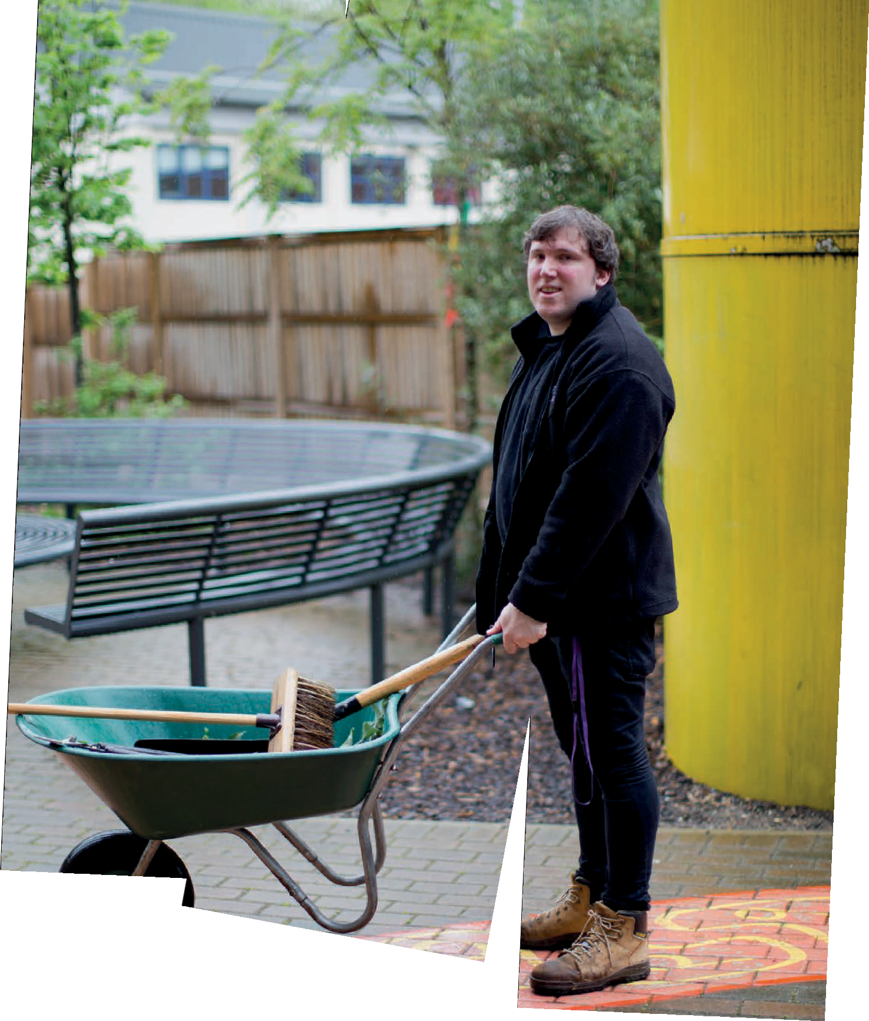

Interns And Outcomes model

Interns And Outcomes is designed to be flexible, but each intern will have individual learning targets set at the start of the programme that will always include elements of English and maths. Where appropriate, there will be qualifications embedded in the programme to help demonstrate development.

7

Interns And Outcomes process
We ensure that individuals receive the best experience, and it is vital that preparation work is carried out thoroughly with all stakeholders to achieve this. Here is an example of how the process works:

Oct – Nov
LA/college identifies Mencap in EHC plan to deliver supported internship.
Dec – Mar
EFA confirms agreement to fund programme for each learner.

Mar – May
Hold information events for parents/carers/ learners.

June - July
Confirm job outcome or progression route.

July
Celebration event

May – June
Carry out vocational profiling in agreement with existing school/ college.

Jan – June
Whilst placement occurs, identify job outcome or progression routes with phased exit.

Abbreviations:
- LA = Local Authority
- EHC = Education Health and Care

June
Identify employers up taster
- EFA = Education Funding Agency

– Aug
range of and set
sessions.

Nov - Jan
Work placements commence.

Oct – Nov
Firm up commitments with employers.

Sept - Oct
Start programme.
Carry out employer visits and tasters.

8

Success: what it means to us
We would love to see everyone who completes Interns And Outcomes to be equipped with skills and confidence, and feel job-ready. The reality is that for some this might take a bit longer. Success to us is
an individual moving into paid employment and thriving with their newfound independence.

Success story: Jonathan Lever
Jonathan is 21 years old and has a learning disability. He was supported by Mencap to complete a supported internship study programme in 2015/16. Here, he tells us about his experience and how it has changed his life.
“I left college the year before, but I wanted some help to take me forward. I’d never had a paid job and I thought this course might help me.”
“At the start, my tutor asked me a lot of questions about what I enjoyed doing and how I liked to learn. We then

made a plan to help me reach my targets. I wanted to work in catering, so I chose units such as Introduction to Catering and Communication at Work to help me get the skills I needed, and build my confidence with customers. I wanted to improve my skills in English and maths too.
Success to us is an individual moving into paid employment and thriving with their newfound independence.

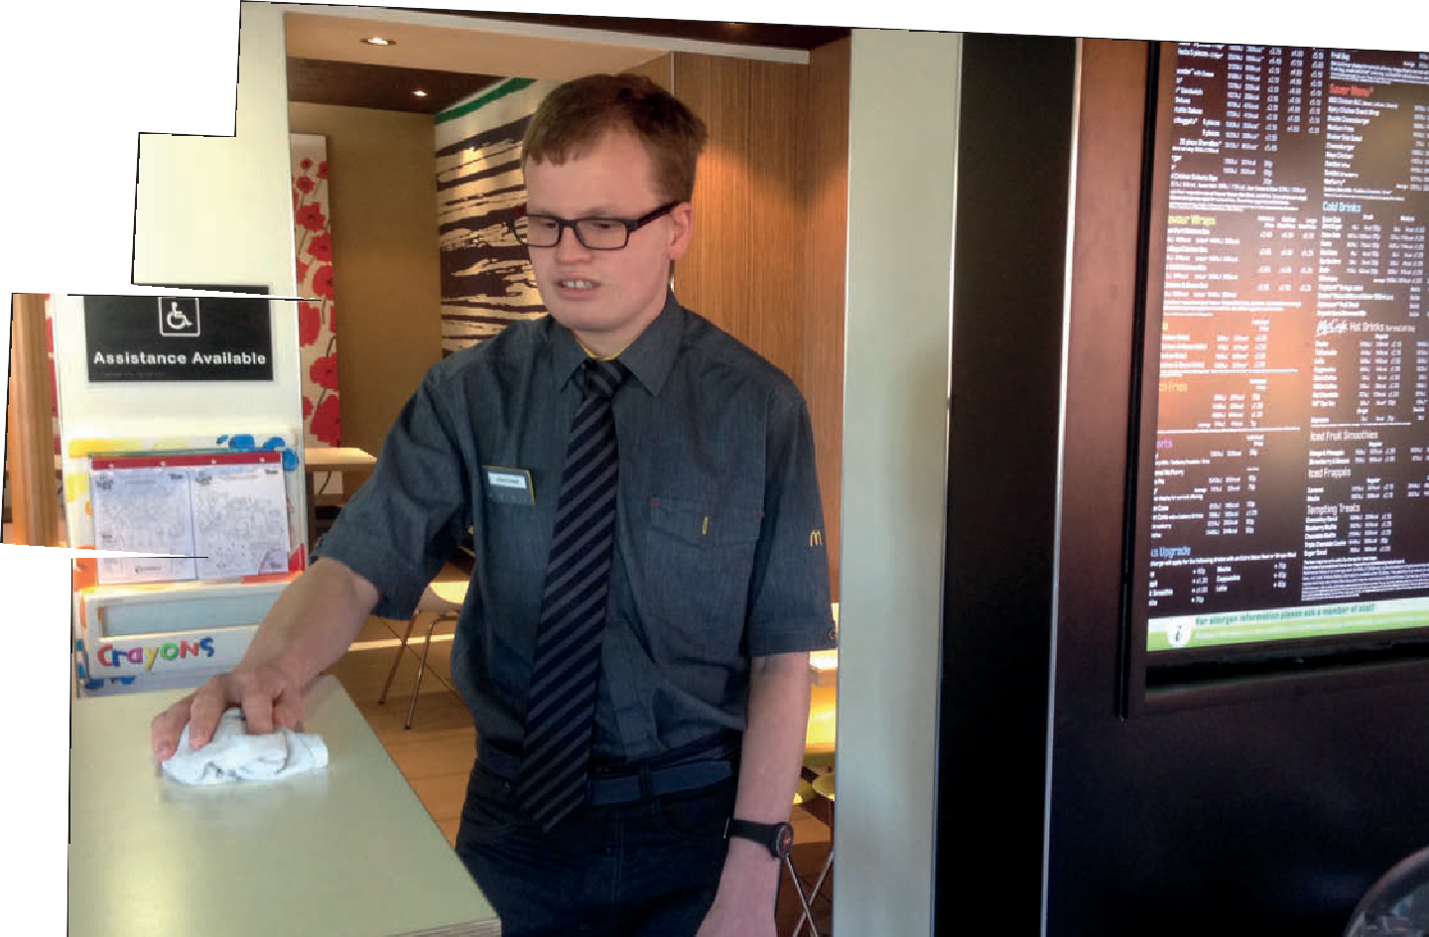

9

Together with Mike, lead coordinator at Mencap, I visited local shops to price up goods, studied local bus timetables and read menus in a café. We also followed the BBC Bitesize programmes on the laptop, which I really enjoyed. I worked really hard at this and am happy to say that I went up a whole level in both my English and maths Functional Skills exams.”
“I completed a placement at the League of Friends Café in John Radcliffe Hospital in Oxford, as part of the catering team. Here I worked with Mike on how to clean and clear the tables, load the dishwasher and butter the rolls. I also got much more confident with talking to customers and asking questions if I did not understand something.”
“I soon managed to get a paid job at Costa Coffee in Thame. I now work there two days per week for a total of eight hours, and Mencap have helped me to get another paid job at McDonald’s, so I am really pleased.”
“I feel that doing a supported internship programme has really helped me. It has been fun working with Mencap and it has helped me move on in my life.”

What the employers say
“It has been a very positive experience and having such a structured programme means that interns can quickly become a big asset to employers or voluntary agencies. I would recommend other employers to get involved.”

David Simpson – Manager, John Radcliffe Hospital, League of Friends Café

“You can see a real change in Jonathan now. He is more confident and much less worried about being asked to do new things – in fact we are now asking him to do a good deal more. He is great to have around!” Reece Eggleton – Assistant Manager, Costa Coffee

Family feedback
“I don’t think Jonathan has ever had anyone outside the family make such efforts to truly get to know him, push him along and develop him! We are truly amazed at your training scheme. He was told at his
previous school that no one with a learning disability went on to get a job. So our deep appreciation for that.”

Mary Lever, Jonthan’s mother

10

How you can help

We need your funding to run this programme
We are seeking local authorities who would like to include our Interns And Outcomes programme on their local offer and can commission Mencap as a training provider to deliver this programme. Alternatively, we would like to speak to colleges or training providers who may wish to team up with Mencap to deliver this programme.

Make a real difference
With your support, we can ensure more people with a learning disability go on to achieve paid employment that lasts, and see us move closer towards our vision: a world where people with a learning disability are valued equally, listened to and included.

11

Taking the next step
If you would like to find out more about our Interns And Outcomes programme, visit our website or get in touch: mencap.org.uk/internships Mark.capper@mencap.org.uk 07984391613

