Sutton’s Future
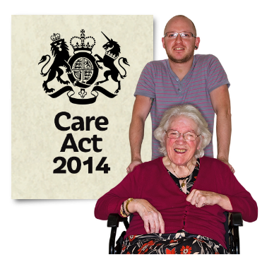

The Care Act 2014
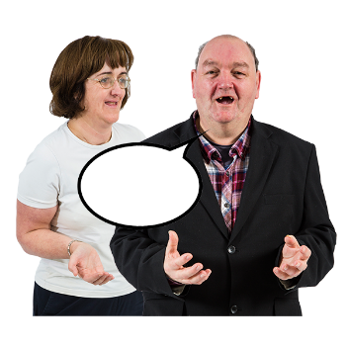
Care and Support

Public Consultation
Closing Date – 21 February 2016

Tell us what you think
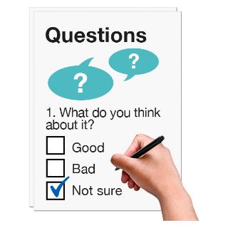

These notes will help you with the questionnaire

www.sutton.gov.uk/suttonsfuture
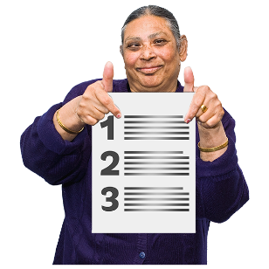
What is in this booklet
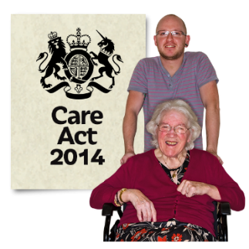

Sutton’s future – our consultation about the Care Act 2014 Care and Support……………………Page 3
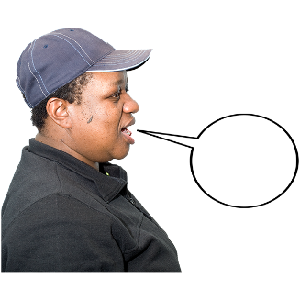

The Care Act 2014 – Have Your Say
Why we are consulting…………………………Page 5

What we are consulting about………………...Page 6
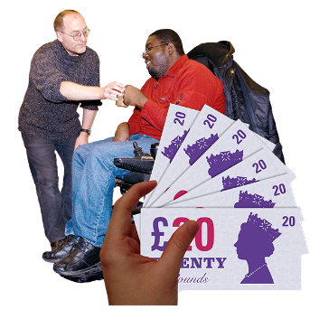

Charging for Adult Social Care……………….Page 8

Who the changes will affect…………………..Page 9
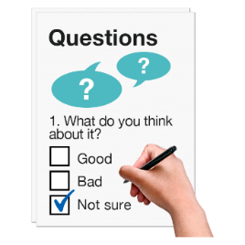

Notes to help you with the questionnaire..Pages 10-25
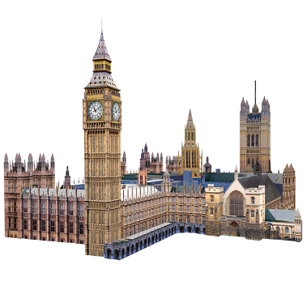
Sutton’s Future – our consultation about the Care Act 2014 Care and Support

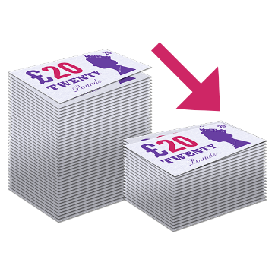
By 2019 Sutton Council must save £74 million from the money it spends every year. This is because we now get less money from the government.

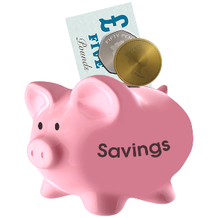
We have already managed to save £43 million, but we must save another £31 million.

It gets harder every year to find ways to save money. We now have to make some difficult decisions about whether to keep, reduce, or change services, or to stop them.

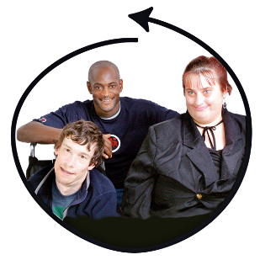
We need you to get more involved in looking after Sutton. With this consultation, Sutton’s Future, we want to talk to you about how we can do this together.
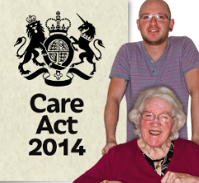
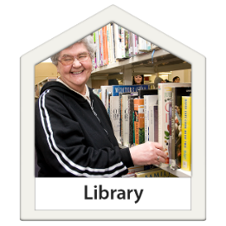
We are asking people what they think about several things including our libraries, children’ centres and youth services. We are also asking people what they think about the changes to adult social services brought in by the Care Act 2014.

You can find more information about Sutton’s Future and the different consultations here:
www.sutton.gov.uk/suttonsfuture

The Care Act 2014 - Have Your Say

Why we are consulting
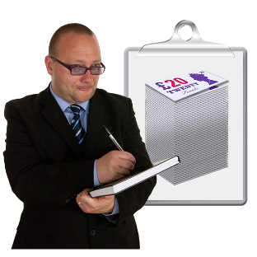
The new Care Act has made changes. It has brought in new ways that people can be assessed and supported to pay for adult social care and support.
The new law lets councils be more generous when deciding who has the right to adult social care. It also means councils can make decisions about some of the rules. And it has new services for carers and self- funders (people who can pay for their own care).
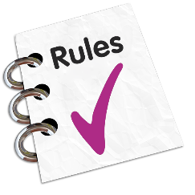
All new laws come with rules and advice from the Government. They say what councils must or can do to put the law in place. The changes could mean the Council spends more money, so it must decide if it should get back some or all of the costs, and how.
Sutton Council will follow all the rules and advice for the Care Act.
What we are consulting about

We want to know what you think about these questions:
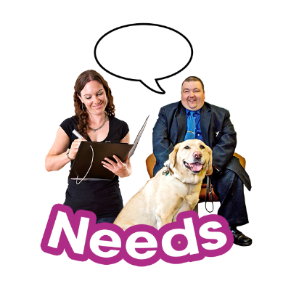
- Should Sutton Council be more generous than the law says it needs to be when deciding if a person has the right to services?
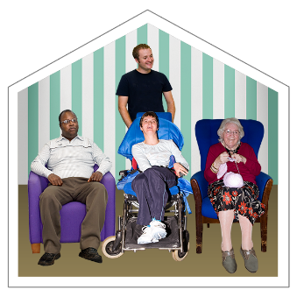

- Should Sutton Council keep charging people for residential and nursing care, working out how much money people have to pay using Government rules?

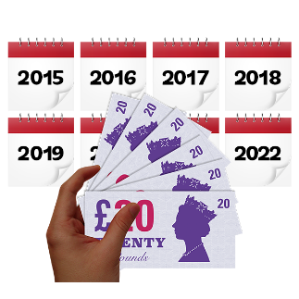
- When should Sutton Council give people a deferred payment? This is a loan of money that you do not have to pay back right away. How much should they pay for it?

- Should Sutton Council try to get back paperwork costs where the law allows it to do this?

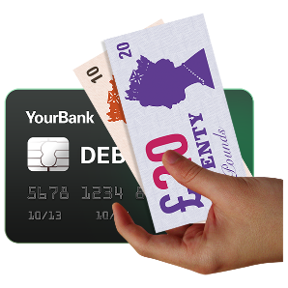
- Should Sutton Council use pre-payment cards as an extra way for people to get the money from their personal budget?

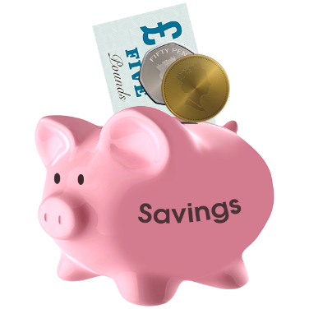

- Should Sutton Council increase the amount of savings people can keep before they must pay all the cost of any service they get at home?

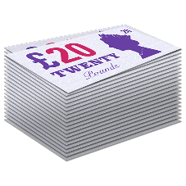
- Should Sutton Council have a maximum amount it asks people to pay for services they get at home?

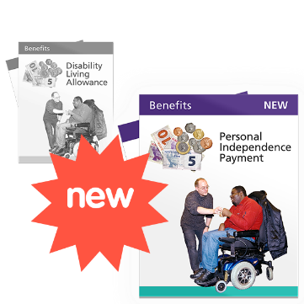
- How should Sutton Council treat Personal Independence Payments (PIP) when it works out how much money people have? PIP is the benefit that is replacing Disability Living Allowance (DLA).

Charging for Adult Social Care
The new law has changed the way we have been charging some people. And it also means some of the freedom Sutton Council used to have to make decisions has been taken away.
For example:
The Council now has to include war pensions, or war disablement pensions, when working out how much someone should pay towards their support.
For example:
The Council cannot now assess people who live with their husband or wife as a couple. It must assess each person alone.
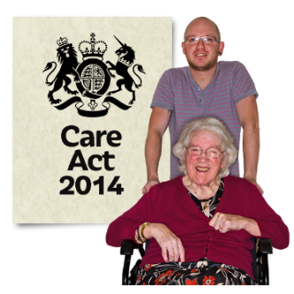
The reason for this consultation is not for the Council to get money from any new charges, but to cover the cost of the new law. The Council’s budget will not get bigger to cover these costs.
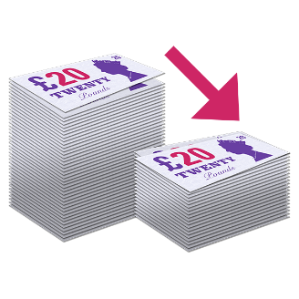
This means that if we do not ask people to pay for services when they have the money, there will be less money to pay for services for people who do not have the money to buy them.

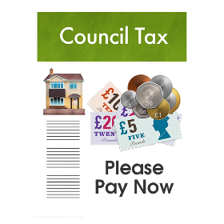
If the Council does not make the changes it suggests, it will have to pay the costs in other ways. This could mean changing, reducing or even stopping other services, or making Council Tax more expensive.

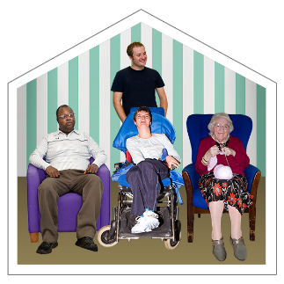
Who the changes will affect

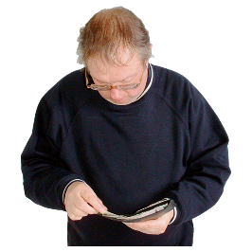
- People living in residential care or nursing homes.

- Self-funders (people who can pay for their own care).

- Carers.

- People who get social care services and are still living at home.
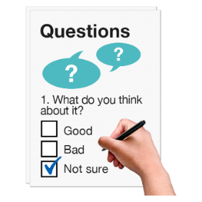
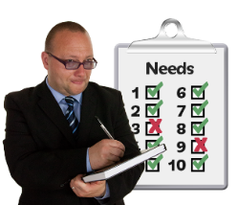
Notes to help you with the questionnaire

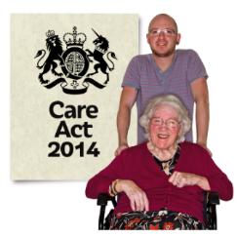
Question 2 – How to decide who has the right to services
Do you agree or disagree that Sutton Council is right to use the rules in the Care Act?
The old system:
2010

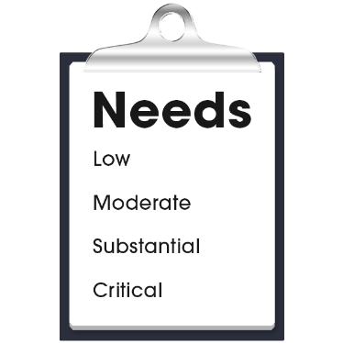
Before the Care Act the Fair Access to Care Services (FACS) was used. It had 4 levels:
- Low
- Moderate
- Substantial
- Critical
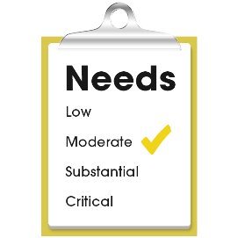
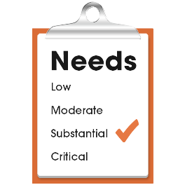
Councils could decide the lowest level people had to be on to have the right to services. This helped them control how many people they gave care and support to. And helped make sure they did not spend more money than they had. For Sutton the level was moderate high, between moderate and substantial.
The new system:
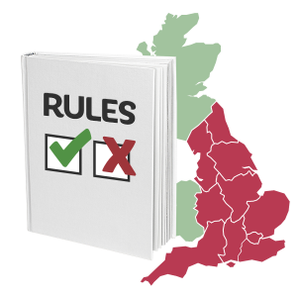
The Care Act has changed the way professionals decide what care and support people should have. There is a new set of rules for all councils in England.
2015
There is a 3 step test:
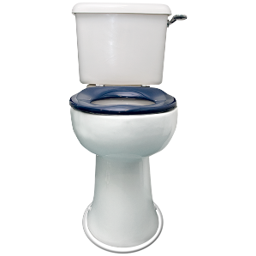
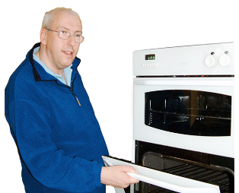
- To get services, a person must be unable to manage 2 out of 10 daily tasks. They include things like going to the toilet and living safely in their own home.
- The person cannot manage the tasks in Step 1 because they have a disability or they are ill.
- Not being able to manage the tasks in step 1 has a big effect on the person’s wellbeing.
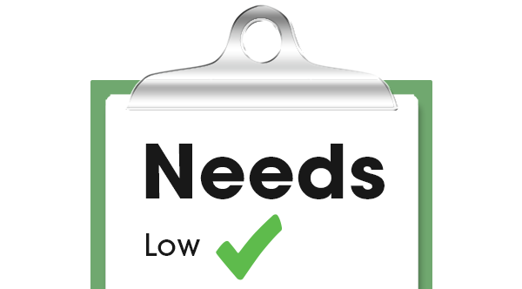
Councils can still choose to meet a lower level of need if they want to and have the money for it. This means the Council can be more generous than the law says it has to be.
But if the Council did do this, the cost would be so high that it would not be able to meet its duty to protect and support the people who need most help.
Old
New

The difference between the old system and the new system
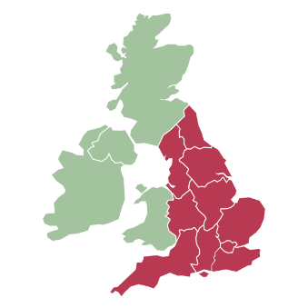
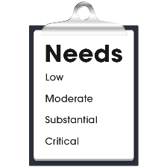
The old system let all councils in England choose which FACS level they wanted to use. This meant that people with the same level of needs were treated differently in different parts of the country.
The new rules try to make sure that people with care needs, and the right to help and support, get the same level of care wherever they choose to live.

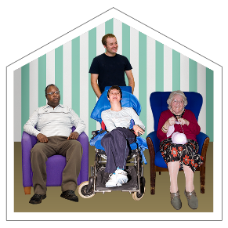
Question 3 – Charging for Residential and Nursing Care
Do you agree or disagree that people living in care homes should still be charged for their accommodation and support?

The old rules
2010
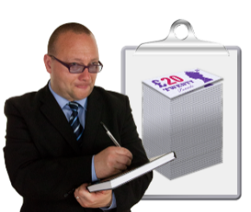
Since 1948 every council has had to charge people who live in care homes whatever they can afford to pay. Councils worked out how much each person should pay by using national rules.

The new rules
Since April 2015 councils can choose whether to charge people for living in care homes. They work out how much to charge in the same way as before.

The proposal
Sutton Council proposes to charge as it always has done. If the council does not carry on doing this, it will lose about £3.4 million. There would then be less money to pay for services that people need.
The council could think about getting the money in other ways, such as making Council Tax more expensive. But we do not think this is a good idea. Again, the council could choose not to collect the money, but then it could not afford services for all the people who we know need support.

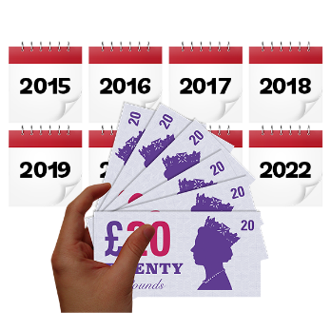
Question 4 – Deferred Payments
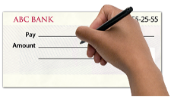
Do you agree or disagree that the Council should use the interest rate decided by the Government when setting up Deferred Payment agreements?

What are Deferred Payments?

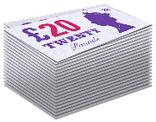
A Deferred Payment allows someone to keep their main possession. This is usually a property like a house or flat. They then get some help to pay their care fees during their lifetime, or until the property is sold.

People can only ask for a Deferred Payment if they:
- Have the right to social care services
and
- Are moving to a residential care home long term.

The Council helps pay the care home fees. It then gets the money back when the property is sold. This is either when the person chooses to sell their home or after they have died.
The old rules
2010
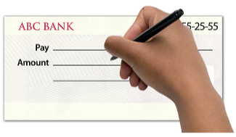
Deferred Payments have been used since 2003. Interest was added 56 days after the Deferred Payment had ended. Interest is the money you pay for a loan.

The new rules

The new system is different. Interest now starts from the date of the agreement. The maximum interest rate is set twice a year by government. Councils can choose to be more generous and charge a lower interest rate.
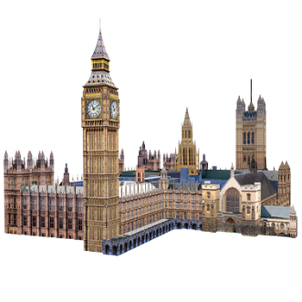
The interest rate set by the Government in July 2015 was 2.25 per cent. This means £2.25 in every £100.

Question 5 – Extending the use of Deferred Payment agreements

Do you agree or disagree that the Council should use Deferred Payments with people who need support but do not live in care homes?

The Care Act lets councils make more use of Deferred Payments if they want to. This is to help people moving into places that are not care homes. These places could be:
- Extra care housing
- Supported housing
- Shared lives scheme (where a person lives with a family who gives them care and support).
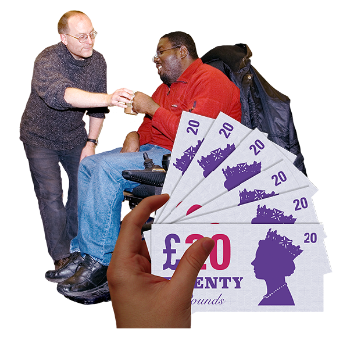
This will make sure that people who need to live in these kinds of places, but who own their own homes and have little or no savings, can borrow the money to pay their rent and get the extra care and support they need.
Question 6 – Deferred Payment Debt Security
Do you agree or disagree that the Council is right to protect itself from the risk of losing money on Deferred Payments?

The council must approve a Deferred Payment request when it can get a ‘First Charge with Land Registry’. A First Charge is like a mortgage, which is for when you borrow money to buy a house. It means that when the property is sold the Council will be first to get any money that is owed to it from the sale of the house.
The Council can choose not to do this. But it would then risk not getting all its money back at the end of the agreement. This is why it prefers only to have Deferred Payment Agreements where it can get a ‘First Charge with Land Registry’.

Question 7 – Interest Rates (what you pay for a loan)

Do you agree or disagree that the Council should use the national rate, and charge the same as other councils?
The Care Act gives councils an interest rate for Deferred Payment Agreements that is the same everywhere in the country. But the Care Act also allows councils to decide a lower rate.
The Care Act rate is lower than people would usually get from a bank, so is good value for the customer.

If the Council chooses to use a lower interest rate, it could mean the scheme costs money. This means there would then be less money to help the people who need the most care and support.

Question 8 – Paperwork Costs

Do you agree or disagree that where possible the Council should get back the money it spends on contracts for self-funding clients?
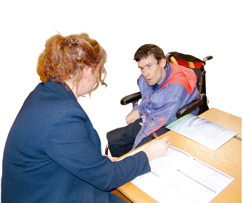
The Care Act lets councils get back the money it spends on arranging contracts for self-funding clients. For example: the Council can charge for the costs of arranging services that are not taken in a care home. It can also charge clients for the paperwork costs of Deferred Payments.

The Council is not allowed to make a profit from running these services but should try to get back its costs. If the Council chooses not to do this, it would need to find extra money from somewhere else. This would mean it had less money to spend on services that people need.

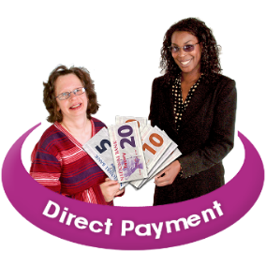
Question 9 – Direct Payments
Do you agree or disagree that it is a good idea for the Council to give people a choice of how they get Direct Payments?
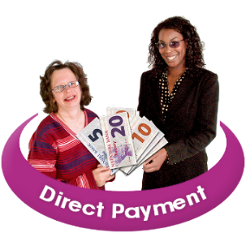
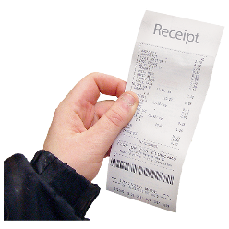
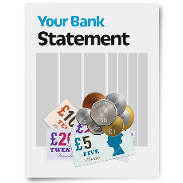
The Council gives Direct Payments to people who want to arrange and pay for their own care, instead of the council providing them with services. People who get Direct Payments must show the council how they spend the money. Every few months they send copies of bank statements and receipts to the Council, so the Direct Payment can be checked. This takes up a lot of Council time. Having to keep records and receipts can also be hard for Direct Payment users.
The Council is thinking of having pre-payment cards. With this system a person’s direct payment is loaded onto their own personal card. The card can be used like a bank card, but the money on it still belongs to the Council. The Council can see how the money is spent, and the card user does not need to keep records and receipts. This would be much easier for the Council and its clients.

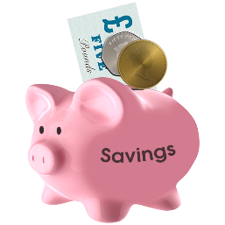
Question 10 – Capital Limits Increase (savings and property a person can have before they must pay for care services)

Do you agree or disagree that the Council should keep to the limits that are set for the whole country?
The Care Act lets councils decide whether to increase the amount of savings or property people can have before they must pay for their support costs.
At the moment people pay the cost of their care if they have savings and property worth more than £23,250. This amount is the same across the country, but councils can be more generous.

If the Council is more generous, it will help people who have more money, but not people on limited budgets and who get benefits.

Question 11 – Setting a maximum weekly charge

Do you agree or disagree that it is still fair for the Council not to have a maximum weekly charge for services given outside a care home?
In 2010, the Council asked people whether there should be a maximum weekly charge for people who get services but who do not live in a care home. People thought having a maximum amount that people should pay was not fair. The only people who would be better off under this system are the ones who have more money.

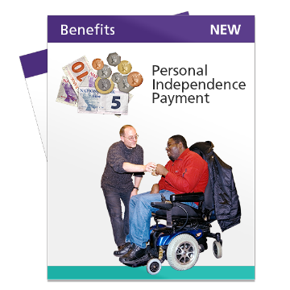
Question 12 – Treatment of Personal Independence Payments (PIP) when working out how much money people should pay for services

Do you agree or disagree that the Council should treat PIP the same as it did the Disability Living Allowance (DLA) when charging for services?

The Government is changing the way it helps people with disabilities pay for the extra costs they have due to their disability. PIP is replacing DLA.
Under DLA the Council has always said that the middle level (covering day or night only) was for day time services. And the higher level (day and night care) was for 24 hour care. The Council did not take into account the difference between levels unless the person had the right to 24 hour care and support. Then it used the higher rate without reducing it.

The new scheme is different. It still has 2 parts to it, Care and Mobility, but treats day and night care the same. This will make sure no one loses out.
This page is for your notes.

This page is for your notes.

This page is for your notes.
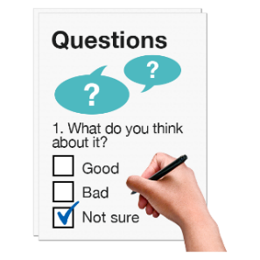
Please fill in the questionnaire and put it in an envelope.
Send it back to us by 21 February 2016 using our Freepost address below. You do not need a stamp.

Care Act, third floor
London Borough of Sutton
FREEPOST CN2117
Civic Offices
St Nicholas Way
Sutton
SM1 1BR

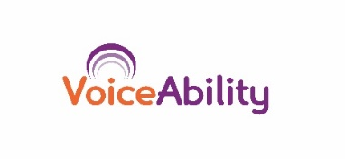
Easy Read by:

