EDUCATION BULLETIN
Guidance

- BACKGROUND

We want to improve the way we communicate with schools, colleges and other educational providers in the Borough. As a result we are introducing an Education Bulletin to improve communications between the Local Authority/Local Area and Schools.

The bulletin will be sent from the Assistant Director for Education and SEND but the articles that will be included in the bulletin will need to come from a variety of different sources from across the ‘local area’. It is intended that the bulletin will become the principle route for sharing information on education related matters including the progress we are making on our Local Area Written Statement of Action with the schools community in Sutton.

This document provides some background information / FAQ to the bulletin and how we anticipate collecting articles / updates and what we expect the bulletin to include as well as the process for submitting items.

- DOES THE BULLETIN REPLACE EXISTING COMMUNICATIONS CHANNELS WITH THE EXISTING SCHOOLS COMMUNITY?

No. The bulletin does not replace day to day communications with schools, nor should anyone have to wait for the bulletin to be published if the communication is time sensitive - the bulletin will in many ways act as a ‘summary’ of preceding or forthcoming communications to schools for the term. It may also act as a useful prompt for schools to refer to previous communications.

- WHO WILL THE BULLETIN GO TO?

The principle audience for the bulletin is schools and colleges in the London Borough of Sutton but also for Local Area Partners themselves to keep in touch with education issues including the Written Statement of Action.

We will send out the bulletins to Headteachers, Governors, SENCOs and College representatives but also Local Area partners including the Sutton CCG, Sutton Parent Carers Forum and other interested parties. There will be an opportunity for colleagues to subscribe or unsubscribe from the bulletins automatically.

- WHO CAN/SHOULD SUBMIT ITEMS FOR THE BULLETIN?

Articles/updates may be submitted from any source within the 'Local Area' including schools themselves:

- Staff across LBS Education in LBS or Cognus Ltd
- Staff in LBS Childrens / Adults Services / Public Health
- Staff from Sutton CCG
- Head Teachers / Governors
- Special Education Needs Coordinators
- Sutton Parent Carers Forum

- WHAT INFORMATION SHOULD BE INCLUDED IN THE BULLETIN?

Items for the bulletin could be information items or updates, consultations, good news stories, reminders, updated policies or practices. We are not setting specific constraints for what should and shouldn’t be included in the bulletin, however below is a general guide that items should comply with. Before submitting an article/update please ensure the guidance below is carefully considered to make sure the information is appropriate for the bulletin:

A bulletin…

- Should be relevant and of interest to schools, colleges or other educational providers in the Borough as the principle audience - however information need not be exclusively ‘educational’ in nature - e.g. social care and health updates that are relevant to schools are just as important
- Can come from any Local Area Partner not just the Local Authority/Cognus/CCG
- Should be relevant to all or a significant group of schools rather than a single school
- Should not duplicate information already sent to schools via an alternative channel - e.g. ESFA bulletins, DfE updates, unless there is a clear and stated reason to do so
- Does not replace normal ‘day to day’ communications with schools - but it can be used as a reminder / round up of issues arising in that particular term.
- Should be of sufficient importance to include in the bulletin - this is a judgement and something that can be reviewed over time depending on the nature of the updates that are provided

We will generally publish the updates/articles we receive but reserve the right to withhold articles should they not meet the criteria above.

- HOW DO I SUBMIT AN ITEM?

We have set up a dedicated inbox for anyone wishing to submit an update for the bulletin. educationbulletin@sutton.gov.uk. We have very limited capacity to edit copy therefore it is essential that the information is provided in a consistent format. Please follow the steps below when submitting a bulletin:

- Review the criteria above to check if your bulletin item is appropriate
- Copy and paste the following fields into your email and then fill out the information under each heading:

- Title of the bulletin item (single sentence) - REQUIRED
- Contact name and contact details (email or telephone) that will be provided alongside the bulletin update for any reader that might want further information (PREFERRED BUT NOT REQUIRED)
- Organisation and Team or Service (REQUIRED)
- Summary text of the update - please submit no more than 300 words - less is usually more - your text will generally not be edited or summarised for you and will appear as written - please use hyperlinks to further information or attachments where possible. You can submit images where necessary but we cannot always guarantee that these will be used. (REQUIRED)

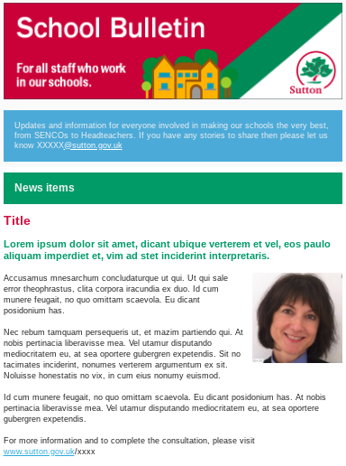
Bulletin items not following the above format will not be included

WHAT IS THE FORMAT OF THE BULLETIN?

The bulletin will be an email newsletter. It will have an introduction from the AD Education or Local Area Partner, a table of contents with the updates following in order underneath. It will look similar to the image provided but called Education Bulletin. Hyperlinks to websites can be used as well as attachments linked in the text.

HOW FREQUENTLY WILL BULLETINS BE PUBLISHED?
Bulletins will be issued on a twice termly basis assuming that there is sufficient information in each on the following yearly cycle. We may run additional bulletins on a more regular basis if there is a need to do so (e.g. bulletins become too big or information can’t wait).

2018
September (First Edition already Issued)
30 November - cut off date 23 November

2019
25 January - cut off date 18th January
25 February - cut off date 15 February
29 March - cut off date 22 March
24 May - cut off date 17 May
19 July - cut off date 12 July
27 September - cut off date 20 September
29 November - cut off date 22 November

2020
24 January - cut off date 17 January
20 March - cut off date 13 March
22 May - cut off date 15th May
17th July - cut off date 10th July

Contributors can submit an item to educationbulletin@sutton.gov.uk for the bulletin at any time however the ‘cut off’ dates are given above. E.g. any item submitted after the cut off date will go out in the following bulletin. As stated above, the bulletins are not about replacing other forms of communication - rather they are about trying to bring communications into one place and therefore could just as easily act as 'reminders' to previous communications already communicated via other channels.

Reminders will be sent out to potential contributors on a regular basis

I HAVE A QUESTION - WHO CAN I ASK?
Please contact educationbulletin@sutton.gov.uk if you have any questions

