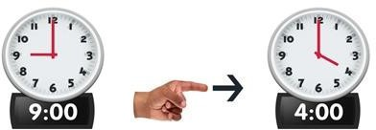
Year One

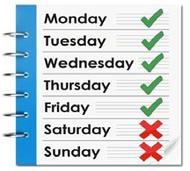
The Autism Project year one is full time; students attend Monday to Friday, 36 weeks a year.

The aim of the course is to get students ‘work ready’.

Students spend approx. 4 days a week in the workplace and complete up to 3 work experience placements during the academic year.

Students spend a day in class where they study towards a City & Guilds Employability Skills qualification and Functional Skills (if required).

Placements are typically based in Guy’s & St. Thomas’ hospitals, or the Whittington hospital. Placements can be in various departments.

Students also have the opportunity to attend social events

Year Two

Once students are ‘work ready’, they can move onto year two of TAP.
This can take up to three terms, but students can also ‘fast-track’ after one or two terms.

Students attend 3-5 days a week, Monday-Friday.

Students attend a work experience or volunteering placement 2-3 days a week. This does not have to be in the hospital.

Students continue to spend a day in class where they study towards a City & Guilds Employability Skills qualification and Functional Skills (if required).

Students have the opportunity to attend practice interviews with real employers or professionals.

Once a week, students have a job search session. Staff help students to create a CV, and to search and apply for jobs.

To apply for The Autism Project you must:
Be aged 18-25

Have an Autism Spectrum Condition

Have an EHCP

Have a desire to find paid work

Be able to study at a minimum of Entry Level 1

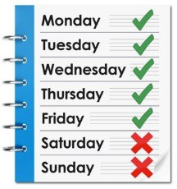
Be available Monday-Friday 9.30-4.30pm (in term-times)

Be able to travel independently to and from the course (or be in the process of travel training when starting the course)

For more information or an application form please contact Jemma Dear jemma.dear@caretradeuk.org TAP Manager

www.care-trade.org

@CareTradeUK CareTrade

