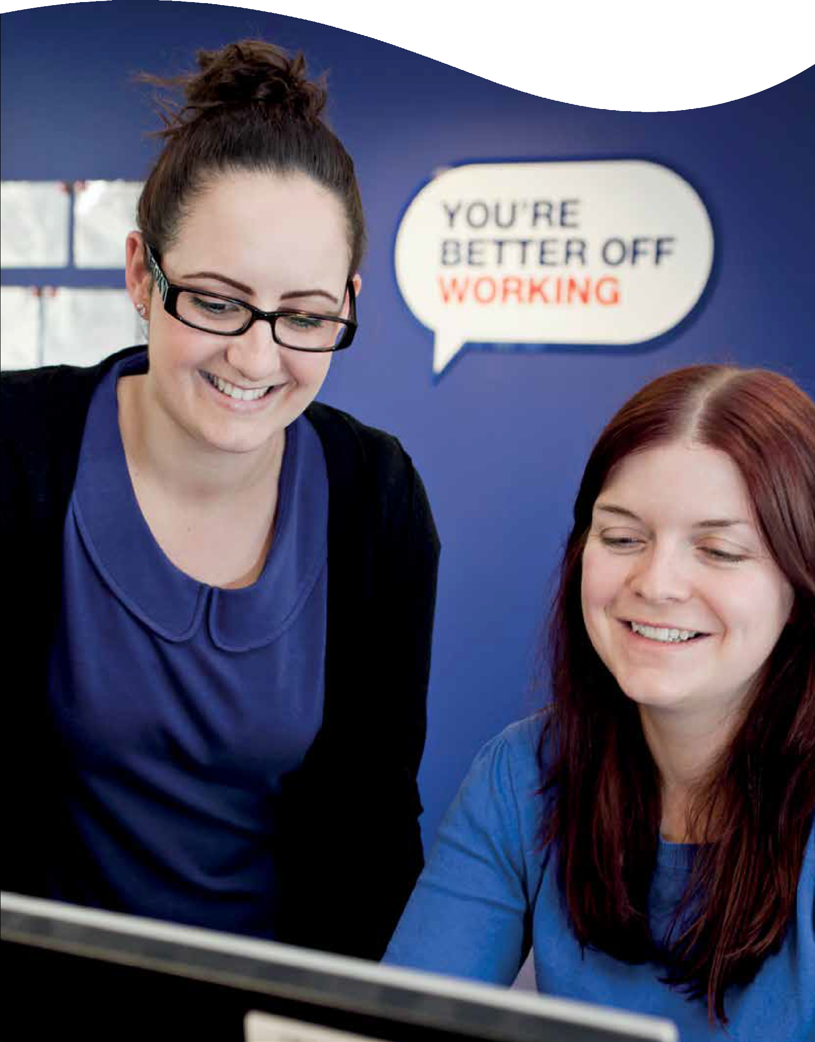Service overview

Every 15 minutes we help someone to start working

Better Working Futures
is our name for the Work and Health Programme.
The programme gives people who face additional barriers to starting work the best support available. We provide holistic and targeted support to people with health conditions and those who are long-term unemployed.

Partnership working is key to supporting Better Working Futures participants into work.

Who we are helping
Participants have been identified by their Jobcentre Plus Work Coach as needing more intensive support to overcome their barriers to employment.

For the majority of participants these barriers will be a disability or health condition.

Our participants fall into the following three categories:

- People with a disability or health condition

- Early Access Disadvantaged Groups

Groups include: carers; ex-carers; homeless; former Armed Forces or member of Armed Forces Reserves; partner of current/former Armed Forces personnel; person with a drug/alcohol dependency; care leavers; refugees; young people in gangs; ex-offenders; and victims of domestic violence.

- People who have been unemployed for 24 months or longer

“The support was
inspirational. And without it I would never have come out of my shell to succeed in a
career.” Sue

Better Working Futures

What we do

Participants will receive personal support from designated Employment Advisers who have caseloads of no more than 45 people and additional time for people with complex needs.

A personally developed action plan

Minimum fortnightly 1-2-1 meetings and reviews

A comprehensive Better Off Calculation
Health and wellbeing support

Access to local service partners
Funding support for travel, childcare and work/interview clothing.

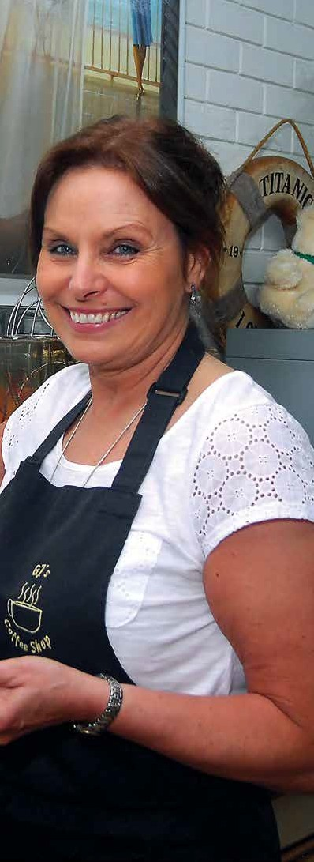

BWFsouthlondon.co.uk

Seven key areas of support

Mindset

We offer a range of courses to help participants get motivated and start thinking positively about employment and their own abilities. We’ll help participants to improve their confidence and increase their readiness to work.

Employability

We support participants to develop the practical skills they need to search and apply for work with a number of courses and workshops including:

- CVs and Application Forms
- Job Searching
- Interview Skills
- Self-Employment

Skills and Qualifications

We help participants to develop their skills and gain the qualifications required to meet local employer needs with a range of free courses, including:

- Identifying Transferable Skills
- Sector Taster and Sector Specific courses
- Accredited Training courses

Better Working Futures

Personal Circumstances

We have extensive experience of supporting people facing challenging and often stressful personal situations, including:

- Housing issues
- Caring responsibilities
  - Previous convictions
  - Financial issues

Participants have access to free and confidential advice and advocacy to help remove potential barriers to employment. They will also benefit from our partnerships with key local support services.

Health and disability

The support offered by Better Working Futures has been developed in partnership with Disability Rights, the leading UK charity run by and for people with lived experience of disability or health conditions.

Our qualified Health Professionals will offer support and advice to those with a disability or health condition. This includes developing a plan to address and manage health barriers to work, utilising our links with local community health and wellbeing organisations, including GPs, NHS Trusts and CCGs.
Health 2 Employment will be providing specialist health assessments for participants with an identified complex health need. This assessment will be conducted by a nurse by telephone. They will provide a personalised report with analysis of the physical and mental health of the participant, agreed strategies for how to manage the condition and medication management. This approach has been proven to improve job outcomes for participants with health conditions.

“All I ever asked for was a chance. Stepping into that Reed in Partnership office was life-changing.”
Shak

BWFsouthlondon.co.uk

Employment Options

Working in partnership with the Reed Recruitment Group we have links and accounts with thousands of employers in your area. We use these links to develop exclusive opportunities for Better Working Futures participants.
We work with employers of all sizes to source vacancies and work placements in a range of sectors. We also work with smaller employers to develop their understanding of health conditions, and make reasonable adjustments.

Specialist Self-Employment Advisers are also available to support participants to identify business opportunities. A range of training courses help equip participants with the skills they need to make a success of their own business.

In-work Support

Participants entering employment (or starting self-employment) agree in-work support and identify risks with their Adviser. An In-Work Plan is created with support arranged around needs and working hours.

A Progression Review is offered to help increase salary, hours or review trading for self-employed participants.

Support for employers is continued with advice, signposting to training and workplace support for reasonable adjustments.

“I suffer a bit from anxiety, and I’m dyslexic - my Adviser has been really supportive, helping me with my CV, filling in lots of forms and pushing me in the right direction. I’m extremely proud
that I came.” Kate

Better Working Futures

Working in partnership

Partnership working is key to supporting Better Working Futures participants into work. By ensuring that wider barriers to employment are tackled, individuals have a better chance of starting and sustaining employment.

Our programme includes linking up with health, social care and other services to meet health needs if they are a barrier to work.

We work with a range of local partners whose specialist provision enhances our programme, including:

- NHS Services
- Local Authority Services, i.e. Community Mental Health Teams, Drug and Alcohol Teams
- Voluntary Sector Services, i.e. refugee provision, domestic violence support
- Housing Associations

As a mother of four, Parvin hadn’t worked while she
raised her children. When she was ready, we helped her create a plan to set up her own business based on the
skills she had.

BWFsouthlondon.co.uk

Contact us
For more information about working with Better Working Futures,
visit BWFsouthlondon.co.uk

