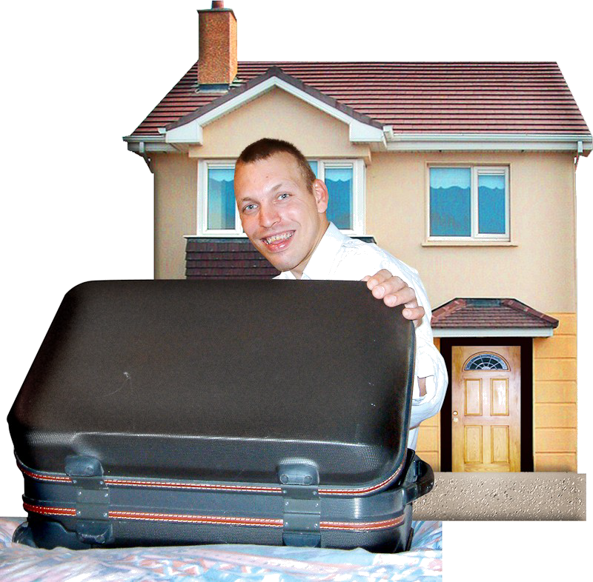

Housing for people with learning disabilities

What is in this booklet?

Chapter | Page
About this booklet | 3
Renting | 4
Renting from a social landlord | 5
Renting from a private landlord | 7
Buying your own home | 9
Shared ownership | 10
Supported housing | 11
Staying in your family home | 13
Supported living | 14
The help you can get | 15
Your housing plan | 16
Who to contact next | 19
List of difficult words | 21

Who is this booklet for?
This booklet is for people with learning disabilities.

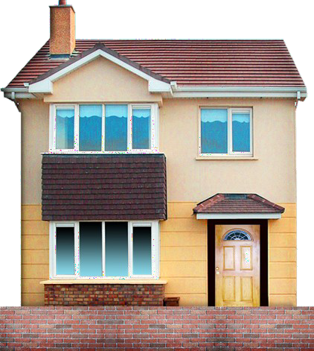
What is this booklet about?
This booklet is about the different types of housing you can live in.

What if I don’t understand something?
If you don’t understand something you can contact Sutton council.
You can find out how to contact Sutton council on page 19.
You can also ask your family and friends for help.

Difficult words are in blue text.

You can find out what the words in blue text
mean on page 21.

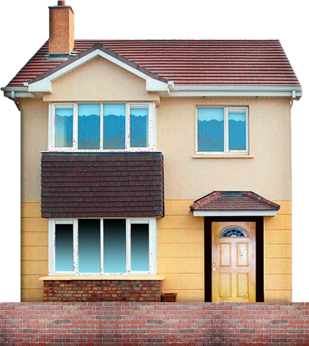
What is renting?
Renting is when you pay money to live in a house or flat owned by someone else.

You are called the tenant.

The person who owns the house or flat is called the landlord.

The landlord can be a social landlord or a
private landlord.

Page 5 explains what renting from a social landlord is like.

Page 7 explains what renting from a private landlord is like.

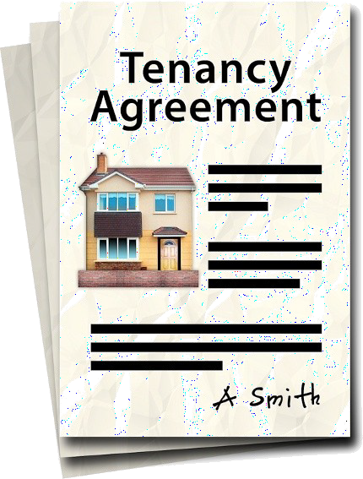
You sign a contract with the landlord.

This contract is called a tenancy agreement. It explains what rights you have.
This includes how long you can stay.

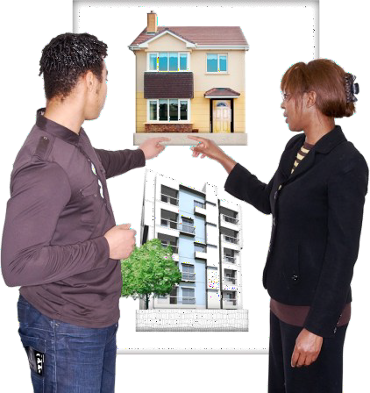
What is a social landlord?
A social landlord is an organisation that gives housing to people who need it most.

The rent is low so lots of people want to rent from social landlords.

You have to go on a waiting list.

This waiting list is called the housing register.

You need to fill in a form to go on the housing register.

When you are first on the waiting list you will be offered whatever housing the social landlord has that is good for you.

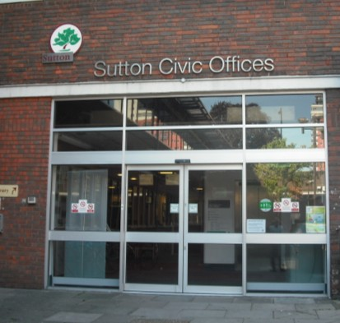
Sutton council is a social landlord.

You might have heard of housing associations. Housing associations are another type of social landlord.

How do I pay for it?
You may be able to get money from Sutton council to help pay the rent.

This money is called housing benefit.

Housing benefit may pay all of your rent or just some of it.

If housing benefit does not pay all of your rent then you will have to pay the difference.

What is good about renting from a social landlord
It is cheaper than renting from a private landlord
You can stay in the same house for as long as you want to

What is bad about renting from a social landlord
You may have to wait a long time for housing
You can not choose where you live

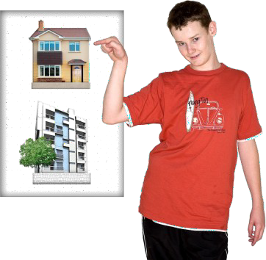
What is a private landlord?
A private landlord is a person who makes money by renting housing to people.

The rent is higher than social landlords charge but it is easier to find a private landlord.

You also have more choice about where you live.

How do I pay for it?

The same way you pay rent to a social landlord.

You can get housing benefit.

If housing benefit doesn’t pay all of your rent then you will have to pay the difference.

What is good about renting from a private landlord?
You do not have to wait long for housing You can choose where you want to live

What is bad about renting from a private landlord?
It is more expensive than renting from a social landlord
You can be asked to leave once your contract has finished

What is buying your own home?
Buying is when you pay for a house or flat and own it.

How do I pay for it?
Buying a house or flat can be expensive.
You would have to borrow the money from a bank.
You then pay a bit of this money back each month for many years.
This payment is called a mortgage.
You may be able to get benefits to help you pay the mortgage.
Your family may also be able to help you with money.

What is good about buying?
You own the house or flat
You can choose where you live

What is bad about buying?
You have to pay to keep the property in good repair

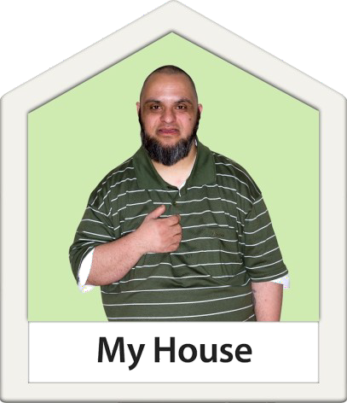
What is shared ownership? Shared ownership is a mix of renting and buying.

You buy part of a house or flat from a housing association.

You pay the housing association rent for the other part.

How do I pay for it?
You would have to get a mortgage to buy part of the house or flat.

You may be able to get housing benefit to pay some or all of the rent for the other part.

Your family may also be able to help you with money.

What is good about shared ownership?
You do not need a big mortgage
You can choose where you live

What is bad about shared ownership?
You may not want a mortgage

What is supported housing?
Supported housing is when you live near other people with learning disabilities.

Sometimes this will be in groups of flats.

Sometimes this will be in a house where you share a bathroom and kitchen with other people.

There is someone who lives nearby if you need help.

How do I pay for it?
You have to pay rent to live in supported housing.

You may be able to get housing benefit to pay all of your rent or just some of it.

If housing benefit does not pay all of your rent then you will have to pay the difference.

What is good about supported housing?
You have someone nearby if you need
help.
You live near other people with learning disabilities

What is bad about supported housing?
You may not want to live with other people
There is not a lot of supported housing in Sutton so you may not be able to live where you want

What is staying in your family home?
If you live with your family then you may want to stay in your family home.

If your family own their home they may be able to pass it on to you.

This means you would own the house or flat.

How do I pay for it?
If you buy the house or flat from your family you would pay a mortgage.

You may be able to get benefits to help you pay the mortgage.

Your family may also be able to help you with money.

What is good about staying in your family home?
You can stay where you are

What is bad about staying in your family home?
You may want a change

What is supported living?
Supported living is when you get help from the council to help you live in your own home.

This could be help to clean your home. Help to do your shopping.
Help to find a job.

How do I pay for it?
Sutton council may pay for the help.

What is good about supported living?
You can live in your own home

Help from Sutton Council
You can get help from Sutton council’s
learning disabilities team.

This team can help you to decide what type of housing and support you need to live as independently as possible.

You can also get help from Sutton council’s
housing centre.

This team can help you to decide what housing option is best for you.

You can find out how to contact both teams on page 19.

Help from your family and friends
You can also get help from your family and friends.

This is your housing plan.

It will help you decide what type of housing is best for you.

Your family, friends or support worker can help you with this plan.

Your current housing

Where do you live?

Who do you live with?

What is good about where you live?

What is bad about where you live?

Tick your answer

Do you want to live with other people?

Your money

Do you work?

Do you get any benefits?

What benefits do you get?

Yes No

Yes No

Yes No

Tick the housing options you want to know more about

Renting
Renting from a social landlord
Renting from a private landlord
Buying
Shared Ownership
Supported Housing

Who to contact next

Now you know what housing options you are interested in, you can contact Sutton council to find out more.

You can contact the learning disabilities team.

Sutton council learning disabilities team

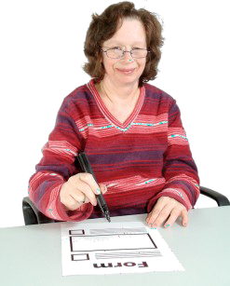
Write to them

Civic Offices
St Nicholas Way Sutton
SM1 1EA

Phone them

020 8770 6080

Email them

learningdisabilities@sutton.gov.uk You can also contact the housing centre.

Sutton council housing centre

Write to them

Civic Offices
St Nicholas Way Sutton
SM1 1EA

More about who to contact next

Sutton council housing centre

Phone them

020 8770 6080

Email them

housing.centre@sutton.gov.uk

You can also contact Mencap.

Mencap is a charity that helps people with learning disabilities.

Mencap learning disability helpline

Write to them

4 Swan Court Yard Coventry Road Birmingham
B26 1BU

Phone them

080 8808 1111

Email them

help@mencap.org.uk

List of difficult words

Word | Meaning
Contract | A legal agreement between two or more people.
Housing association | A type of social landlord.
Housing benefit | Money from Sutton council to pay for rent.
Housing register | A waiting list to rent from social landlords.
Landlord | A person that owns a house for someone else to live in.
Mortgage | Money from a bank to buy a house.
Private landlord | A person who makes money from renting houses to people.
Social landlord | An organisation that gives housing to people who need it most.
Tenancy agreement | A contract between a tenant and landlord.
Tenant | A person that pays to live in a house owned by someone else.

Housing for people with learning disabilities

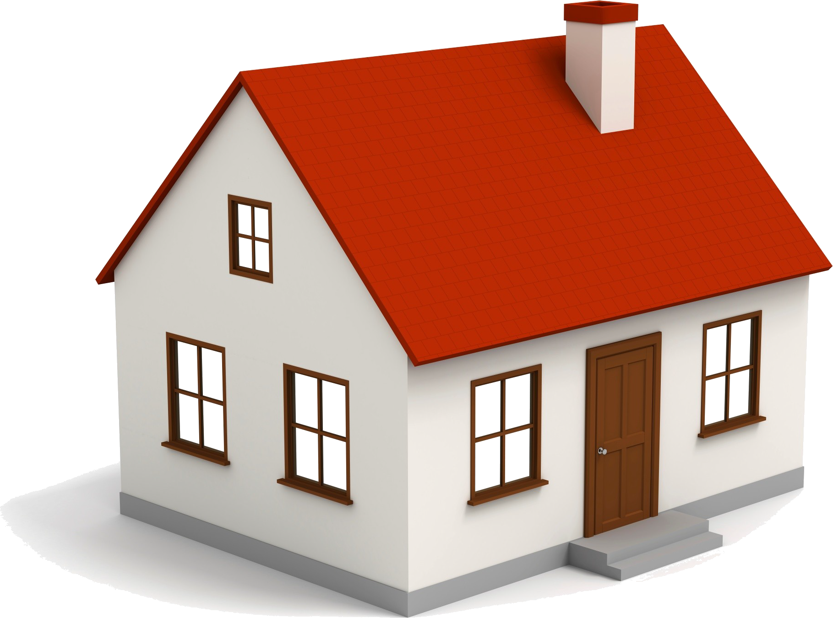

This booklet was written by Sutton council.

This booklet is for people with learning disabilities.

It explains the different types of housing you can live in.

22

