Banking made clearer
Quick reference guide

Contents

- How do I pay money into my account?
- How do I get money out from the bank?
- How do I get money from a cash machine?
- How to cash a cheque?
- How do I get cashback from shops?
- How to make contactless payments on your debit card?
- How do I set up a Direct Debit or Standing Order?
- How do I change my PIN using the cash machine?
- How do I get a mini statement from the cash machine?

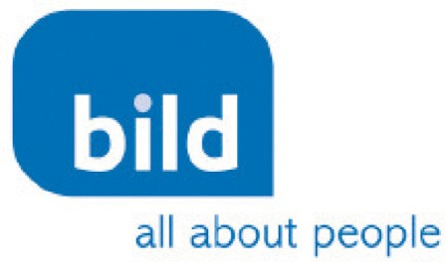
Barclays has developed this resource in partnership with the British Institute of Learning Disabilities. To learn more about the work of the British Institute of Learning Disabilities go to www.bild.org.uk

How do I pay money into my account?

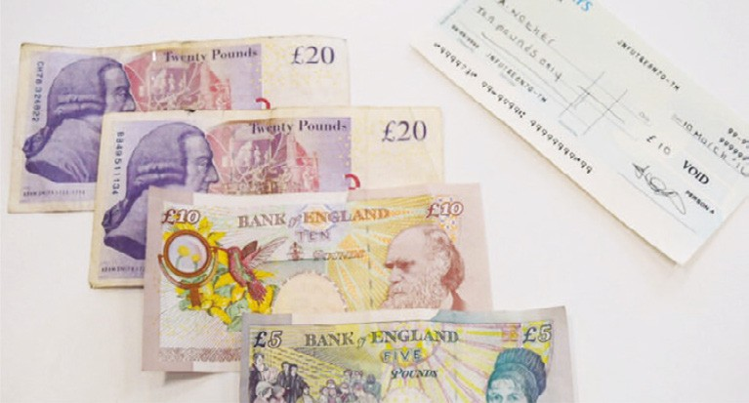
You can pay cash or cheques into your bank account.

To do this you will need to visit the bank and go to the counter.

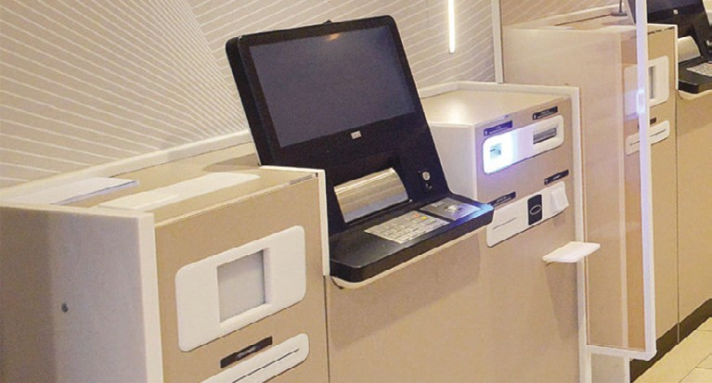
Some branches will have an Assisted Service Counter for you to use.

You can ask a friend, family member or bank staff to help you use the Assisted Service Counter.

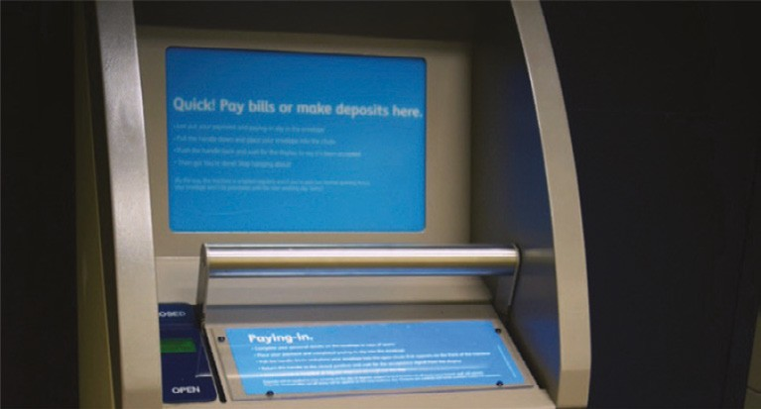
Some branches will have a Quick Pay Point you can use.

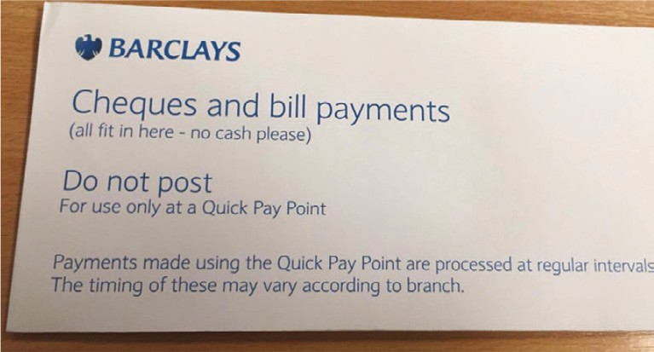
You will need a special envelope to use this.

You can ask a friend, family or member of bank staff to help you use the Quick Pay Point.

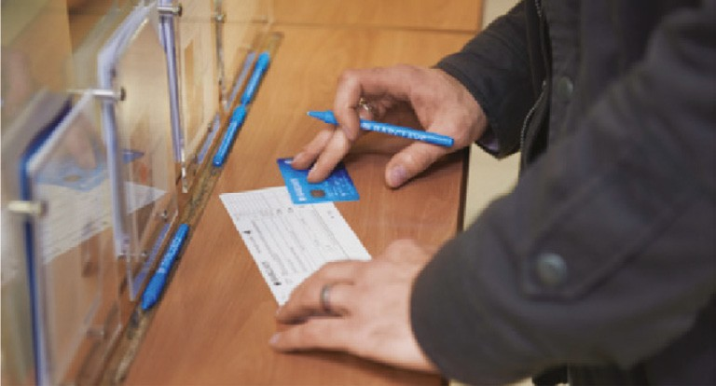
You will need to take the cash or cheques that you want to pay into your account.

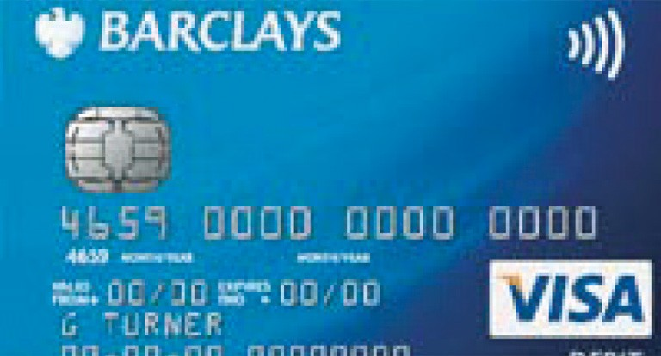
You will also need your debit card.

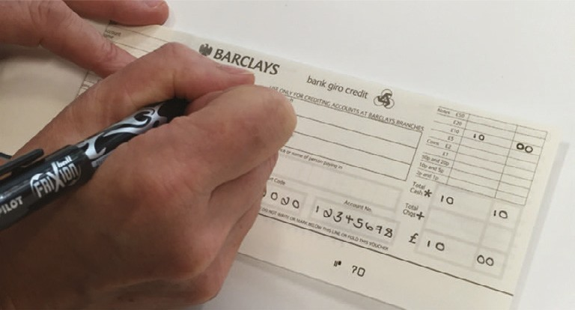
You can also use a paying-in book.
A paying-in book is a set of paying in slips (special forms) to fill in when paying money into your bank account.
Paying-in slips are not used a lot now.
You can ask a friend, family member of bank staff to help you complete the paying-in slip.

How do I get money out from the bank?
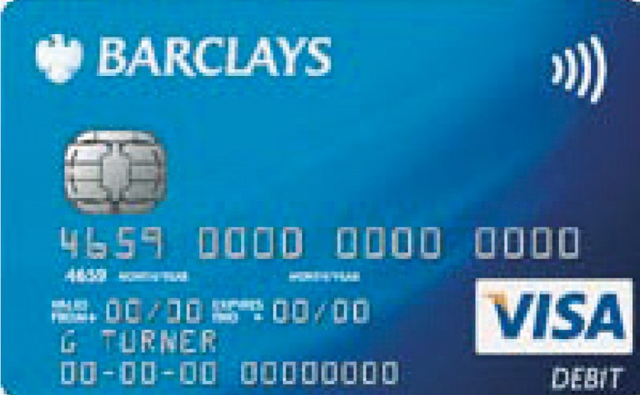
To get money out from your bank you will need to have:
  - Debit card/cash card or
  - Cheque book and debit card/ cash card.

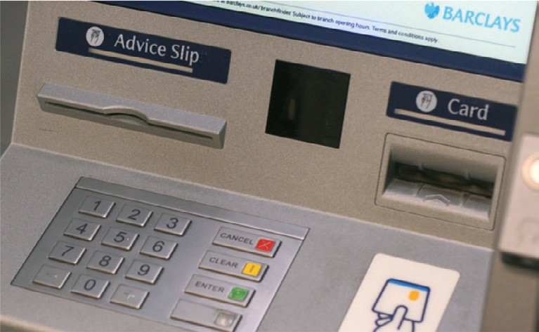
You can use your debit card at the cash machine.

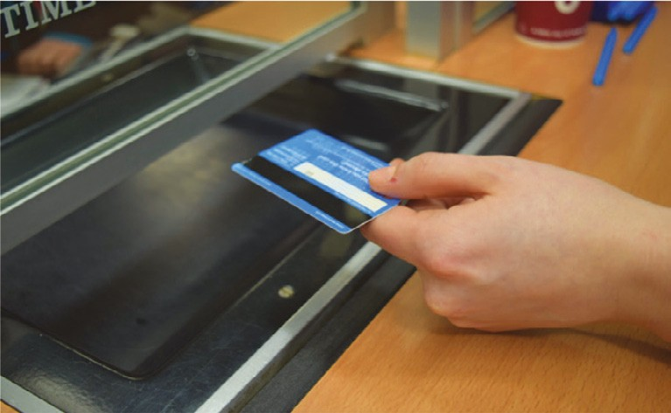
You can use your card at the counter to get money.

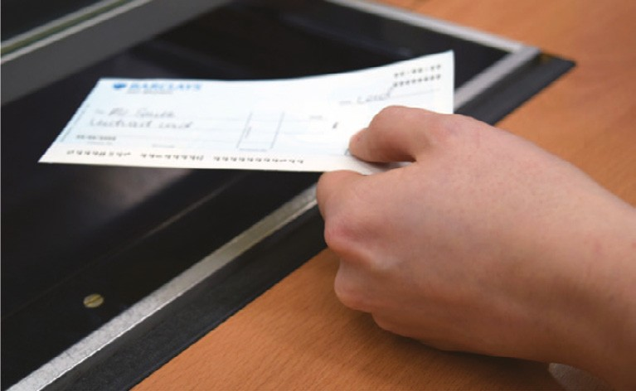
A cheque can be cashed at the counter.

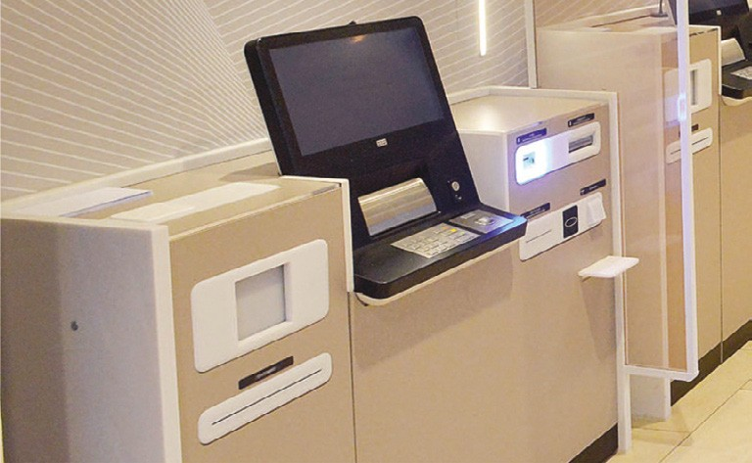
You can use an Assisted Service Counter in the branch to get money.

How do I get money from a cash machine?
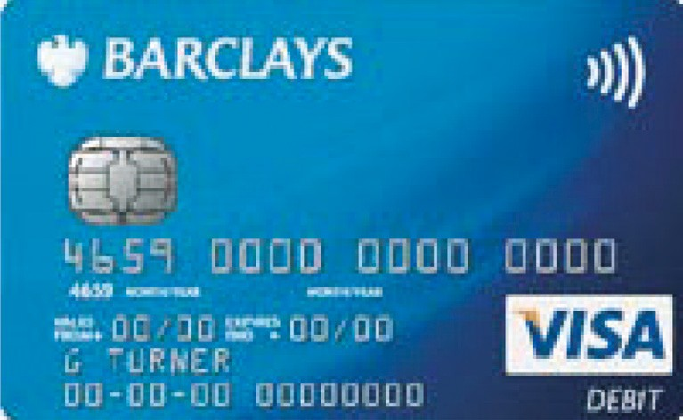
To use a cash machine, you need to have your debit or cash card with you.

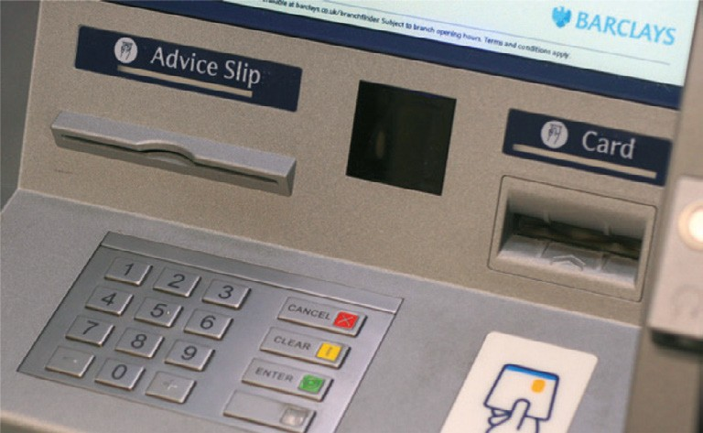
  - Most banks will have a cash machine
– always try and use one that’s inside the bank:
  - Less queues
  - You can take more time
  - Safer.

You can also find cash machines at supermarkets, train stations and other places.

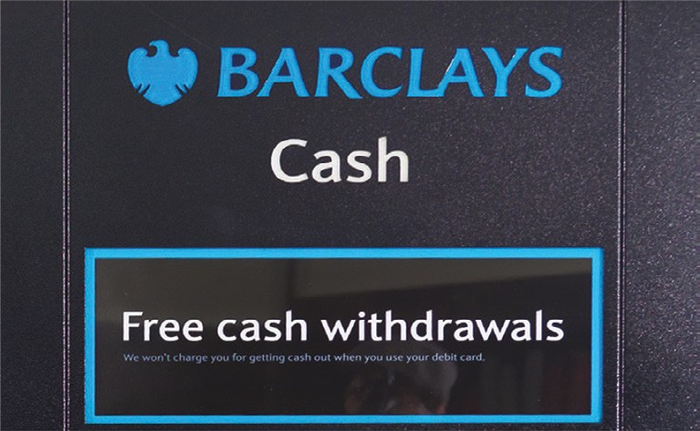
Most cash machines are free, but some cash machines might charge you for taking money.

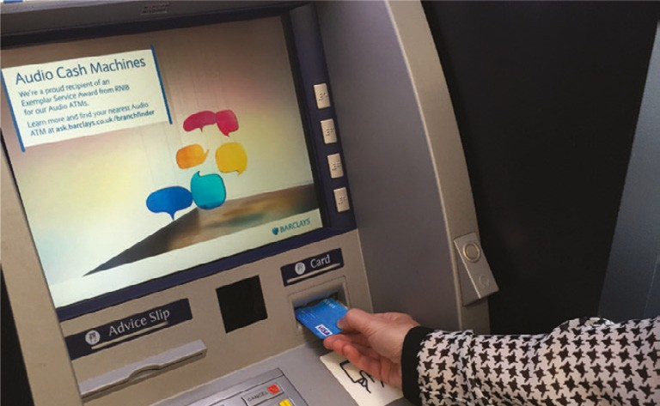
To use a cash machine you will need to put your card into the machine.

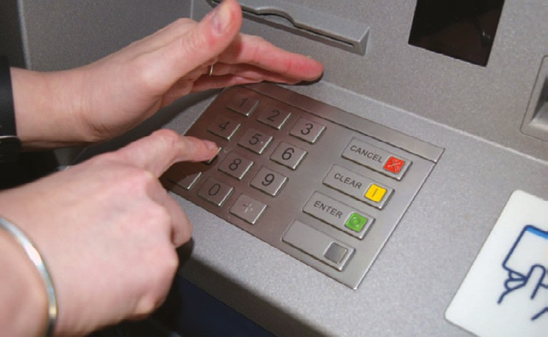
Then you will need to put your PIN (secret number) into the cash machine to get your money.
Always cover your hand so other people do not see the numbers you are pressing.

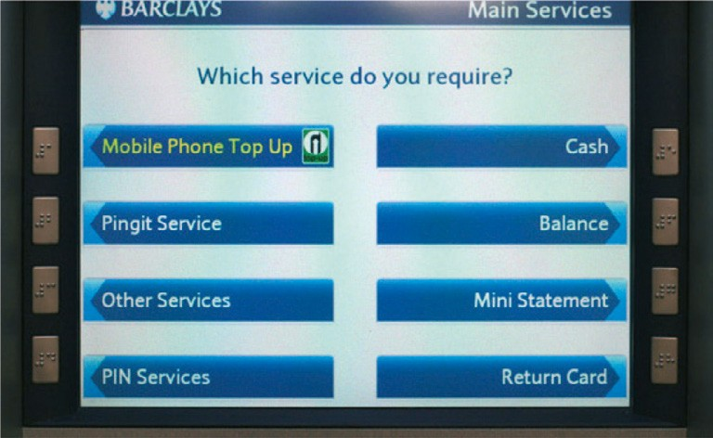
The machine will then give information to you on a screen, including asking if you want cash.
It will ask you how much cash you want to take out of your account.

It will also give you a balance of your bank account. This is the amount of money you have in your bank account that you can use.

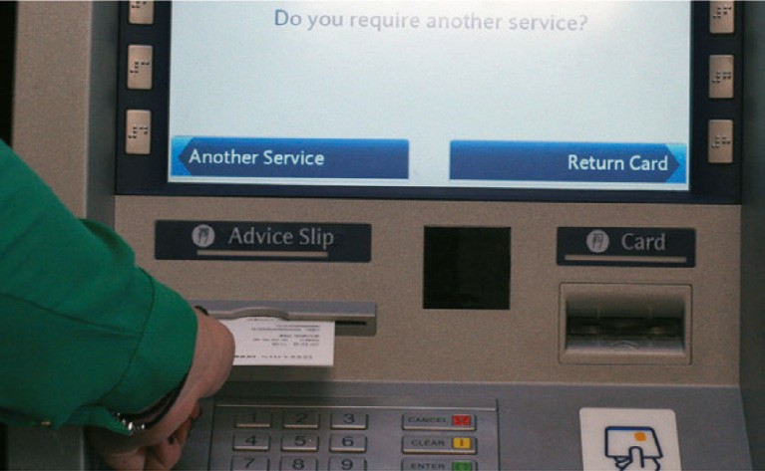
It is a good idea to press the button that will give you cash with an advice slip. That way you will have a record of using the cash machine and how much money you got out.

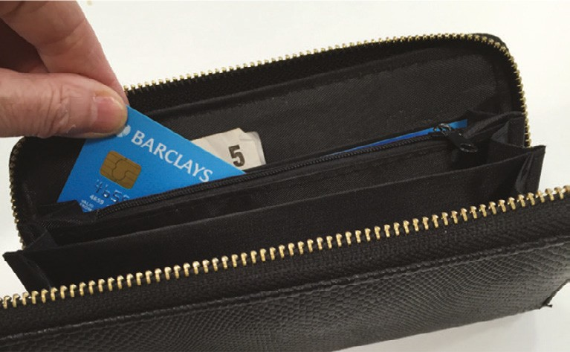
Remember to take your money and your card from the cash machine and put it somewhere safe.

How to cash a cheque?

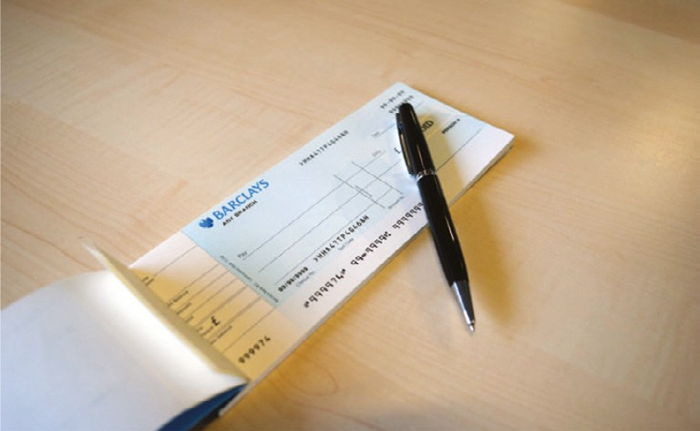
Remember – to check your balance first to make sure you have enough money in your bank account.
To withdraw money from the bank using your cheque book at the counter. You will need to:
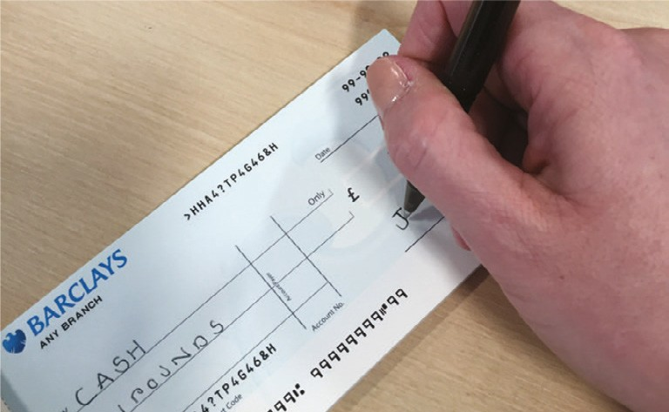
  - Write CASH on the line where it says Pay......
  - Write the amount of money you want to take out in words and the same in numbers
  - Write the date
  - Sign your name.

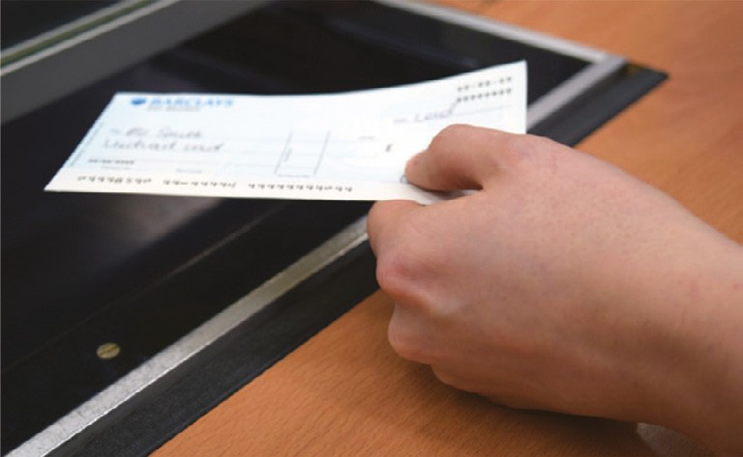
You will need to hand over the cheque and your debit or cash card to the bank staff. They will then give you the money you have asked for.

Cheques are not used a lot now.

If you need help to do this, ask a friend, your family or the bank staff.

How do I get cashback from shops?

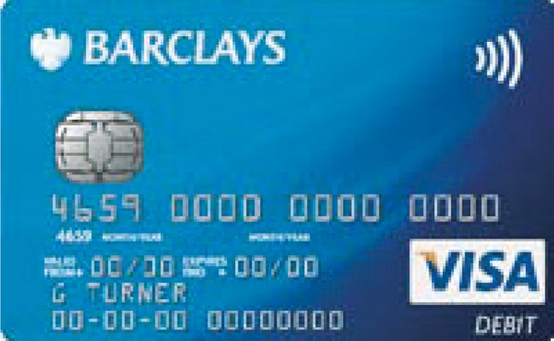
Some shops allow you to get money from your bank account, using your debit card. This is called ‘cashback’.

Most of the big supermarkets and large shops will have cashback, but some smaller shops may not be able to
do this.

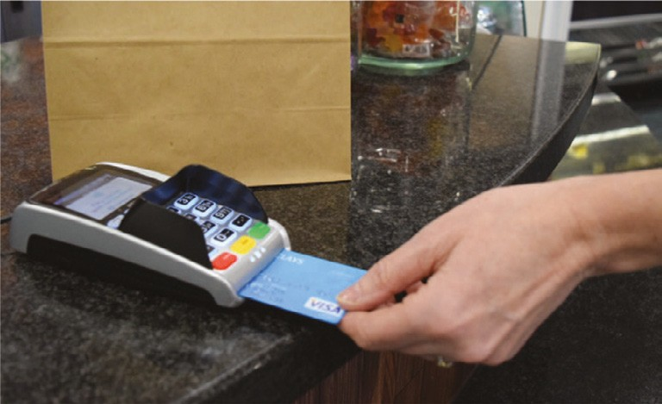
You can only get cashback if you are buying something at the shop using your debit card.

If you want money, you need to tell the shop assistant that you want cashback.

The shop assistant will ask you how much you want. Some shops may have a maximum of £50. This amount will be added to your shopping bill.

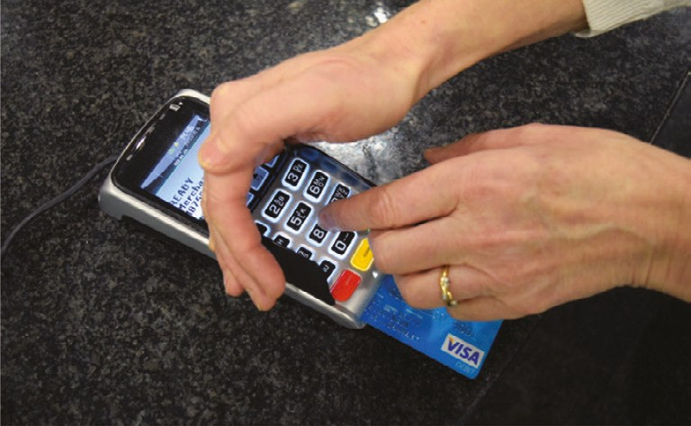
You will need to type your PIN (secret number) into the machine. Always cover your hand so other people do not see the numbers you are pressing.

Remember to take your card out of the machine and put it somewhere safe.

The shop assistant will then give you the amount of money that you have asked for.

Put it in a safe place such as your wallet or purse.

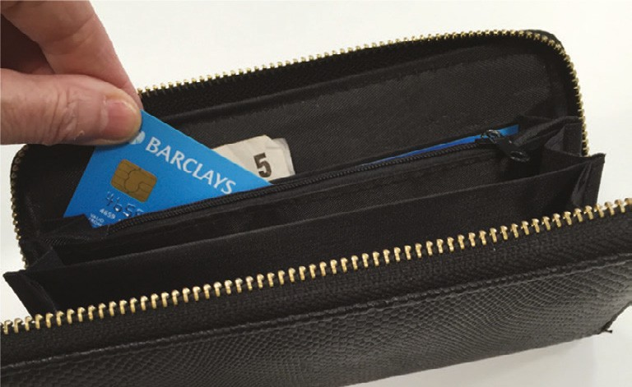
Remember this is money from your bank account – it is NOT the shop giving you money.

How to make contactless payments on your debit card?

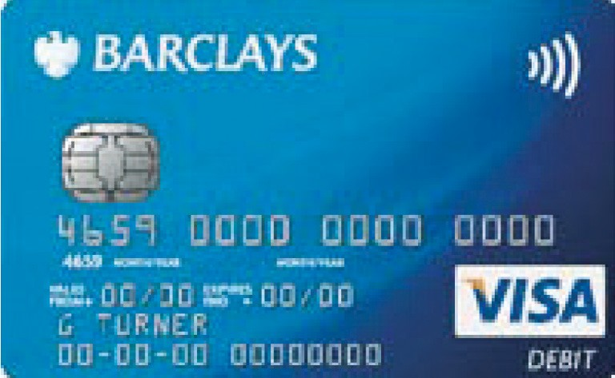
Some debit cards will allow you to buy items using contactless technology when you pay.

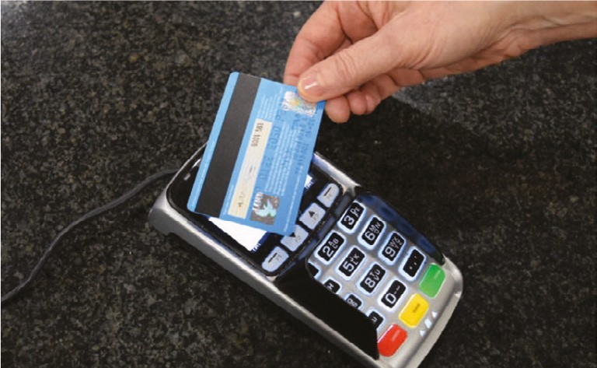
Contactless means that the machine can securely read your card information without having to insert it.

Gently tap your card on top of the machine and the money will be taken from your bank account.

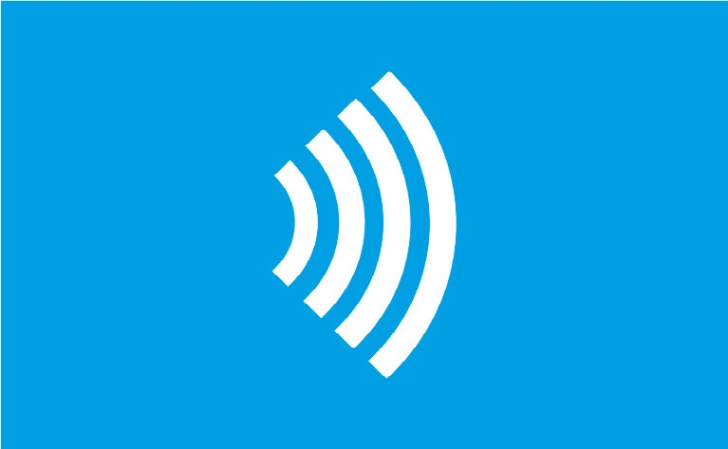
You can use contactless on your debit card if your card has the contactless sign and the contactless
sign is displayed at the terminal where you are paying. You can spend up to
£30 when paying contactless.

How do I set up a Direct Debit or Standing Order?

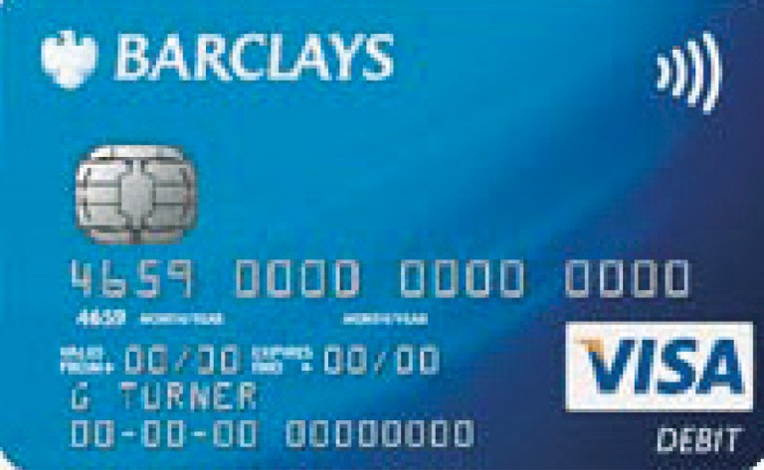
If you want to make a regular payment for something, you can set up a Direct Debit or a Standing Order with your bank.

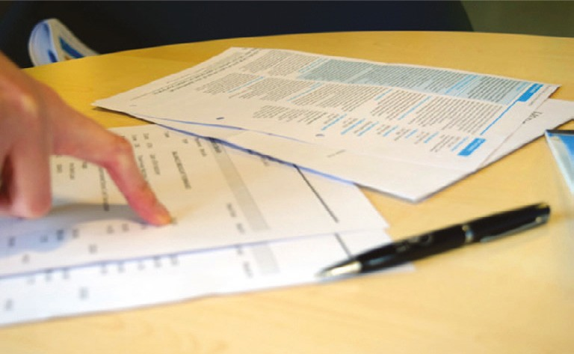
Here are some examples of when you might want to set up a Direct Debit or a Standing Order:
  - To pay your rent or mortgage
  - To pay your bills (gas, electricity, telephone)
  - To pay for big things for your home – like a sofa or television.
Sometimes, it may be cheaper to use a Direct Debit or Standing Order to pay bills because the company you are paying may charge less when you pay this way.

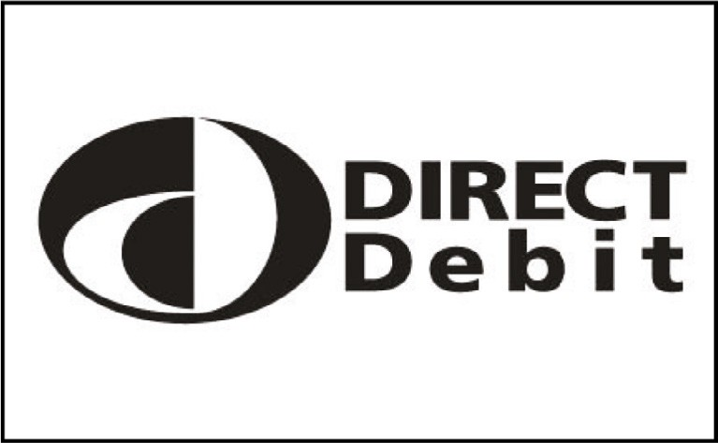
Direct Debit
The company that you need to pay money to will work out how much money you need to pay them each month.

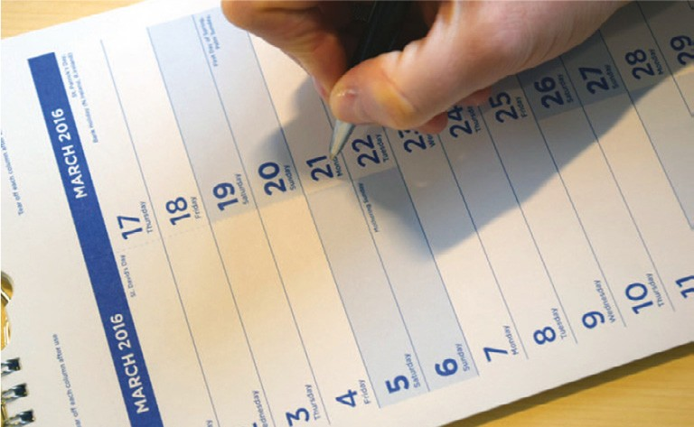
It could be a different amount every month, for example the amount of your phone bill may depend on how many phone calls you have made that month.

They will also work out when these payments will start and when they will finish.

The money might come out of your account on a different day each month.

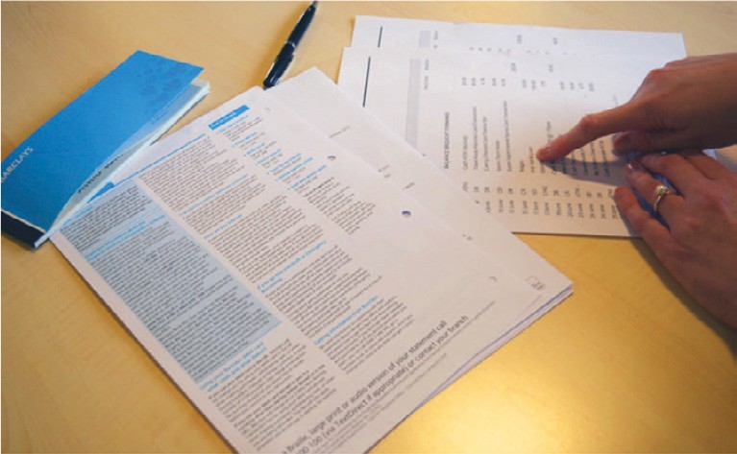
The company may send a letter to you with this information. You will need to sign this to tell your bank that you agree to the Direct Debit.
The company will send the letter to your bank and your Direct Debit will start on the date that has been agreed with you.

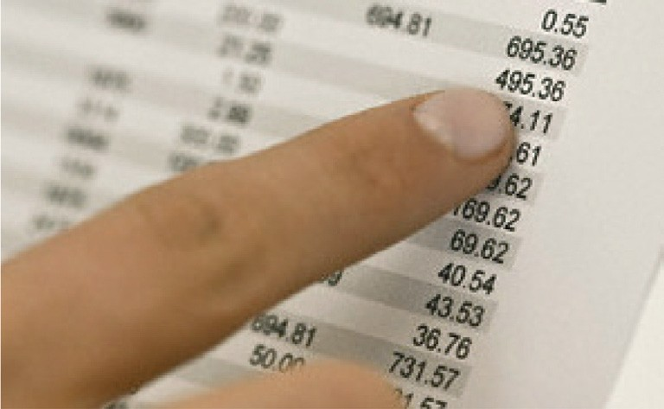
The company will send you a statement each month, which will show you what you have paid and when you paid it. Statements can come in the post or you may be able to get them online or by email depending on which company you use.

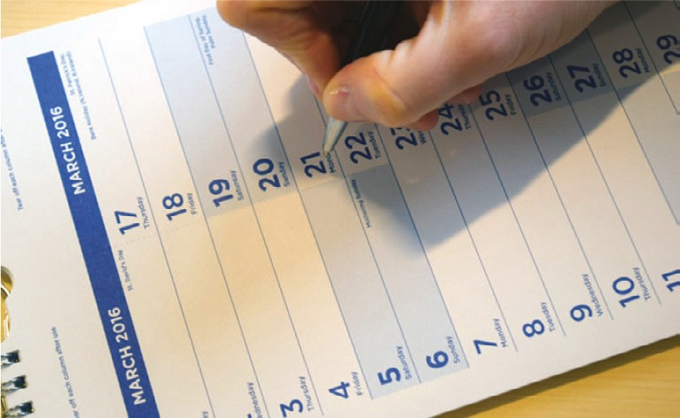
Standing Order
If you want to pay the same amount of money to someone (a person or a
company) on the same day every month or week, you can use a Standing Order.

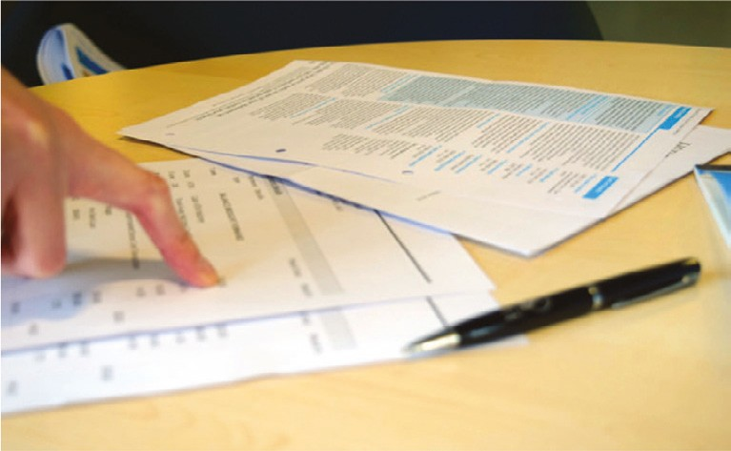
You will need to know the information of the person you want to pay:
- Name
- Account number (eight numbers)
- Sort code (six numbers)
- How much you want to pay them?
- Which day you want to pay them?
- Reference to go with the payment.

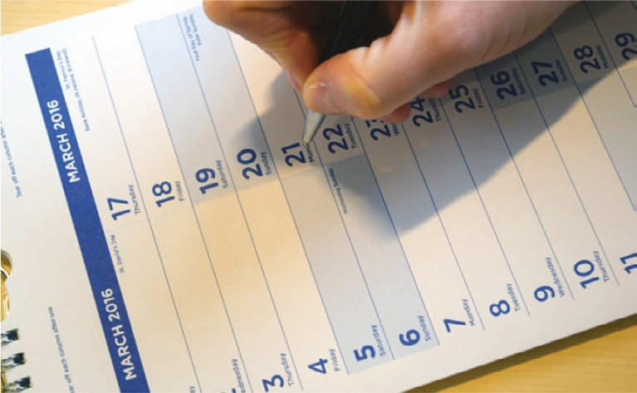
You will need to tell the bank the date you want the payments to start and the date you want them to finish.

How do I change my PIN using the cash machine?

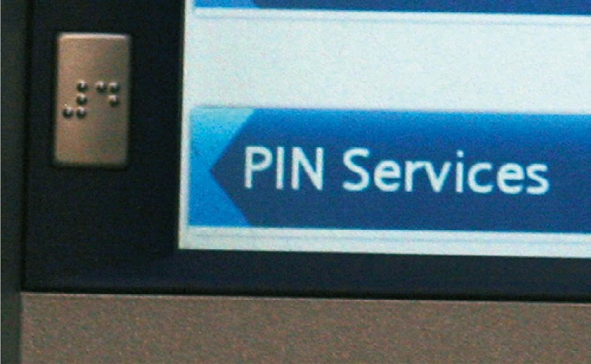
You can change your PIN (secret number) if you want to use one that is easier for you to remember, or if you think someone else knows your PIN.

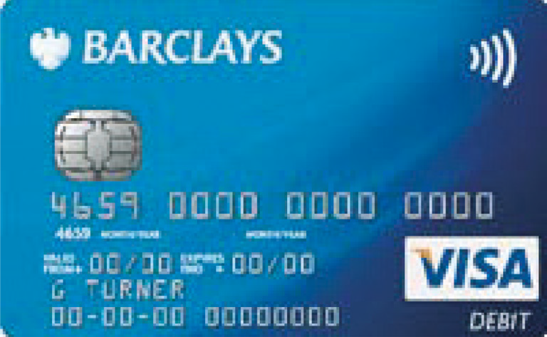
To use a cash machine to change your PIN (secret number), you need to have your debit card or cash card with you.

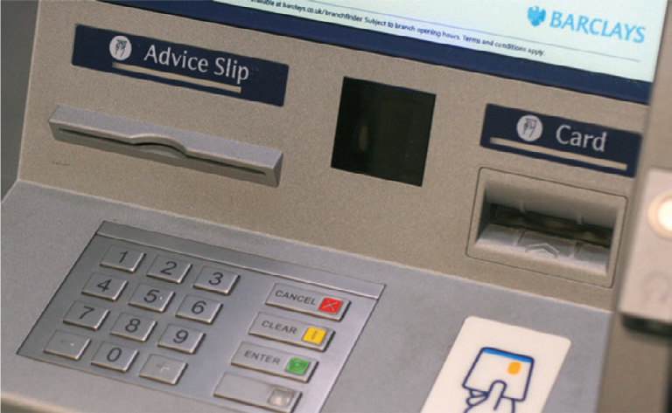
Your bank will have a cash machine – always try and use one that’s inside the bank.

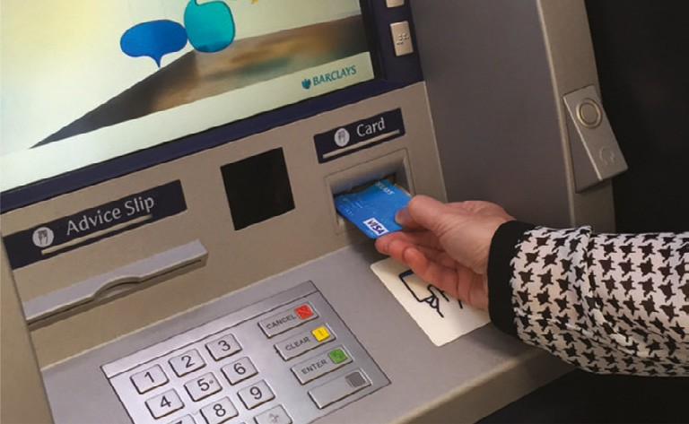
To use a cash machine, you will need to put your card into the machine.

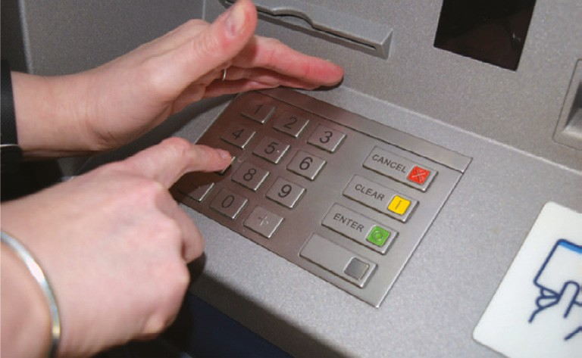
After you have put your card in, you will need to put your PIN (secret number) that we’ve sent you by post.

Remember that your PIN shouldn’t be so easy that anyone can
guess it. Do not use 1234 or your birthday.

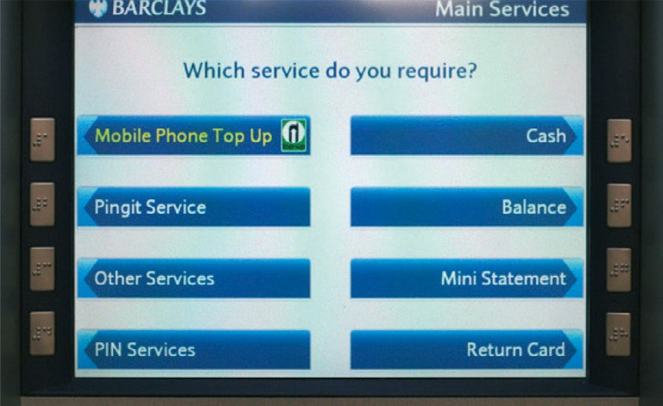
The machine will then give information to you on a screen, including asking if you want to change your PIN.
Press the button next to the PIN Services option.

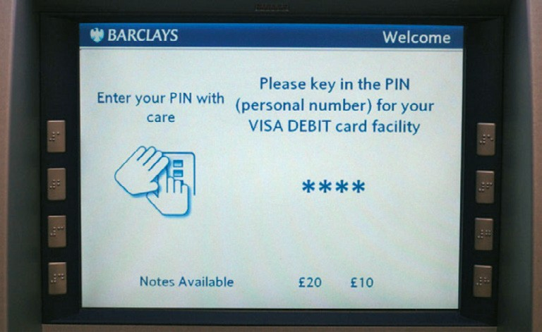
The machine will ask you to put in your original PIN first and then you will need to put your new PIN in, using the number keypad.

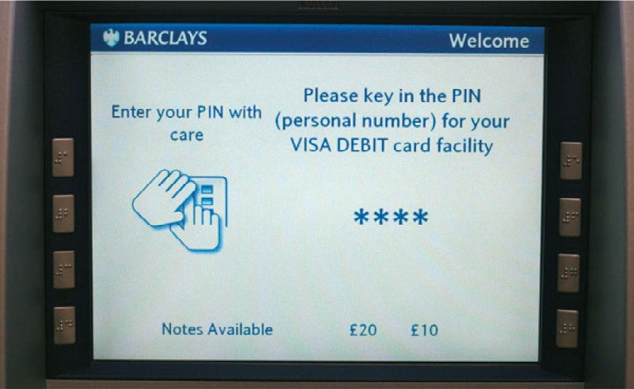
You will need to put your PIN in twice. This is to make sure that you haven’t made a mistake when you typed in the new PIN.

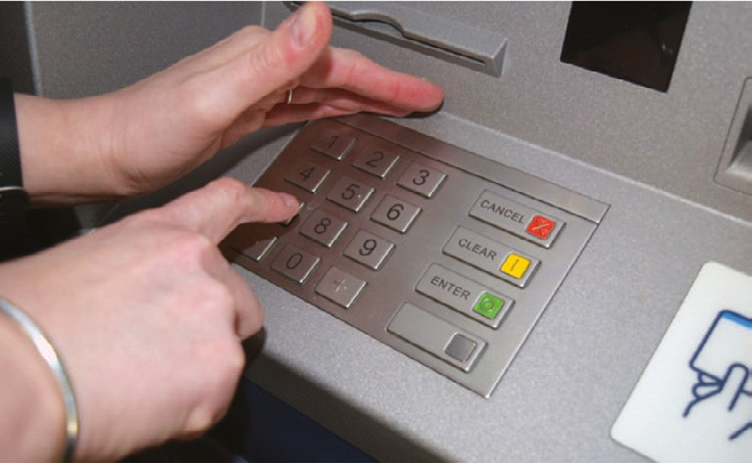
Always cover your hand so other people do not see the numbers you are pressing.

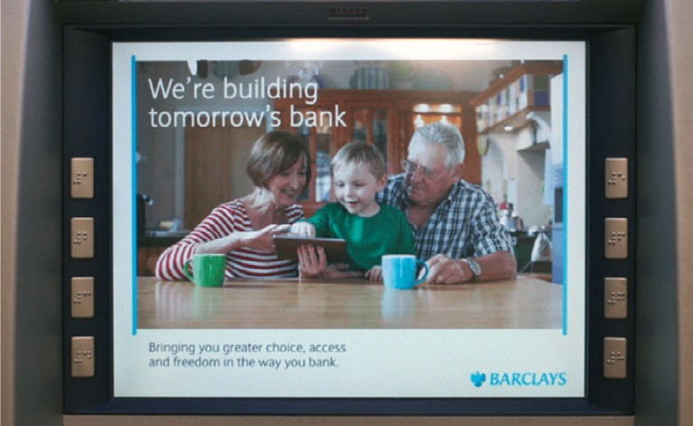
The screen on the machine will then tell you that your PIN has been changed.

You need to memorise this number and not write it down.

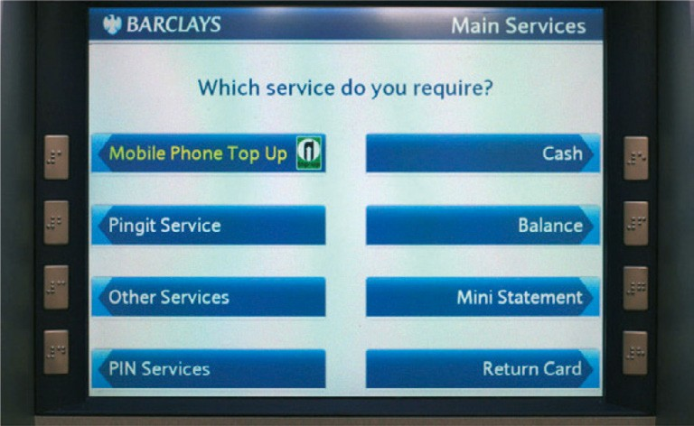
When you have changed your PIN you can carry on using the cash machine to get money, but make sure you have
enough money in your bank account to do this.

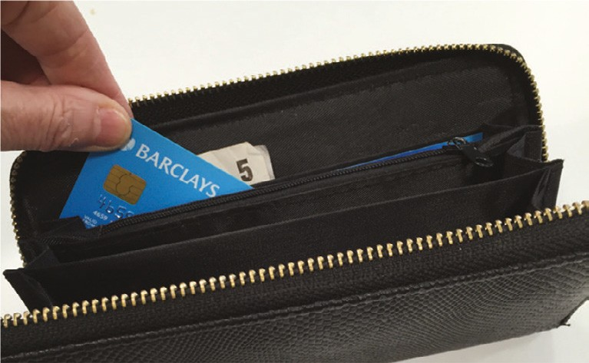
Remember to take your money and your card from the cash machine and put it somewhere safe.

How do I get a mini statement from the cash machine?

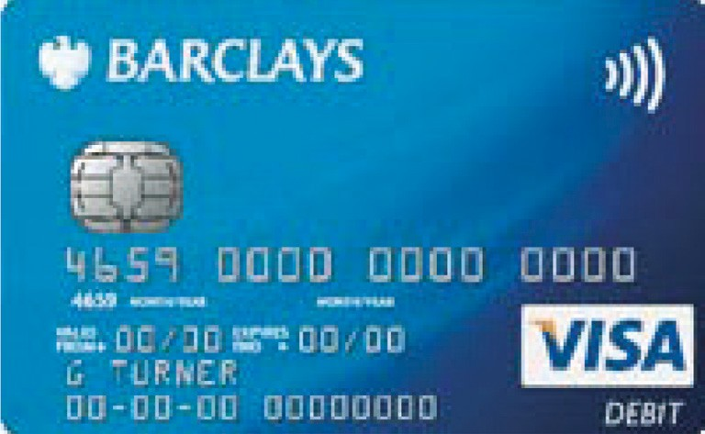
Mini statements show the most recent money that has gone into your bank account and money that has been taken out.

To use a cash machine to get a mini statement, you need to have your debit or cash card with you.

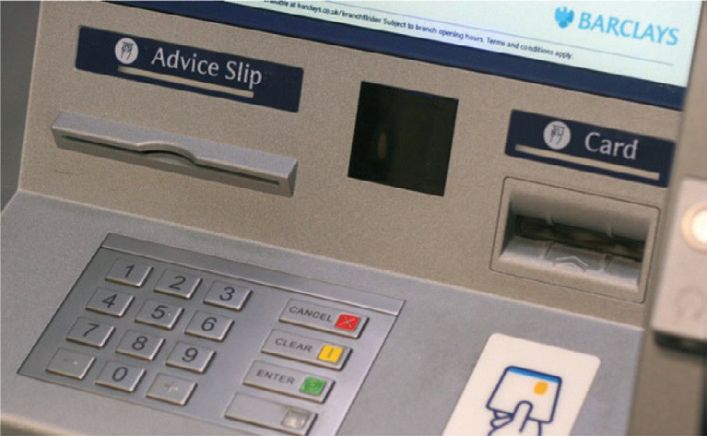
Your bank will have a cash machine – always try and use one that’s inside the bank.

You can also find cash machines at supermarkets, train stations and other places.

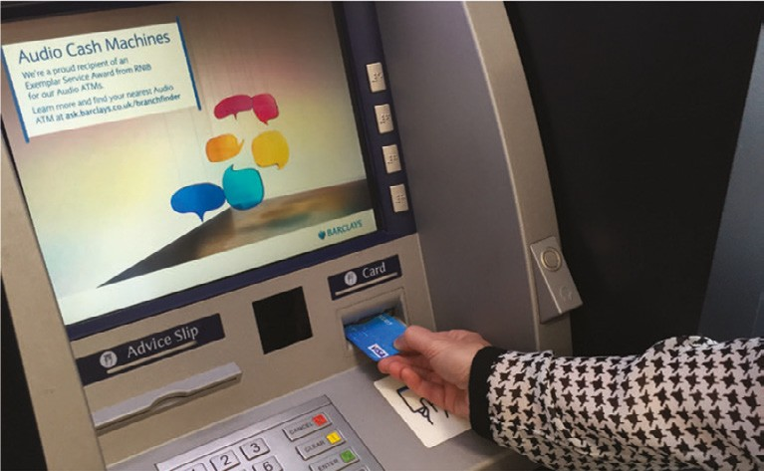
To use a cash machine you will need to put your card into the machine.

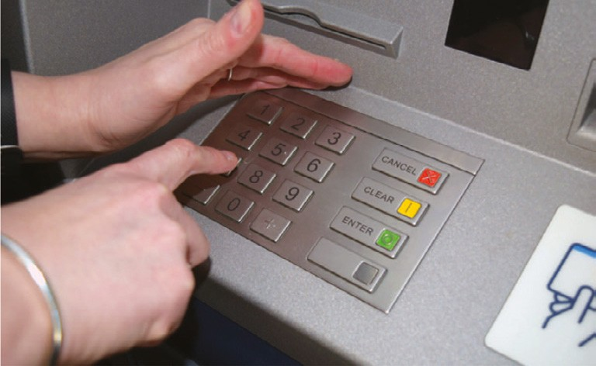
After you have put your card in, you will need to put your PIN (secret number) into the cash machine to get your mini statement.

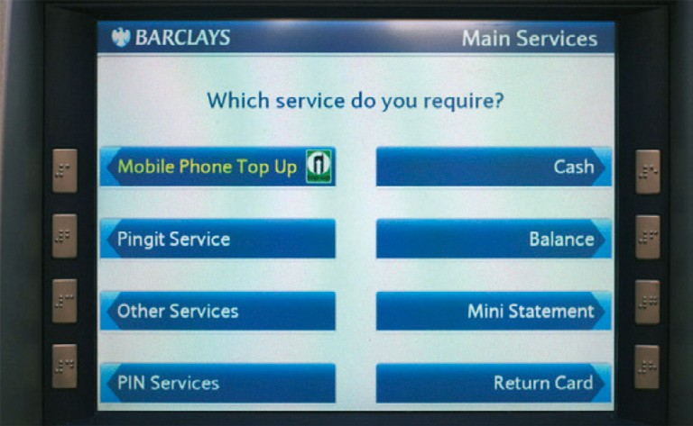
The machine will then give information to you on a screen, including if you want a mini statement.

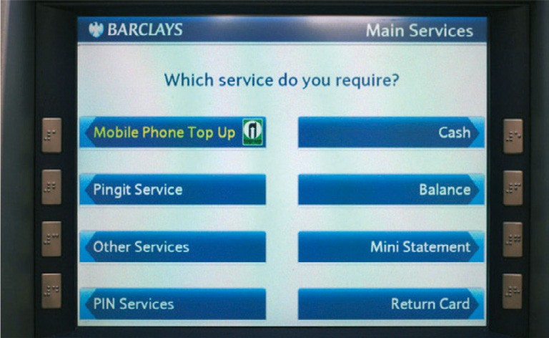
Press the button next to the mini statement option.

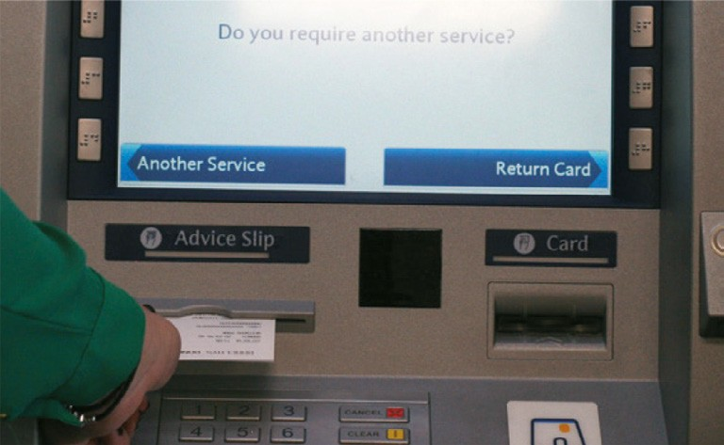
The machine will print you a mini statement. This will then come out of the machine for you to take.

It will also give you a balance of your bank account. This is the amount of money you have in your bank account that you can use.

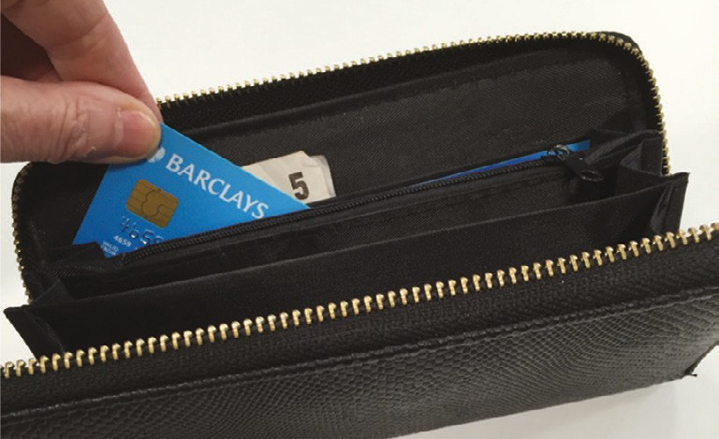
After you have looked at your mini statement, remember to put it away somewhere safe.

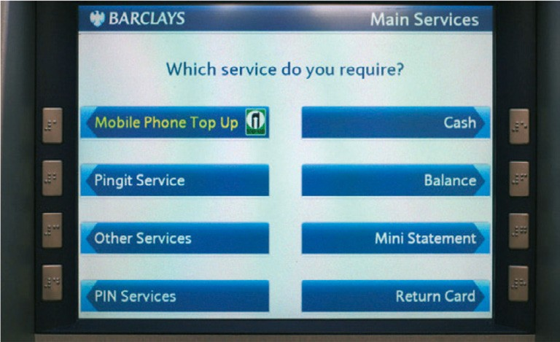
You can carry on using the cash machine to get money, but make sure you have enough money in your bank account to do this.

Remember to take your money and your card from the cash machine and put it somewhere safe.

You can get this in Braille, large print or audio by calling 0800 400 100 (via Text Relay or Next Generation Text Relay
if appropriate). Barclays also welcomes calls via SignVideo for BSL users. Visit barclays.co.uk/signvideo
All Barclaycard customer service lines are non-premium rate numbers.
Calls to 0800 numbers are free from UK land lines and personal mobiles, otherwise call charges may apply. Please check with your service provider. Calls may be monitored or recorded in order to maintain high levels of security and quality of service.
Barclays Bank PLC. Authorised by the Prudential Regulation Authority and regulated by the Financial Conduct Authority
and the Prudential Regulation Authority (Financial Services Register No. 122702). Registered in England. Registered No. 9740322. Registered Office: 1 Churchill Place, London E14 5HP. Item ref: 9913024_UK_Access 04/18

