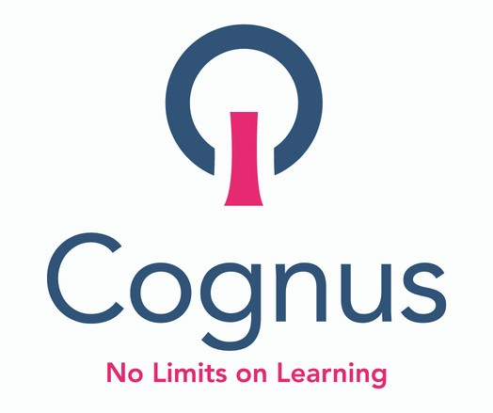
LOCAL RESOLUTION PARENT LISTENING EVENT
Having the right conversations, at the right time to improve communication and outcomes for children,
young people and families

J U L Y 0 9 , 2 0 2 1 | 1 0 : 3 0 A M T O 1 1 : 3 0 A M O R
J U L Y 2 3 , 2 0 2 1 | 1 4 : 3 0 P M T O 1 5 : 3 0 V I R T U A L E V E N T S

JOIN US & OUR EXPERT PANEL FOR A Q& A
SESSION
Cognus are hosting a Q&A session to raise
awareness of routes for tackling challenges as
they arise. Supporting early resolution to prevent escalation and support positive outcomes.

S E S S I O N S W I L L I N C L U D E :

L O C A L R E S O L U T I O N M E D I A T I O N
N E X T S T E P S M E E T I N G S S C H O O L E X C L U S I O N
A P P E A L S T O F I R S T T I E R T R I B U N A L C O M P L A I N T S T O O F S T E D
D I S S A B I L I T Y D I S C R I M I N A T I O N F I R S T T I E R T R I B U N A L S

Book your place now and pre-submit any specific questions you would like answers to at Enquiries@cognus.org.uk or
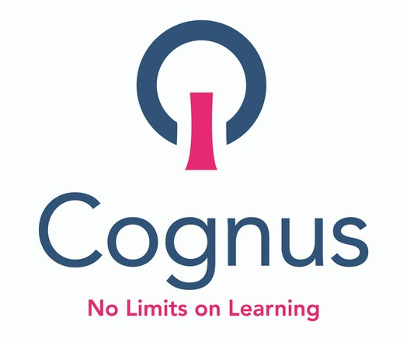
Tel 020 8323 0450

