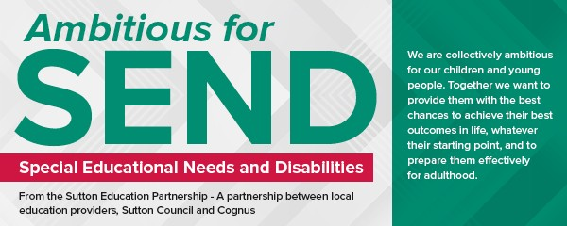View this email in your browser

Welcome to the June edition of our Ambitious for SEND newsletter!
We are ambitious for SEND in Sutton and it's important we communicate that ambition to the people that matter the most - parents and young people. Improving the way we communicate has been an important part of our journey over the last few years and as much as I hope that you find this newsletter useful, it is much more than newsletters and websites. It's about how we communicate with each other in our everyday conversations.

I came across a piece of work called reshaping conversations that Swindon SEND Families Voice have been working on which highlights the importance of using positive language to foster better working relationships between SEND children and practitioners and gives practical examples of how small changes can make a big difference to families' experiences. If you find a spare 5 minutes it's worth a watch - I am sure the video will resonate with parents - I know it did with me, and it's something we continue to work on in the local area.

This is why we have made how we 'communicate' a central plank in our new SEND Charter - a description of how we want to work in the local area (see below). Of course communication works both ways so, in that spirit, I would welcome your views on the charter or anything else in relation to SEND in Sutton including how you might help us to make our SEND charter a reality! Do get in touch - education.sendfeedback@sutton.gov.uk

Fiona Phelps
Assistant Director for Education and SEND

Ambitious for SEND - what have we been working on since our last update in February

(at a glance)...

We continue to work hard on our Ambitious for SEND Programme - here are a few updates 'at a glance' on what we have been working on, some of which have more information below:

We have developed a draft 'SEND Charter' with parents and professionals describing our values and attitudes to supporting young people with SEND (see below).
We are finalising our plans for supported internships from September next year for young people with SEND (see below).
We continue to establish a strong community of practice with our 'SENCO
clusters' - most recently creating an online 'knowledge hub' to enable SENCOs to share information and best practice as well as publishing our SENCO webpages on the Local Offer
With the help of Sutton Parent Carer Forum, Sutton has adopted the Hidden Disabilities Sunflower to support and raise awareness of those living with a hidden disability.
We have invited bids from the education community in Sutton on how we can invest over £3.5m to improve the educational environment / facilities for young people with SEND across the local area as part of our 'Special Provision Capital Fund'.
We have been invited by the GLA and RSA to take part in a 'deep dive' workshop on inclusion and nurture - a subject very close to our hearts! We have set up a Multi-Agency Learning and Development site for anyone who is involved with children, young people and their families in the London Borough of Sutton.
We have invited schools to take part in a pilot programme to offer Independent Travel Training to pupils in Sutton - delivered by school staff how know the children the best!
We have undertaken the first phase of our review on how we deliver
therapies to children in the Local Area.
Last but not least one of our local area professionals Pam Fry, Founder and CEO of PlayWise CiC has been awarded an MBE in the Queen’s Birthday Honours for the for services to children with Special Educational Needs and Disabilities (SEND) - read more here.

Our new Draft SEND Charter now Published - let us know your views!

What is an SEND Charter?

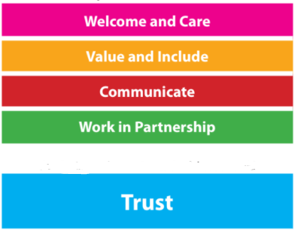The charter is a set of values and attitudes agreed with all stakeholders with regard to how we approach SEND in the local area. It provides us with a framework to pick up where we fall short, and more positively, a framework to celebrate when we are all working well together.

It is something we have worked up in partnership with Education, Health and Social Care professionals from across the Local Area, with the Sutton Parents Carers Forum, the Sutton Education Partnership, Cognus and Schools/education settings.

You can download a copy of the draft charter here.

We are very grateful to the Sutton Parent Carer Forum for their time and thought in helping us get to this point and want to hear the wider views of other parents from across the Local Area. Please let us know what you think by emailing - education.sendfeedback@sutton.gov.uk

What happens next?
Once we have confirmed the principles, we will work with partners from across the Local Area to develop our existing practices and processes in line with these charter principles.
Help us live our SEND Charter - volunteer for the Sutton Information and Advice Service!

Sutton Information and Advice Service (SIASS) is currently recruiting for the following volunteer positions:

3 x SIASS Steering Group Members - Parent/Carer Representatives 2 x SIASS Information & Support Volunteers

For more information about the roles please click here!

To find out more please take a look through their Spring/Summer newsletter or visit the website.
Update on the Children’s Therapy Review

The London Borough of Sutton (LBS) and South West London Clinical

Commissioning Group, Sutton Borough (SWLCCG) have been working together to review therapy provision. The aim of the review is to develop and improve children’s therapy services in Sutton, and develop a sustainable model which reflects national best practice.

We want to strengthen what works, as well as identifying ways to do things differently, to ensure we can continue to best meet the needs of children and young people, and improve their outcomes.

Read more about the Children's Therapy Review.
Preparation for Adulthood - do you know someone with SEND that might benefit from a supported internship?

Supported internships are aimed at young people aged 16 to 25 with an Education, Health and Care Plan, They provide students with real life experience needed to gain paid employment. Interns will work for one year, completing three, ten-week job rotations and will be supported at every stage by a Job Coach. If you know someone who might be interested then click here to find out more!

Cognus have been also been busy...

The SEND service met with over 60 local families collectively and individually to talk about key stage transfer - particularly critical during COVID-19. Placements have been agreed for September 2021 and we look forward to hearing of children's progress when they join their new schools!
Praise for 'Brighter Futures' - Cognus together with local area partners have been recognised by the DfE when identifying 'what works' in how young people can be supported in making sustained post-16 transitions. Well done team!
Making Music with Students with PMLD - Sutton Music Service's (SMS) mission is to provide access to music in all its forms for every young person in the borough. With support and training from Open Orchestras, SMS has been working with Sherwood Park School (an all-age foundation special school) to create an orchestra accessible to young disabled people.
Sutton young people can now learn about personal budgets via a new video on the Local Offer. This will help young people understand the

choices they have and work towards their goals.
Supporting Sutton's Traveller community - Cognus have recently been working with St Elphege's RC Infant on an Early Language Intervention programme designed for reception pupils with some fantastic results! One of the traveller pupils supported through the programme scored joint highest in his class - a great achievement!
The Hearing Impairment service have been enjoying being back out on home visits working with families. It has been great to see some our (almost) 2 year olds getting comfortable with their hearing aids something that is critical to early language skills.
If you want to find out more about anything above or about the services that Cognus provide please do get in touch - enquiries@cognus.org.uk

Upcoming SPCF Events

Please visit the Sutton Parent Carer Forum website for more details of future events this summer.

www.suttonparentsforum.org.uk

For more information please visit Sutton's Local Offer Website

Copyright © 2021 London Borough of Sutton, All rights reserved.

Sutton Council, Civic Offices, St Nicholas Way, Sutton, SM1 1EA

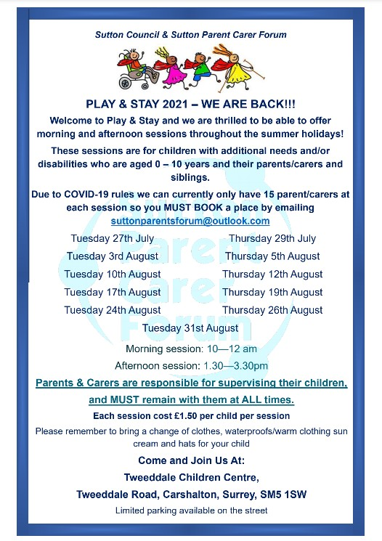
update your preferences unsubscribe from this list.

