Vicky Ford MP
Parliamentary Under-Secretary of State for Children and Families
Sanctuary Buildings 20 Great Smith Street Westminster London SW1P 3BT tel: 0370 000 2288 www.education.gov.uk/help/contactus

24 June 2021

AN OPEN LETTER TO LEADERS OF SPECIAL AND ALTERNATIVE PROVISION SCHOOLS

Dear Colleagues,

As we approach the end of one of the most challenging and extraordinary academic years in recent history, I wanted to write to you to extend my thanks for your continued dedication. The dedication and adaptability which you and your staff members have shown in uncertain circumstances never fails to amaze me. It has been invaluable in enabling some of the most vulnerable children and young people in special settings and AP across England to attend and re-engage in education, spending as much time in school as possible.

As we look ahead to the summer holiday, I am sure that many of you will all be looking forward to the opportunity for a well-deserved rest. I wish you all the best and hope that you and yours have a pleasant time wherever you choose to spend it.

I am, however, conscious that many of you are already thinking about how the children and young people that attend your settings can be best supported throughout the summer holiday. I want to use this opportunity therefore to remind you of two key areas of support which the government is offering this summer to pupils in your settings and ask for your cooperation:

- Summer schools - Firstly, I would like to draw your attention to the £200m of funding which is available for secondary schools to deliver face-to-face summer schools this year to support children with their mental health and wellbeing and to catch up on missed face-to-face learning. For pupils in your settings (special schools, AP or special units in mainstream schools) funding is
£1791 per pupil (3x the standard rate) for a two-week summer school (or
£179.10 per day). This is in recognition of the importance and increased costs of providing high-quality support for pupils with additional or complex needs and ensuring that they can access the same opportunities as their peers in mainstream settings. Funding for your settings has now been calculated on the basis of 50% of your year 11 cohort, in recognition that your settings generally have few year 7 pupils. For any special settings or AP whose year 7 cohort is larger than their year 11 cohort, those schools’ initial funding allocations will stand.

If you haven’t yet decided whether your setting will be running a summer school, I recommend visiting the GOV.UK page, where you can find published guidance and the funding allocation for your setting. The guidance also includes links to potential sources of support in planning and delivering a summer school. You can then confirm whether you will be running a summer school and secure your funding allocation here by 30 June.

- Holiday Activities and Food – Secondly, I want to remind you of the Holiday Activities and Food programme which will be running once again this summer. We have made up to £220 million available to local authorities to coordinate free holiday provision, providing nutritious food, as well as activities like arts and crafts, sport, and music.

The programme offers free places to children in receipt of free school meals in every local authority in England. Local authorities have flexibility to expand the reach of their programme beyond children who are eligible for free school meals, by using their funding to provide subsidised holiday club places. This may include children who are considered by the local authority as vulnerable or in need of this provision.

Please contact your local authority for further information and consider advertising this to children and young people in your settings. I myself saw first-hand how local partnerships helped to deliver these excellent schemes last summer.

Finally, I would again like to express my appreciation for your continued support, patience and dedication whilst we navigate through these challenging times.

Yours sincerely,
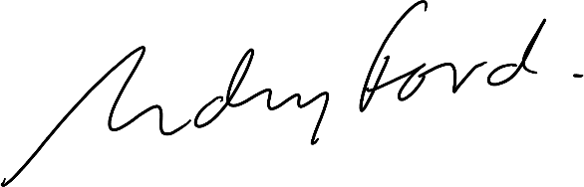
Vicky Ford MP
Parliamentary Under-Secretary of State for Children and Families

