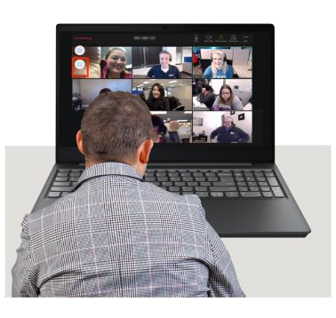



Are you a young person with a

learning disability living or learning in Sutton?

**Topic: Talk about issues affecting**

**young people**

**Play games and quizzes**

**Make friends**

**When: Wednesdays fortnightly**

**From:**

**5:00 – 18:30**

**Please contact Gracie or Juan for more information:**

[Gracie.mirembe@advocacyforall.org.uk](mailto:Gracie.mirembe@advocacyforall.org.uk) [juan.sanchez@advocacyforall.org.uk](mailto:juan.sanchez@advocacyforall.org.uk)

**Gracie mob: - 07395789110**

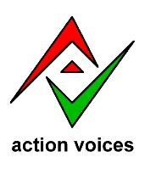

**Action Voices**

speaking up for young people with disabilities in the Sutton borough