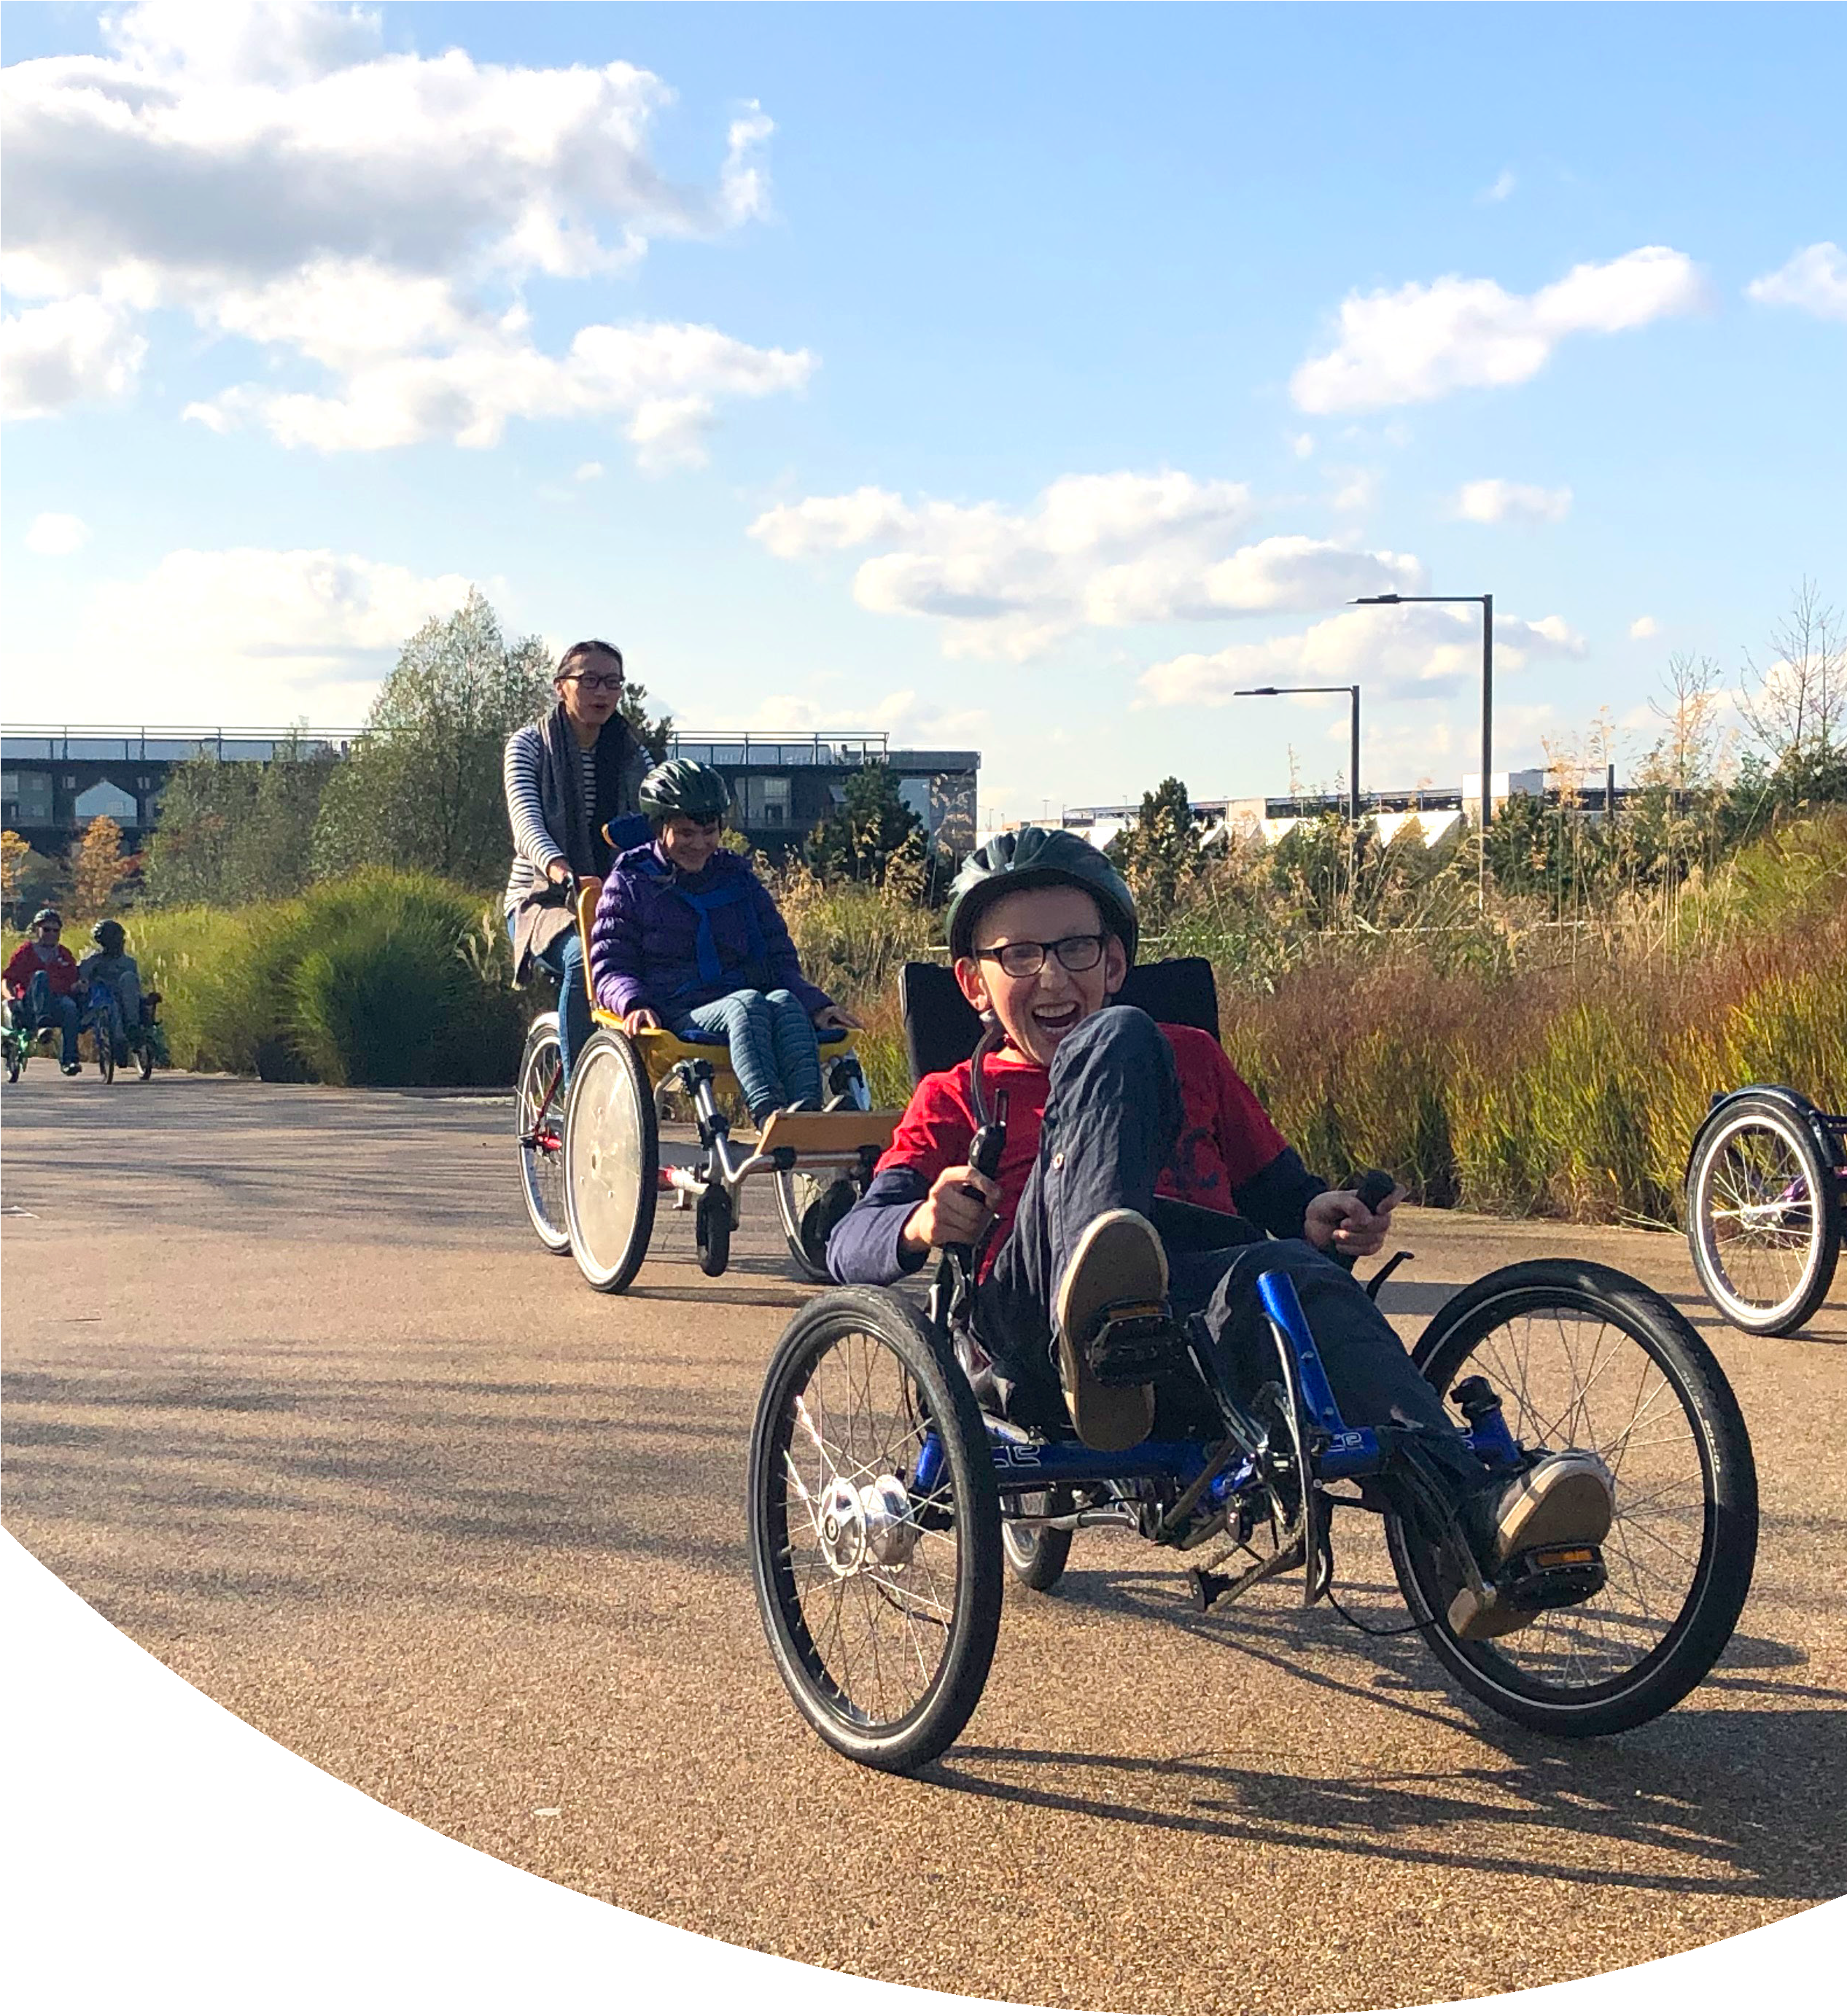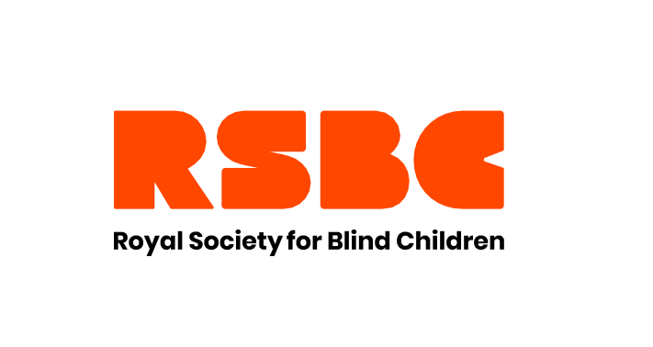

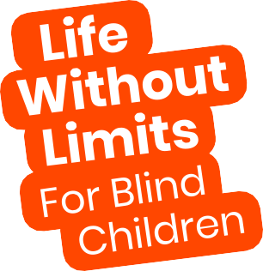
SUMMER HOLIDAY
ACTIVITIES 2021

There’s lots to look forward to this summer at RSBC! Check out our timetable of fun virtual and face- to-face summer activities for vision

What’s On?
impaired children and young people.

Tuesday 27th July Summer Welcome Picnic
WELCOME
Join our Summer Welcome Picnic as we kick off our gradual return to face-to-face activities with games, socialising and celebrations!
Victoria Park, Grove Road, London,
E3 5TB
11am - 3pm 0 - 25 years

Thursday 5th August Stubbers Adventure Day Trip
We’ll be chasing the excitement across land and water with exciting attractions like climbing, off-road driving, water sports and other skill-building activities!
Stubbers Adventure Centre,
Ockendon Road, Upminster, Essex,
RM14 2TY
11am - 4pm 8 - 25 years

Friday 6th August Freshers’ Event
FRESHERS’
Find out how to adjust to university and make the most of those first few weeks and months. We’ll be hearing from VI graduates and there will be a chance to ask your burning questions!
Online 1pm - 3pm
16 - 25 years

Friday 13th August Kew Gardens Tour
The Kew gardens sensory team will give us a guided tour made specifically for vision
impaired people, and you’ll have the rest of the day to explore the gardens!
Kew Gardens, Richmond, London,
TW9 3AE
11am - 4pm 8 - 25 years

Thursday 19th August Gaming Session
Join us as we will play a variety of interactive online games suitable for all levels of gamers.
Online 1pm - 3pm
8 - 25 years

Tuesday 24th August
Stubbers Adventure Day Trip Part 2
We’ll be chasing the excitement across land and water with exciting attractions like climbing, off-road driving, water sports and other skill-building activities!
Stubbers Adventure Centre,
Ockendon Road, Upminster, Essex,
RM14 2TY
11am - 4pm 8 – 25 years

Thursday 26th August Gaming Session
Join us as we will play a variety of interactive online games suitable for all levels of gamers.
Online 1pm - 3pm
8 - 25 years

Thursday 26th August Afrobeat’s Project Showcase
We’ll be showcasing the amazing song that our Creative Group put together in their sessions with Silvastone!
Online
4pm – 5:30pm All ages

Friday 27th August Sisterhood Workshop
This is your chance to try out the amazing hair care packs from Denham, GHD and L’Oreal, and to ask any hair care and styling questions you might have. If you’re new to sisterhood, get in touch for more information and a chance to receive a hair pack!
Building 113,
29 Wadeson Street, London,
E2 9DR
3pm - 5pm 11 - 25 years

Inclusive Vision Residential
Our residential is the ultimate weekend adventure! Please contact enquiries@rsbc.org.uk for more information on this session.

0203 198 0225
enquiries@rsbc.org.uk www.rsbc.org.uk/calendar-of-activities
Registered charity No: 307892
Interested?
Get in touch to find out more!

